**School of Computer Science**

**UNIVERSITY OF PETROLEUM AND ENERGY STUDIES**

**DEHRADUN, UTTARAKHAND**



**PHYSICAL AND IT SECURITY LAB**

**Lab File**

**(2023-2024)**

**for**

**3rd Semester**

**Submitted To: Submitted By:**

Dr Gopal Rawat Akshat Negi

Assistant Professor-SS Btech CSF [3rd Semester]

School of Computer Science 500106533

Batch 2

**TABLE OF CONTENTS**

1. **EXPERIMENT 1:**

Learn about Logs for Windows and Linux

**2. EXPERIMENT 2:**

Trace Email sender location, Date/time, IP Address

**3. EXPERIMENT 3:**

Understanding Vulnerability in local operating system

**4. EXPERIMENT 4:**

Find vulnerabilities in Live IoT devices on Internet

**5. EXPERIMENT 5:**

Lab Objective: Perform Internet Footprinting

**6. EXPERIMENT 6:**

Hack using Search Engines

**7. EXPERIMENT 7:**

LAN KALI LINUX

**8. EXPERIMENT 8:**

Network Scanning Tool - NMAP

**9. EXPERIMENT 9:**

Network Traffic Sniffing – Wireshark

**10. EXPERIMENT 10:**

Nessus Essentials for Vulnerability Scanning

**LAB EXPERIMENT – 1**

**LOGS TABLE FOR WINDOWS**

|  |  |  |  |  |
| --- | --- | --- | --- | --- |
| **Windows Log** | **Source** | **Event ID** | **General Info** | **Mitigation Steps** |
| Critical | **Kernel-Power** | **41** | The system has rebooted without cleanly shutting down first. This error could be caused if the system stopped responding, crashed, or lost power unexpectedly. | Basically, to get rid of this type of error is by outdated drivers installed on your devices, so kindly update the audio drivers if still didn’t receive any fix, then you can go for all drivers updating process. |
| Critical | **WinREAgent** | **4502** | This problem occurs when a MicrosoftDNS container is created before a full replication of the application partition. | A supported hotfix is now available from Microsoft, but it is only intended to correct the problem. Only apply it to systems that are experiencing this specific problem. You do not have to restart your computer after you apply this hotfix. |
| Error | **BugCheck** | **1001** | This type of error usually occurs when third party antivirus software conflicts with windows security. | To resolve this type of event error you need to disable your third-party antivirus installed and even the firewall applications if you are not using antivirus software. |
| Error | **Service Control Manager** | **7024** | This issue is when the component that raises this event is not installed on your local computer or the installation is corrupted. | To resolve this kind of issues kindly install or repair the component on the local computer. |
| Error | **DistributedCOM** | **10010** | The server {A463FCB9-6B1C-4E0D-A80B-A2CA7999E25D} did not register with DCOM within the required timeout. | Some steps by which you can fix it are: -  1. Tweak Component Services  2. Enable Function Discovery Resource Publication service  3. Reset DCOM permissions  4. Use SFC Scan  5. Install the latest Windows update  6. Reset your PC |
| Error | **WindowsUpdateClient** | **20** | Installation Failure: Windows failed to install the following update with error 0x80073D02: 9NMPJ99VJBWV-Microsoft.YourPhone. | If updates are available but are not automatically downloaded then restart the system which can fix these issues. |
| Error | **Service Control Manager** | **7000** | The Steam Client Service failed to start due to the following error:  The service did not respond to the start or control request in a timely fashion. | To fix this error you have to manually give a start to the SteamClient service in services pannel from the START menu. |
| Error | **NDIS** | **10317** | Miniport Microsoft Wi-Fi Direct Virtual Adapter #2, {1848adcf-46a9-4b89-8ee6-dbcd71e49c54}, had event Fatal error: The miniport has failed a power transition to operational power | This frequently occurs when the mobile broadband device was turned off and is restarting. If you are using router then I suggest you to reset the router and check if the issue persist otherwise reinstall the network drivers. |
| Error | **Service Control Manager** | **7023** | The NVIDIA LocalSystem Container service terminated with the following error:  A generic command executable returned a result that indicates failure. | This is the service failed issue that can be resolved when you just have to restart the service from services from Start Menu. |
| Error | **volmgr** | **162** | Dump file generation succeeded. {Some files of the Windows 11 are corrupted} | This can be fixed by troubleshooting or repair of Windows 11 by a USB bootable pen drive. |

**LOGS IN LINUX**

**STEP 1: Use the command /var/log**

**STEP 2: Use the command ls to list the logs for the OS.**

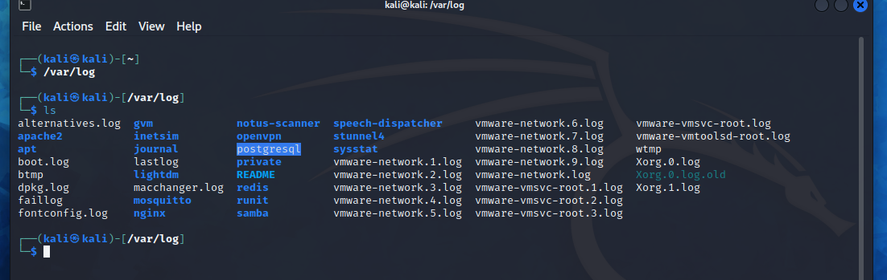

**STEP 3: Use the command line ‘tail boot.log’ for few information of the log file to be displayed.**



**Step 4: Use the command line ‘cat boot.log’ for all the information of the individual log file to be displayed.**

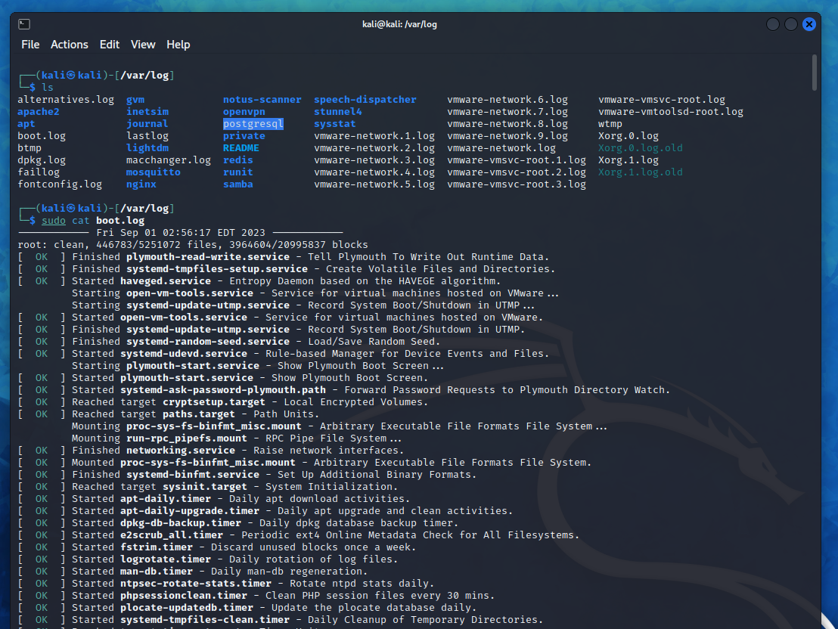

**STEP 5: Use the command line ‘dmesg’ shows entire log file contents.**

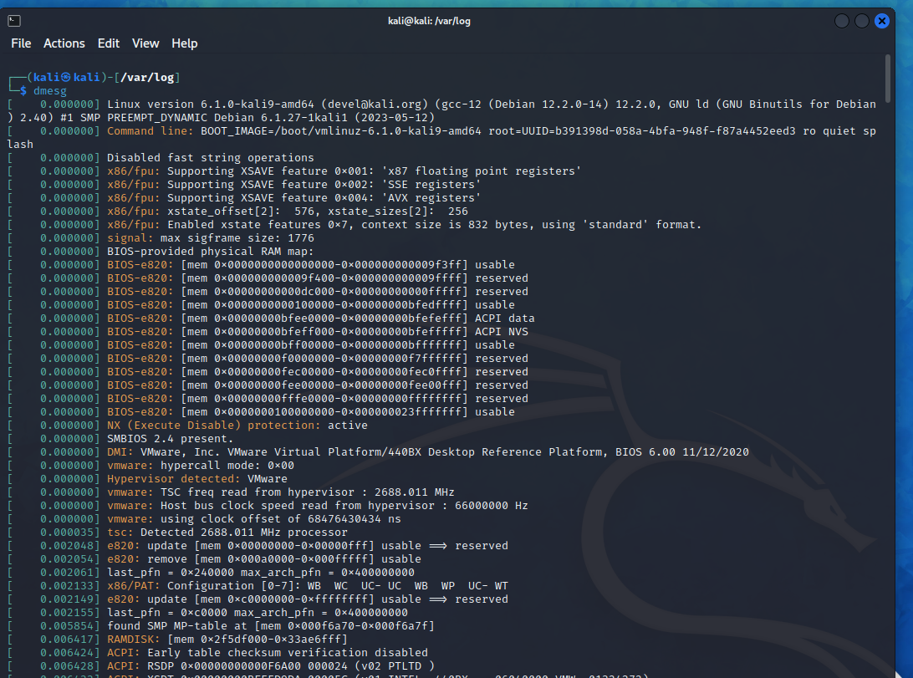

**INTRODUCTION**

***Logging is a crucial aspect of managing and troubleshooting computer systems, applications, and networks. Different levels and categories of logs help you track events, errors, and activities. Here's an overview of important commands and log details for various levels and categories of logs, primarily focusing on Unix/Linux systems:***

**Logging Levels:**

**DEBUG:** Detailed information, typically used for debugging purposes.

**INFO:** General information about the system or application.

**WARNING**: Indicates potential issues or anomalies that should be monitored.

**ERROR**: Denotes errors that need attention but don't cause system failure.

**CRITICAL**: Severe errors that may lead to system failure.

**LOG CATEGORIES**

**System Logs:**

**Command: dmesg** - Display kernel ring buffer.

Log File: /var/log/syslog (Ubuntu) or /var/log/messages (Red Hat).

Description: Contains kernel and system-related messages.

**Authentication Logs:**

**Command: *auth.log*** (Ubuntu) or secure (Red Hat).

Log File: /var/log/auth.log (Ubuntu) or /var/log/secure (Red Hat).

Description: Records authentication-related events like login attempts.

**Application Logs:**

**Command:** Varies by application (e.g., Apache, Nginx, MySQL).

Log Files: Typically, in /var/log or specified in application configuration.

Description: Contains information about specific applications' activities.

**System Performance Logs:**

**Command:** vmstat, iostat, top, sar.

Log Files: Typically, not stored as logs but generated on-demand.

Description: Provides system performance metrics like CPU, memory, and disk usage.

**Security Logs:**

**Command:** auditd (Audit daemon).

Log File: /var/log/audit/audit.log.

Description: Records security-related events for auditing purposes.

**Common Log Commands:**

View Log Contents:

cat, less, more, tail, head.

Example: tail -f /var/log/syslog (real-time log updates).

Search for Specific Entries:

grep, egrep.

Example: grep "ERROR" /var/log/application.log.

Rotate and Archive Logs:

logrotate.

Configuration files located in /etc/logrotate.conf and /etc/logrotate.d/.

Monitor Logs in Real-Time:

tail -f, journalctl -f.

Clear Log Files (Be cautious):

echo > /var/log/file.log (Truncates the file).

truncate -s 0 /var/log/file.log (Zeroes the file).

Analyze Log Files:

Tools like awk, sed, and log analysis software (e.g., ELK Stack).

Log Format:

Logs typically follow a common format, which may include the following information:

Timestamp: When the event occurred.

Hostname: The name of the system generating the log.

Application/Process Name: The source of the log entry.

Log Level: The severity level (e.g., INFO, ERROR).

Message: A description of the event or error.

Remember to consult documentation and specific log sources for more details and customization options. Proper log management is essential for system troubleshooting, security analysis, and performance optimization.

|  |  |  |  |  |  |
| --- | --- | --- | --- | --- | --- |
| **S.NO.** | **SENDER’S DOMAIN** | **EMAIL PROTOCOL** | **DATE/TIME SENT** | **TIME ZONE** | **GEOLOCATION** |
| 1. | .ru | ESMPTS | 06 Sep 2023, Wed 17:06:10 | UTC+03:00 | UN |
| 2. | .org | SMPTS | 22 Mar 2023, Wed 07:51:50 | CDT-05:00 | UN |
| 3. | .com | SMTP | 09 Jul 2023, 05:07:01 | GMT +5:30 | US |
| 4. | .com | LSMTP | 09 Aug 2023, 09:47:58 | GMT +5:30 | US |
| 5. | .com | ESMPTS | 18 Apr 2021, 05:22:09 | GMT +5:30 | France |

**LAB EXPERIMENT – 2**

**EMAIL HEADER ANALYSIS**

**BONUS**

**There are three methods of EMAIL AUTHENTICATION:**

* SPF (Sender Policy Framework) : It allows email senders to stipulate the IP addresses allowed to send mail for a specific domain. SPF helps to harden your DNS servers and limit those who use your domain to send emails.
* DKIM (DomainKeys Identified Mail) : It offers an encryption key and digital signature that confirms an email is authentic and not faked or modified.
* DMARC (Domain-based Message Authentication, Reporting, and Conformance): It offers directions on what the receiver should do if a message from a domain fails the authorization test.  The email receiver can reject or junk such an email. Unlike SPF and DKIM that can be employed as stand-alone methods, DMARC depends on SPF or DKIM to offer authentication.

ONLY **SPF** IS PASS IN EMAIL AUTHENTICATION

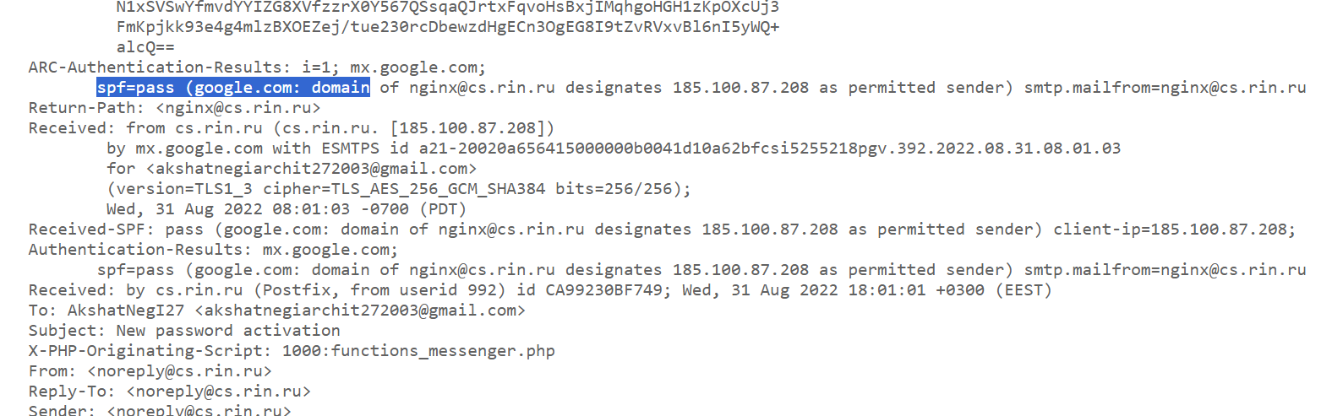

In this **SPF**, **DKIM** & **DMARC** all three are passed fully Authenticated.

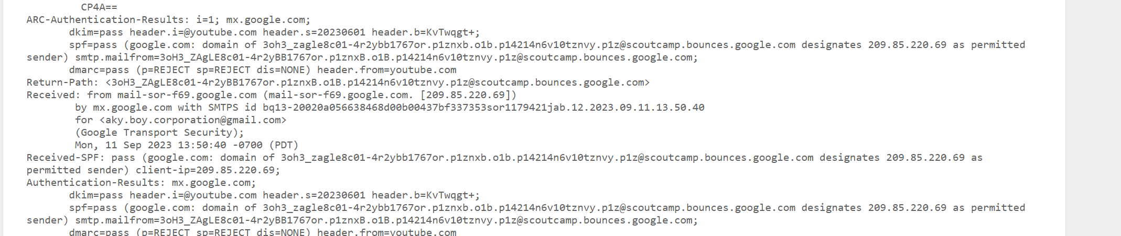

**EMAIL 1**

**GMAIL ORIGINAL HEADER VIEW**

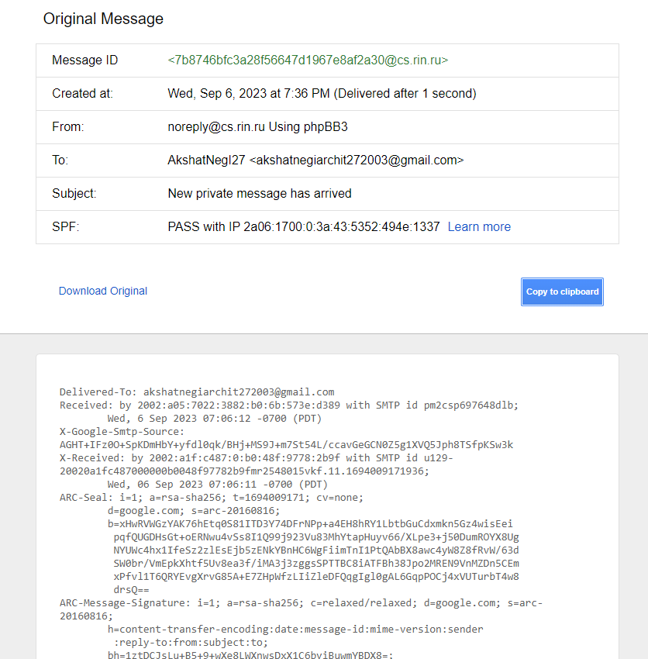

**https://toolbox.googleapps.com/**

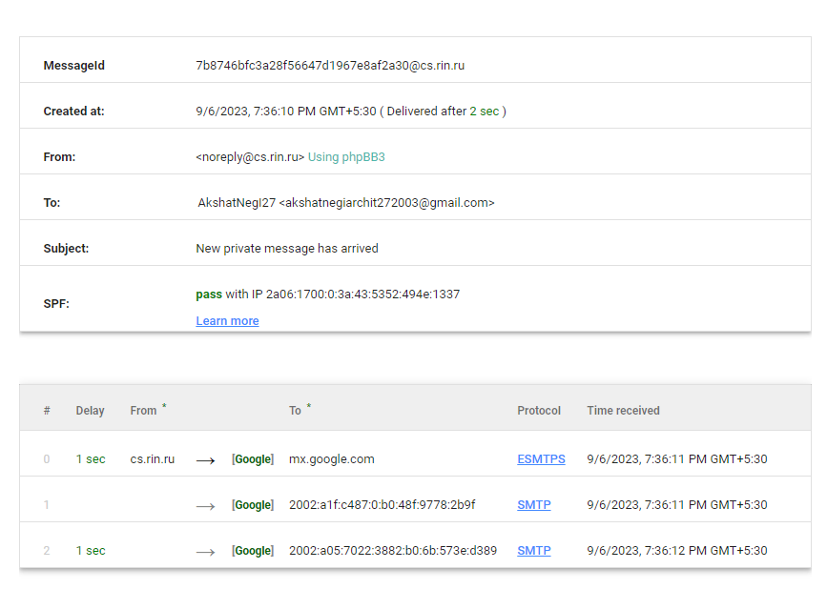

[**https://whois.domaintools.com/**](https://whois.domaintools.com/)

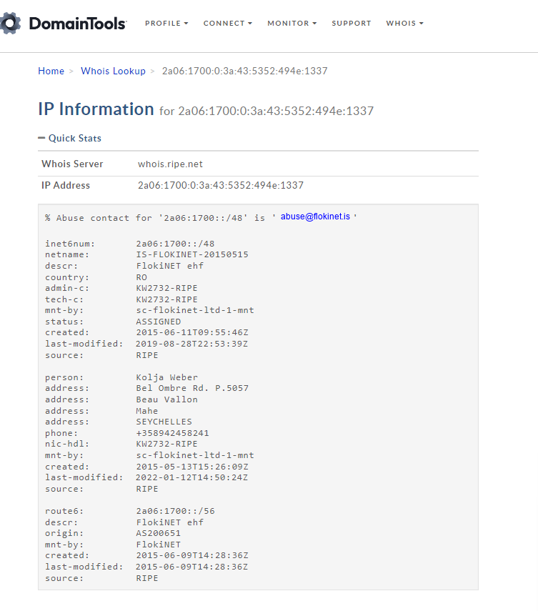

**https://mxtoolbox.com/**

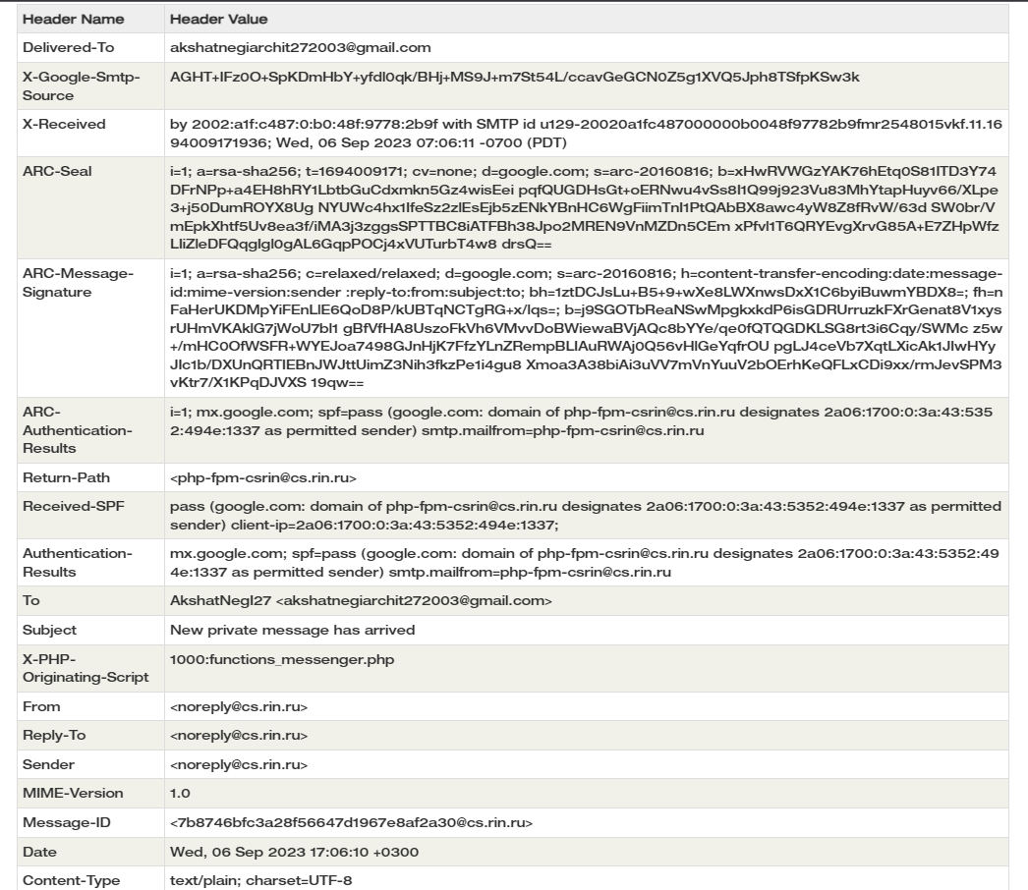

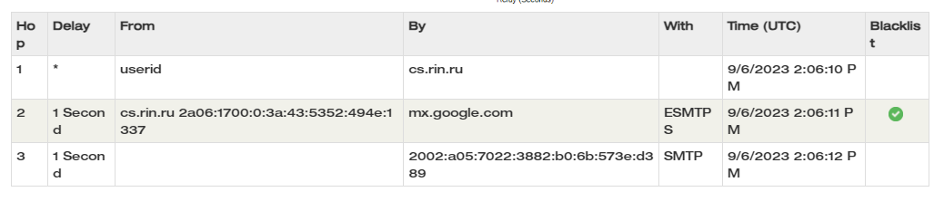

**EMAIL 2**

**GMAIL ORIGINAL HEADER VIEW**

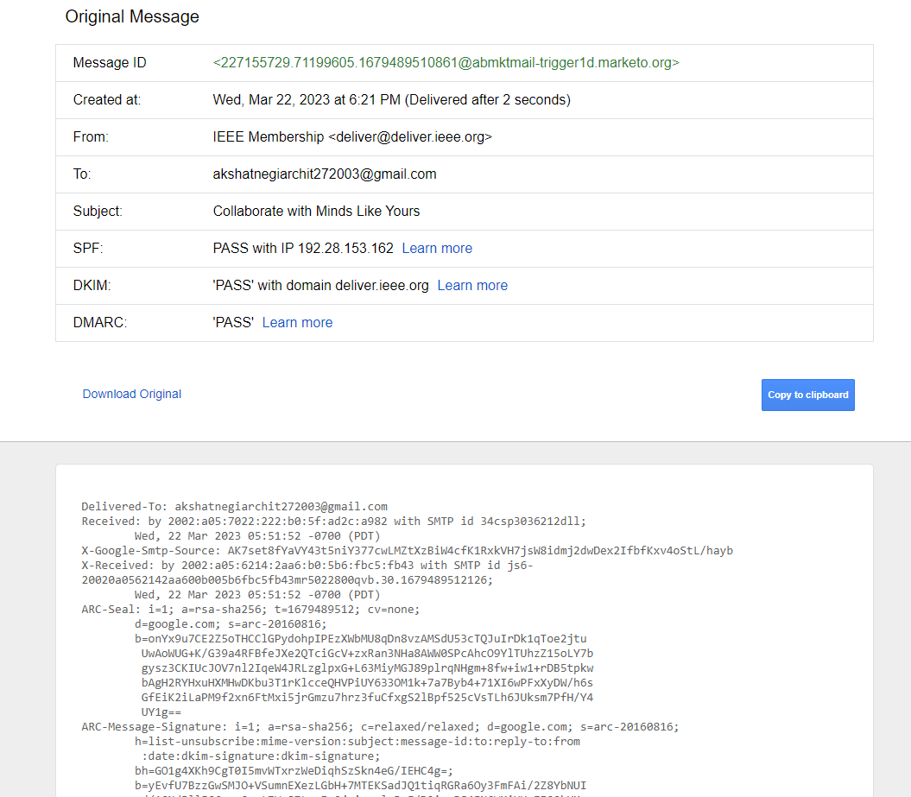

**https://toolbox.googleapps.com/**

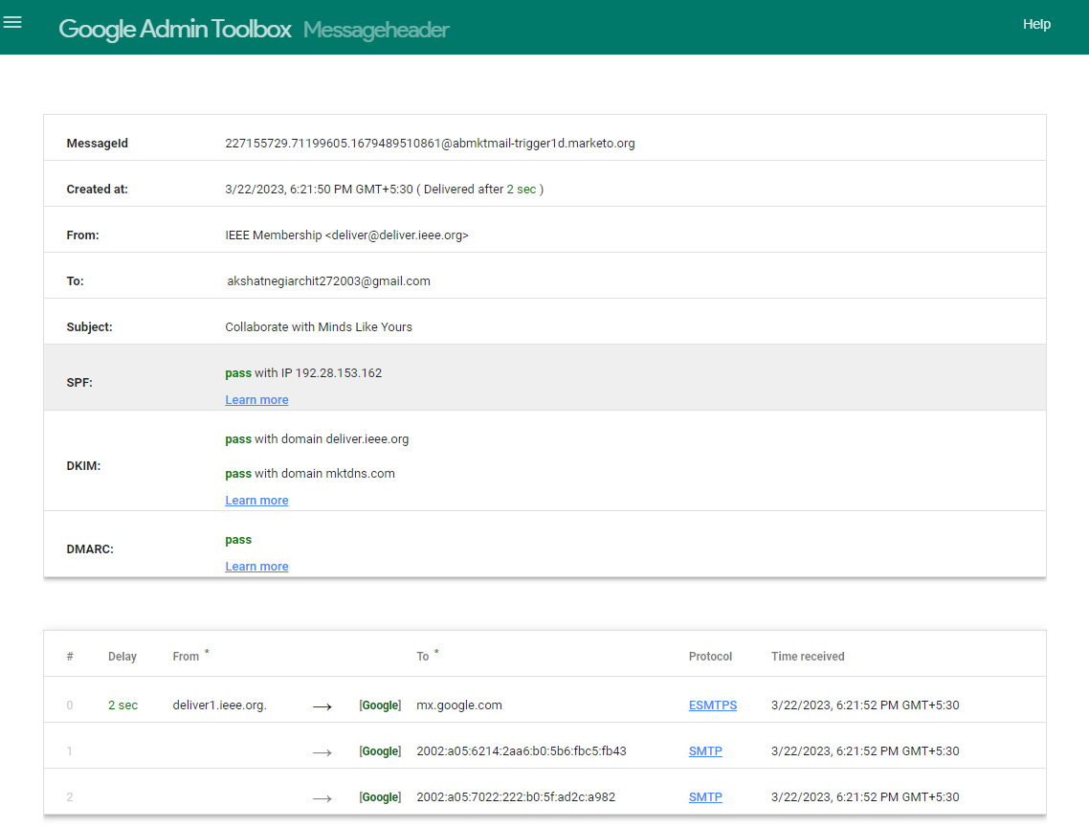

[**https://whois.domaintools.com/**](https://whois.domaintools.com/)

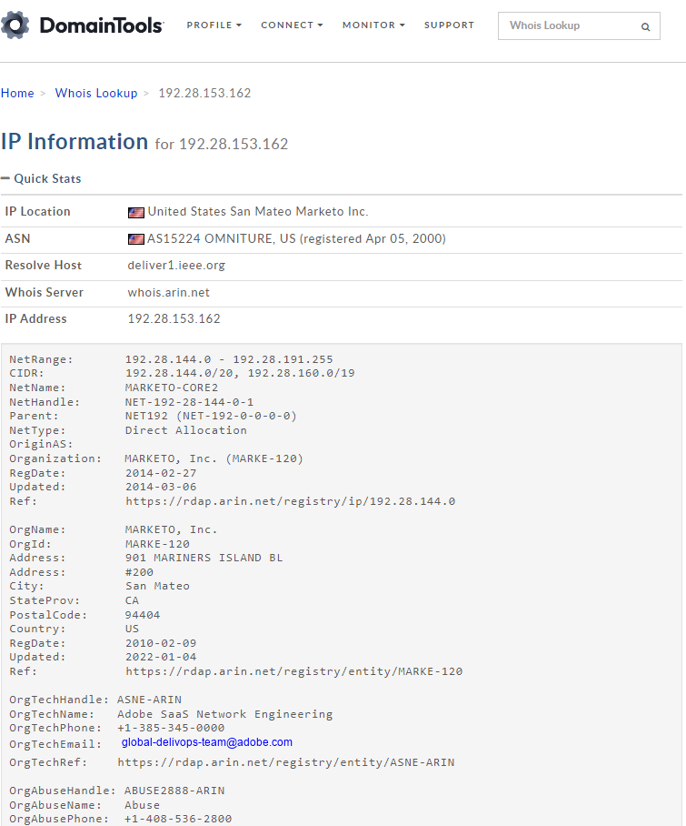

**https://mxtoolbox.com/**

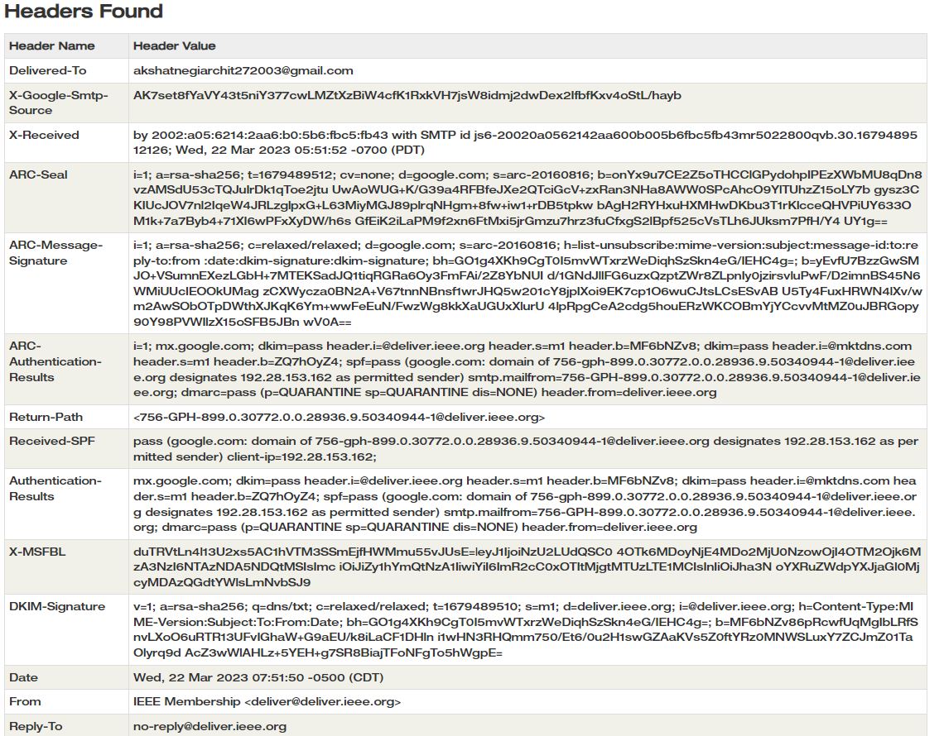

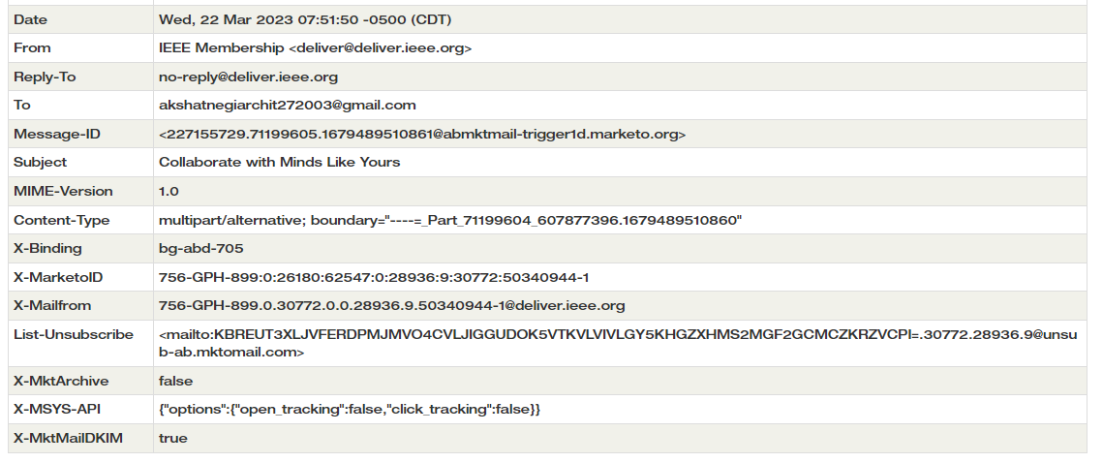

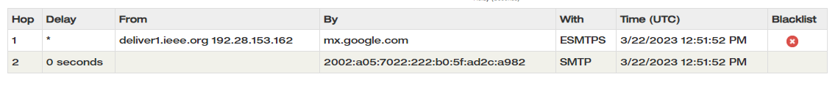

**EMAIL 3**

**OUTLOOK ORIGINAL HEADER VIEW**

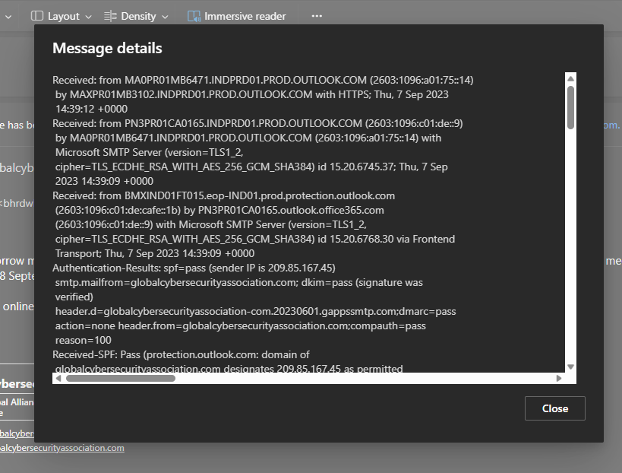

**https://toolbox.googleapps.com/**

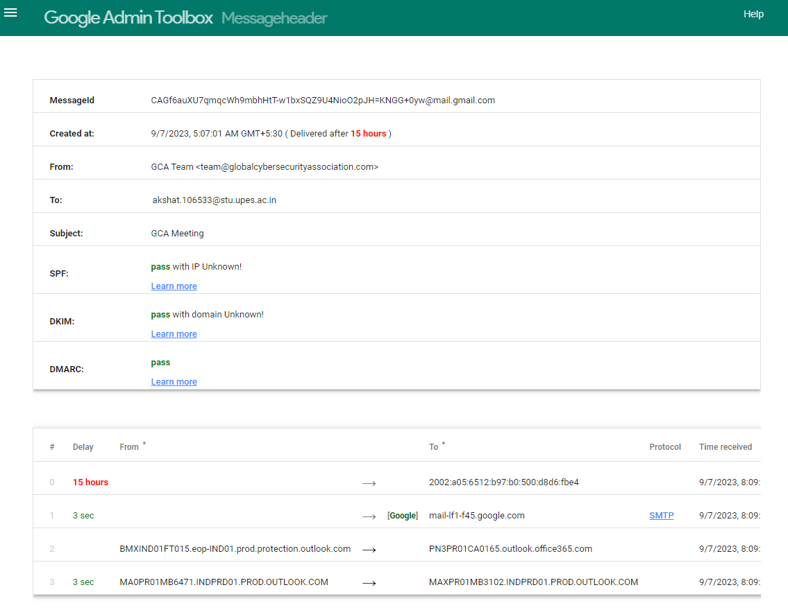

[**https://whois.domaintools.com/**](https://whois.domaintools.com/)

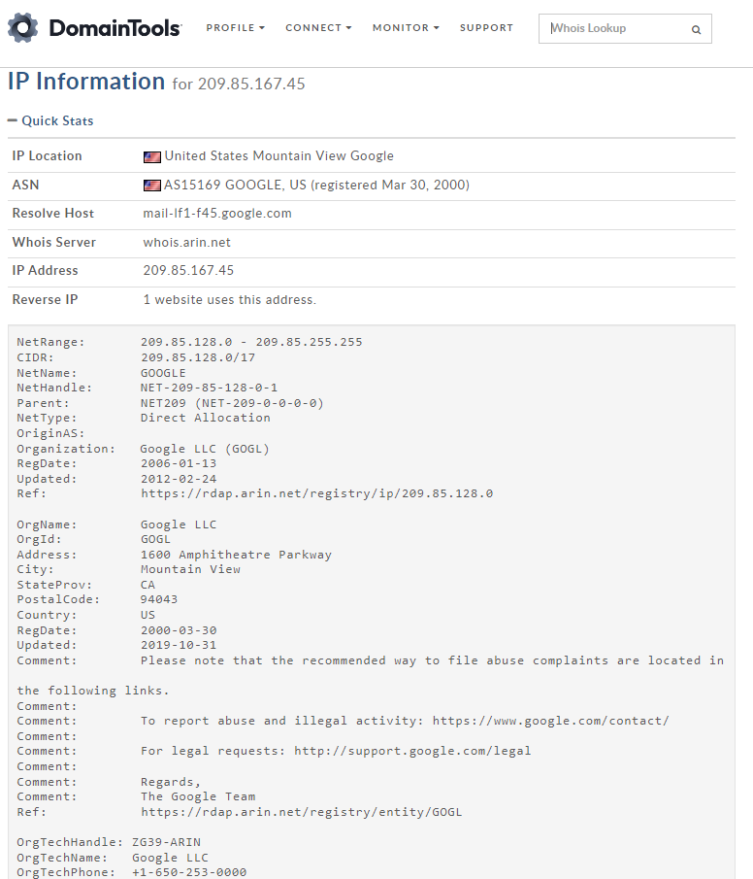

**https://mxtoolbox.com/**

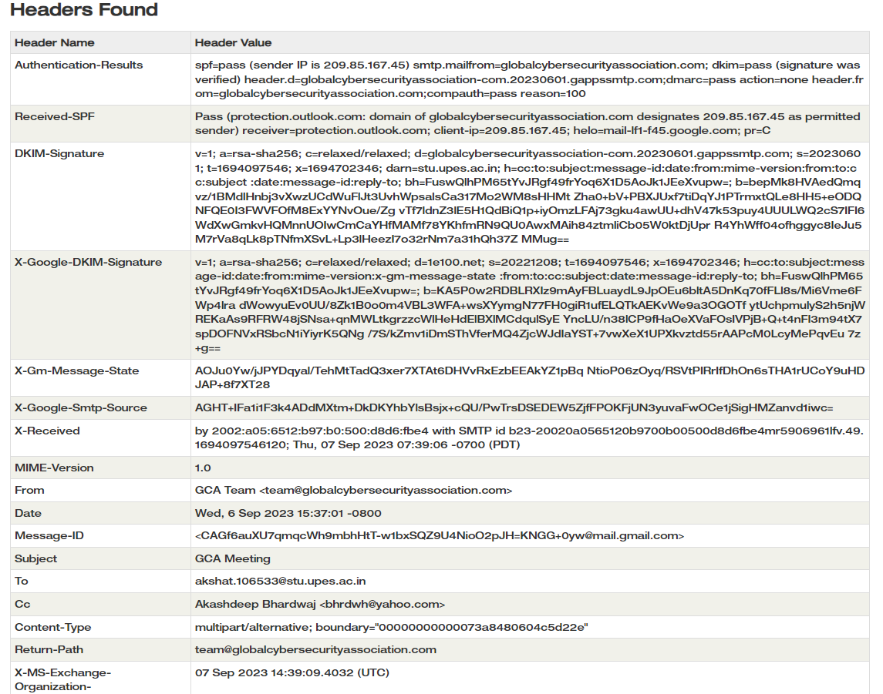

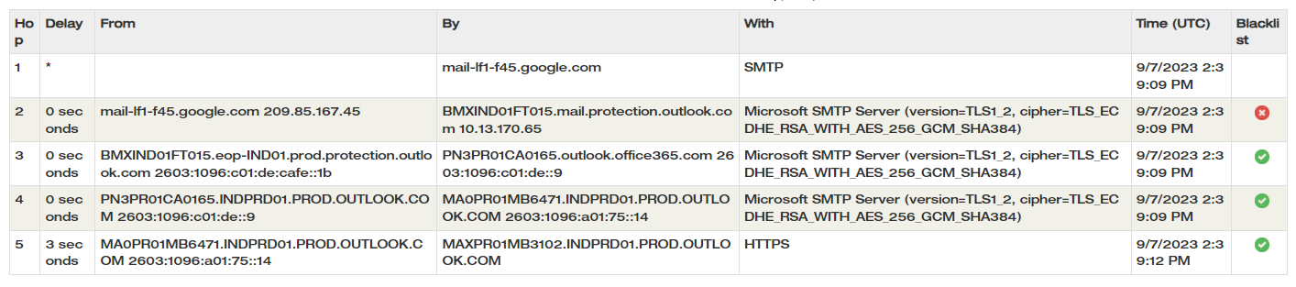

**EMAIL 4**

**OUTLOOK ORIGINAL HEADER VIEW**

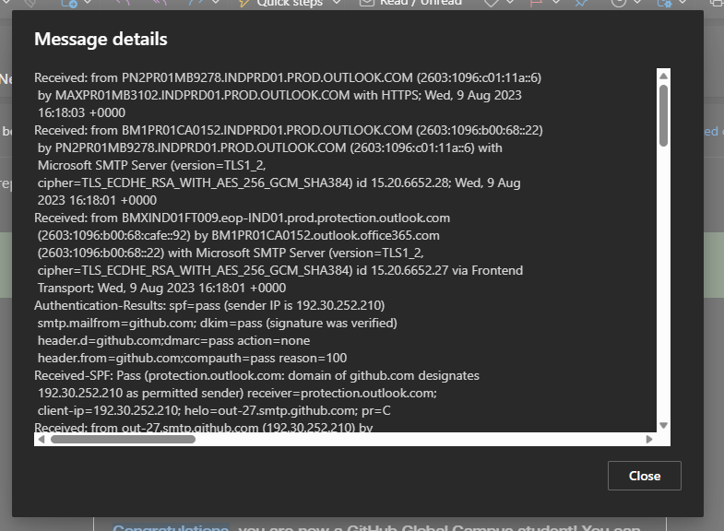

**https://toolbox.googleapps.com/**

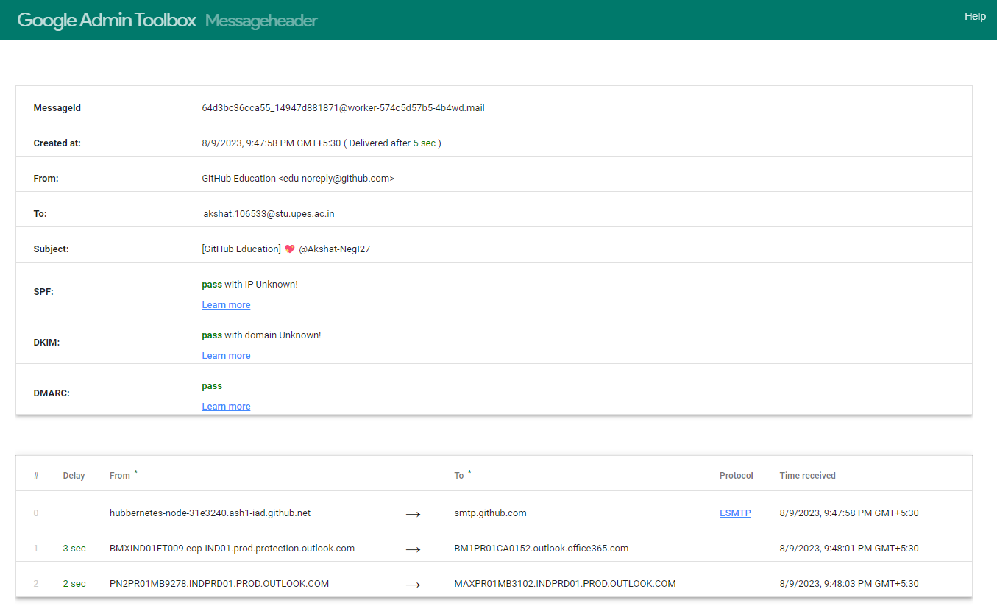

[**https://whois.domaintools.com/**](https://whois.domaintools.com/)

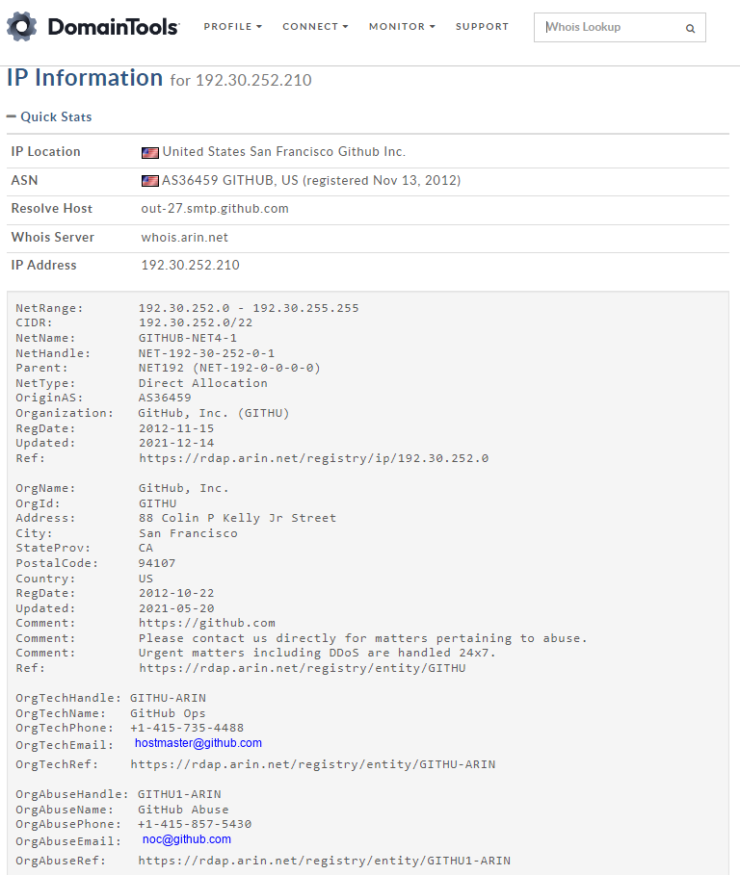

**https://mxtoolbox.com/**

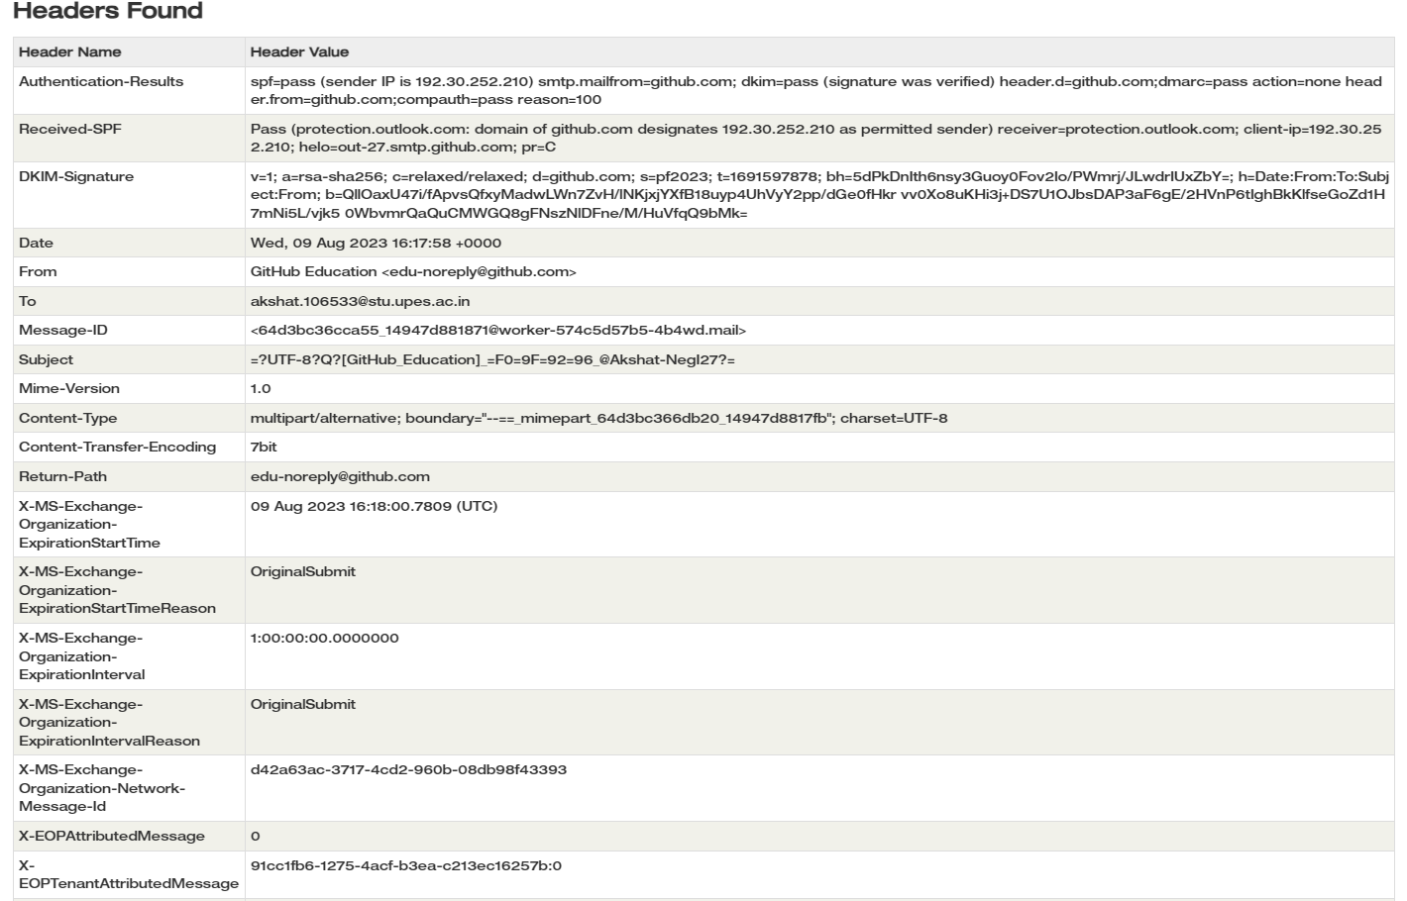

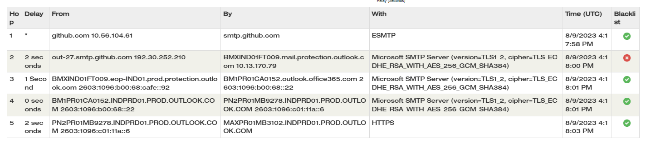

**EMAIL 5**

**OUTLOOK ORIGINAL HEADER VIEW**

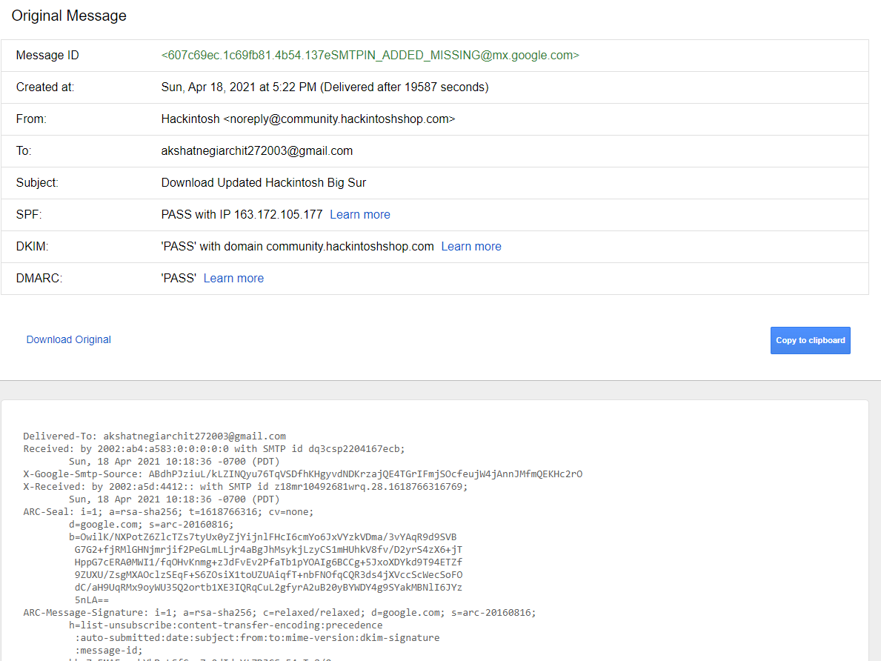

**https://toolbox.googleapps.com/**

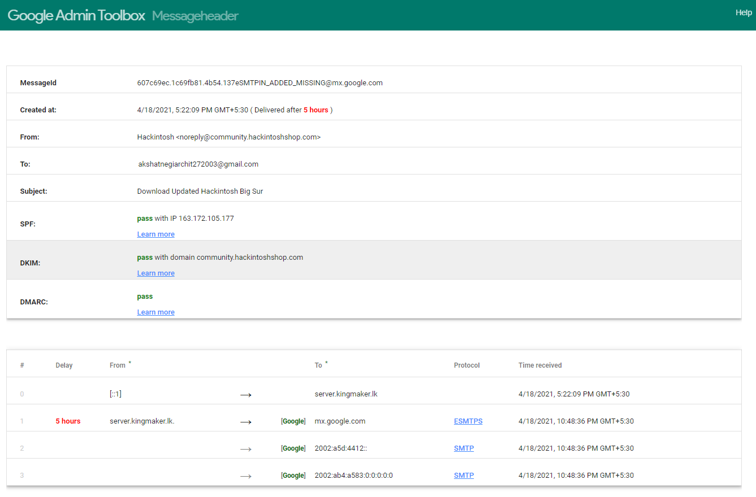

[**https://whois.domaintools.com/**](https://whois.domaintools.com/)

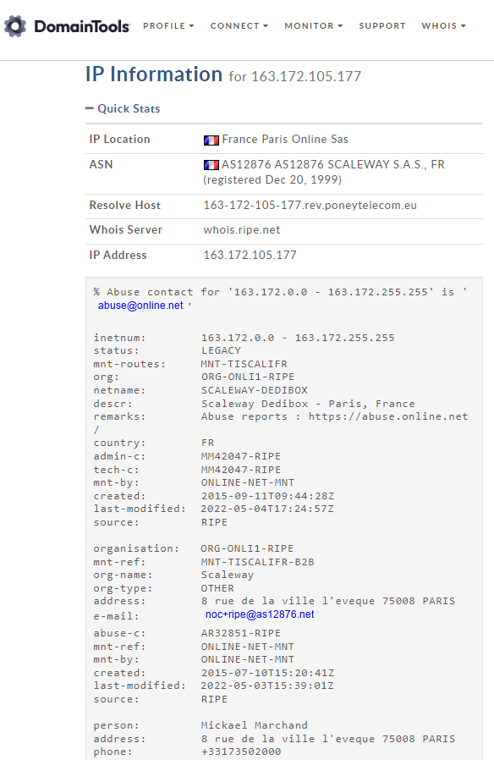

**https://mxtoolbox.com/**

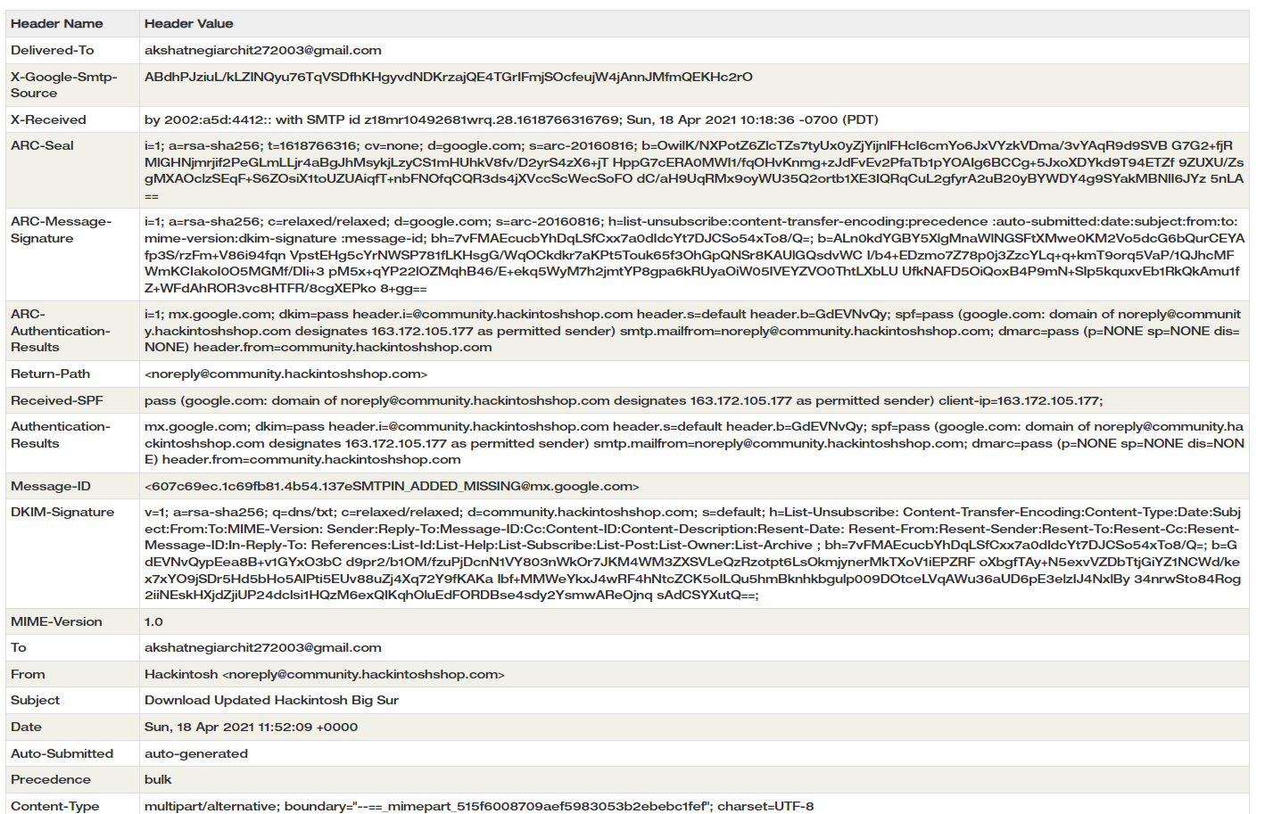

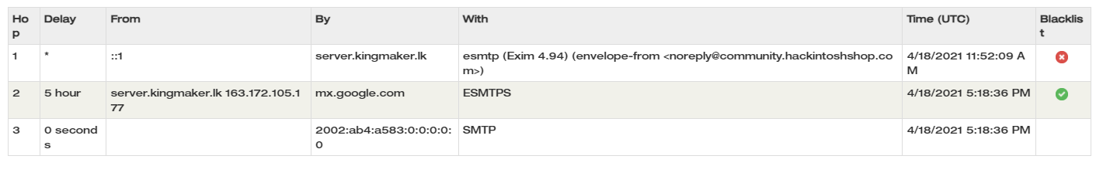

**LAB EXPERIMENT – 3**

**Understanding Vulnerabilities in Local Operating Systems**

**Windows Vulnerability CHECK**

1. Python --version
2. pip3 install chardet
3. git clone <https://github.com/bitsadmin/wesng.git>
4. systeminfo
5. systeminfo > sysinfo.txt
6. cd wesng-master
7. dir
8. python wes.py ..\sysinfo.txt
9. python wes.py ..\sysinfo.txt -s critical
10. python wes.py ..\sysinfo.txt -s critical > critical.txt

|  |  |  |  |
| --- | --- | --- | --- |
| **Type of OS** | **Vulnerability** | **Vulnerability Details** | **Mitigation Steps** |
| Windows 11 | CVE-2023-24054 | Elevation of privilege vulnerability in Windows Update Assistant | Install the latest security updates from Microsoft. |
| Windows 11 | CVE-2023-21999 | Remote code execution vulnerability in Microsoft Exchange Server | Install the latest security updates from Microsoft. |
| Windows 11 | CVE-2023-21996 | Denial-of-service vulnerability in Microsoft Exchange Server | Install the latest security updates from Microsoft. |
| Windows 11 | CVE-2023-21995 | Remote code execution vulnerability in Microsoft Exchange Server | Install the latest security updates from Microsoft. |
| Windows 11 | CVE-2023-21985 | Remote code execution vulnerability in Windows Print Spooler | Disable the Print Spooler service if not in use. |
| Kali Linux | CVE-2023-24056 | Elevation of privilege vulnerability in OpenSSH | Upgrade to the latest version of OpenSSH. |
| Kali Linux | CVE-2023-24055 | Remote code execution vulnerability in Samba | Upgrade to the latest version of Samba. |
| Kali Linux | CVE-2023-24053 | Denial-of-service vulnerability in Apache HTTP Server | Upgrade to the latest version of Apache HTTP Server. |
| Kali Linux | CVE-2023-24052 | Remote code execution vulnerability in BIND | Upgrade to the latest version of BIND. |
| Kali Linux | CVE-2023-24051 | Remote code execution vulnerability in MySQL | Upgrade to the latest version of MySQL. |

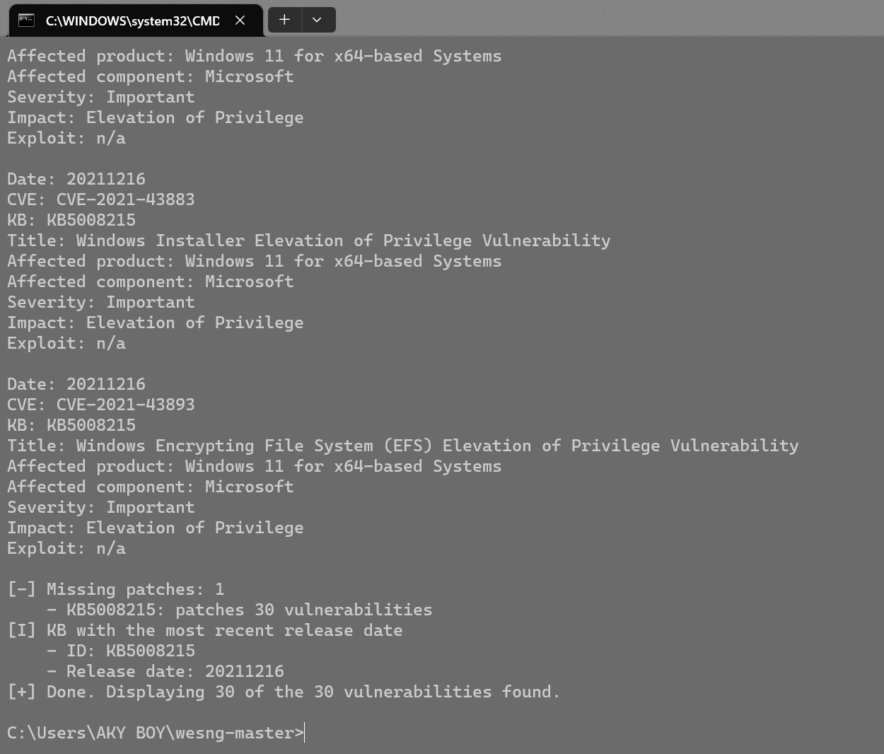

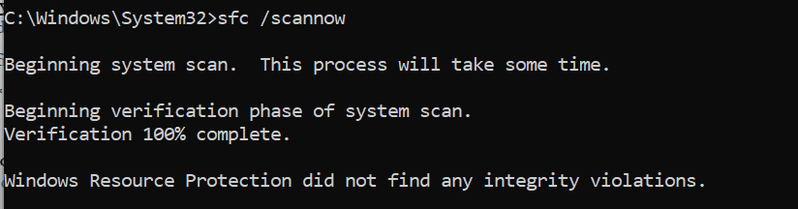

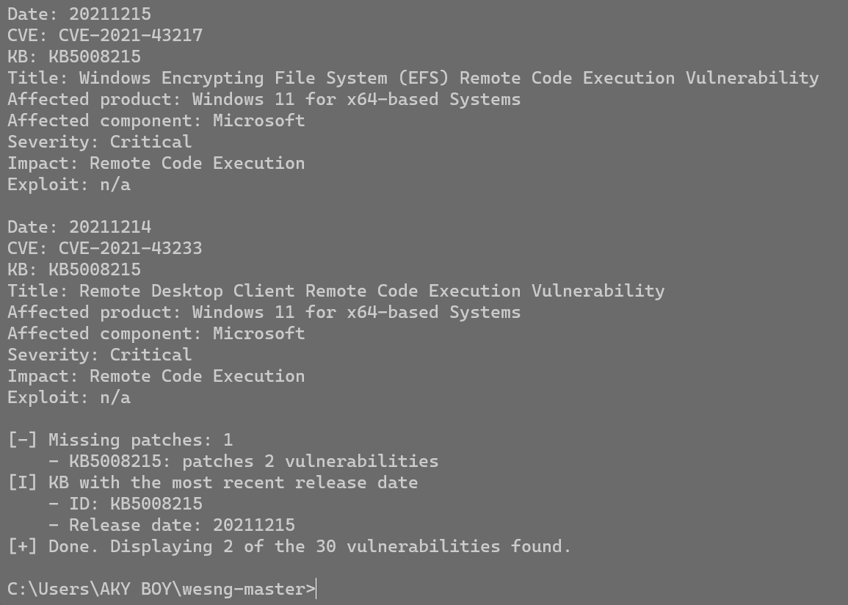

**USING LYNIS**

* Install Lynis using command: **sudo apt install lynis**
* Check audit using: **lynis audit system --quick**

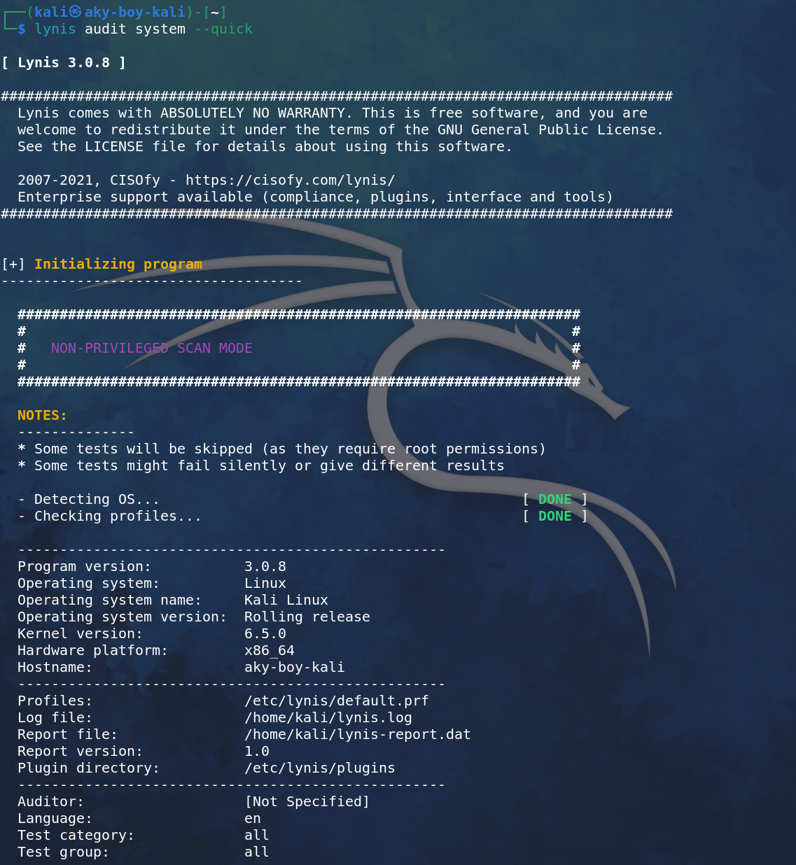

* Warnings and Suggestions by Lynis after detecting OS.

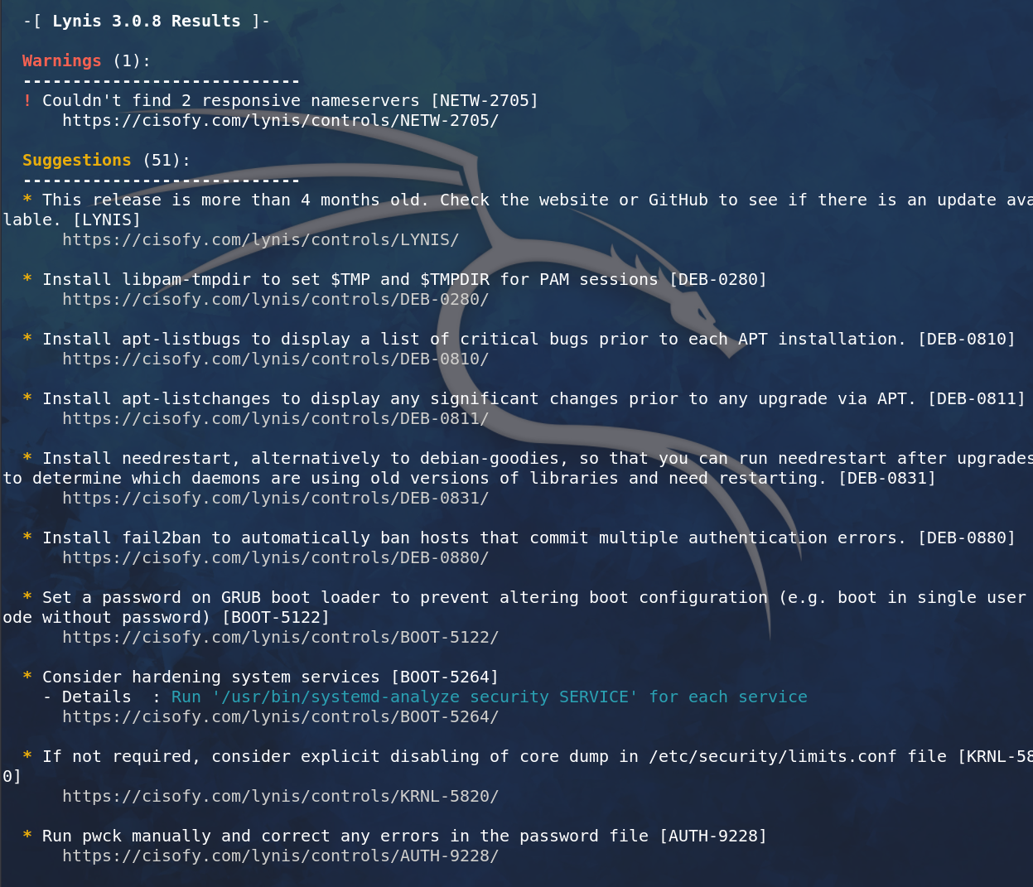

* To view all commands: **lynis show** and to view audit commands: **lynis show commands**

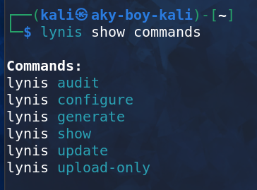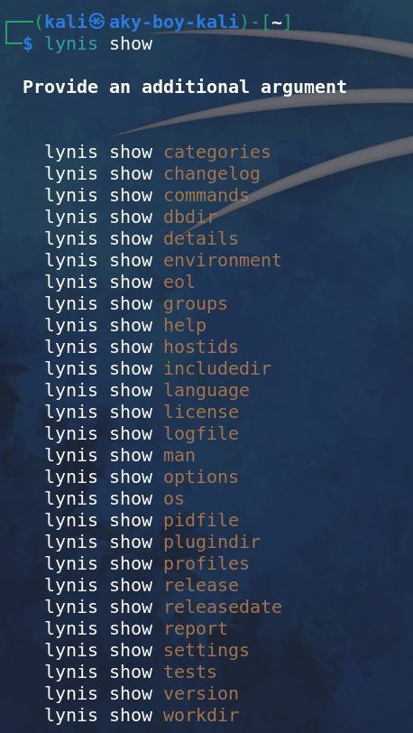

* **Lynis show tests ACCT – 9626** to view particular test.

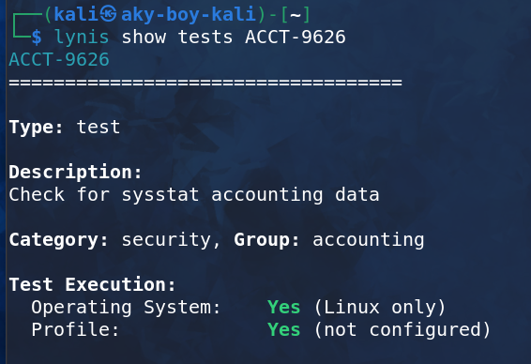

* To view all test together: **Lynis show tests**

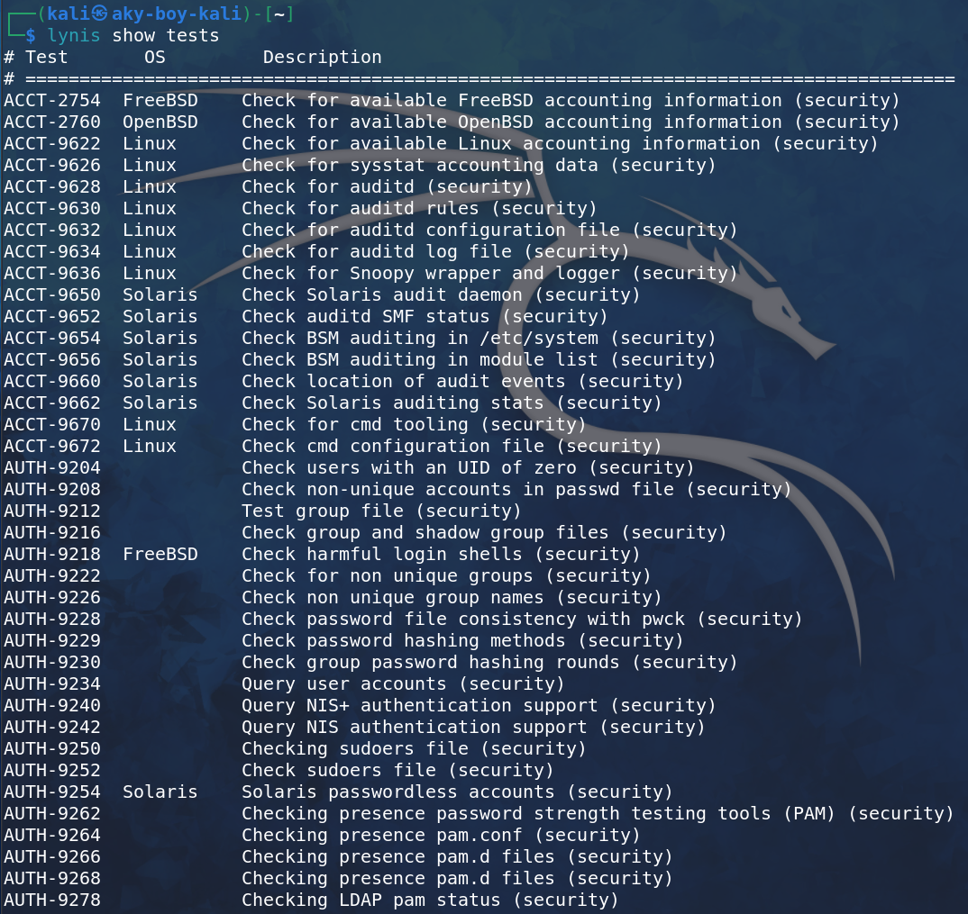

* Some individual details of particular tests.

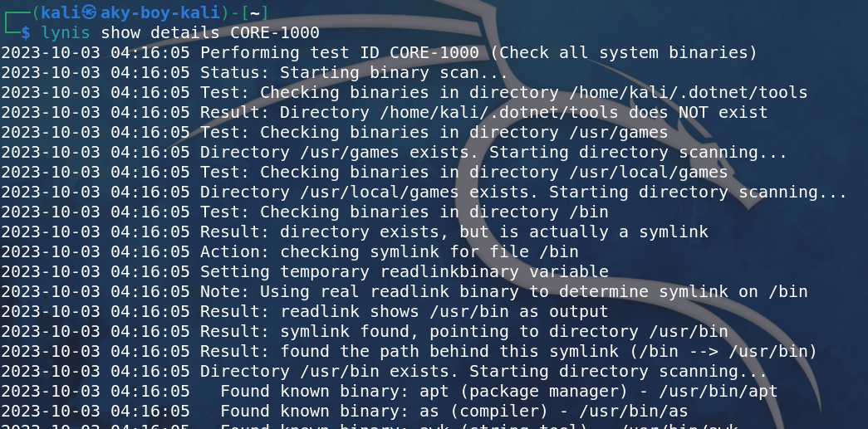

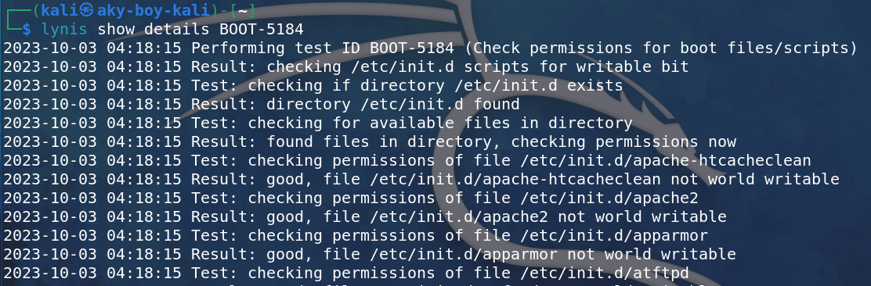

**USING TRIPWIRE**

* Install tripwire using: **sudo apt install tripwire** and do the configuration using same password.
* **Sudo tripwire --init**

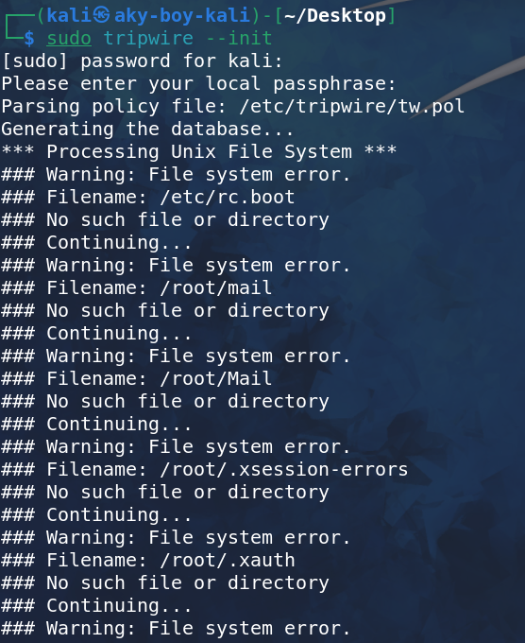

* Table below is the Integrity report generated by Tripwire.
* **Sudo apt tripwire –check > tripwire.txt**

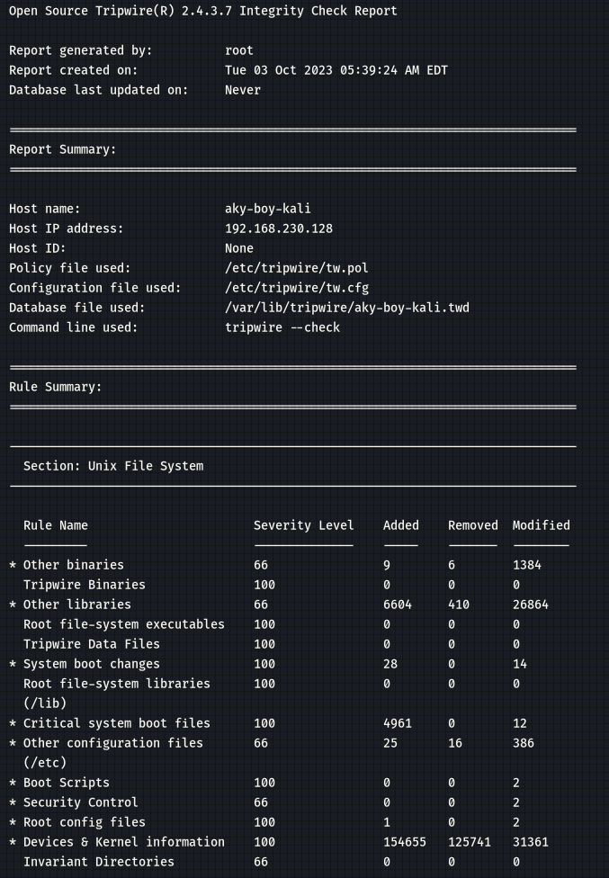

**BONUS: Crontab Scheduling**

* To view the number of Crontabs: **crontab -l**

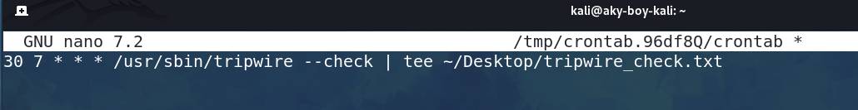

* To install or schedule new crontab using the nano editor: **crontab -e**

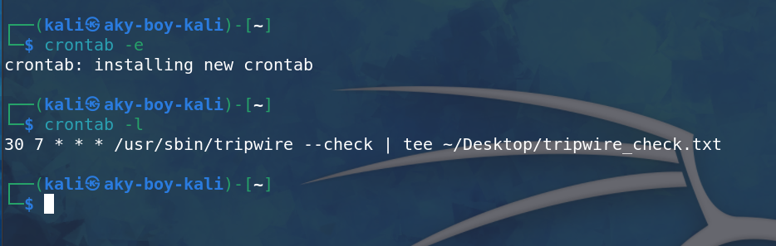

* File auto-generated at 7:30 according to 24hr clock with the Integrity Report using Tripwire.

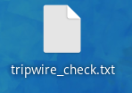

**LAB EXPERIMENT – 4**

**Vulnerabilities in Live IOT devices on Internet**

|  |  |  |  |  |  |  |
| --- | --- | --- | --- | --- | --- | --- |
| **IP Address** | **Device** | **Open Ports** | **Geolocation** | **Mode/Make** | **Product Version** | **Admin Password** |
| 123.208.5.80 | Webcam | 554,**8085**,2123,9000 | Sydney, Australia | Telstra Internet | v0.1.2 | Not found |
| 182.138.139.41 | Webcam | **8081** | China, Chengdu | CHINANET Sichuan province network | V0.1.1 | Not Found |
| 81.174.128.10 | webserver | **4444** | United Kingdom, Pontypridd | British Telecommunications PLC | v0.1 | Admin page found |
| 124.246.151.142 | MJPG-Streamer | **9000** | Japan, Chino | LCV Corporation | v0.2 | Not Found |
| 90.187.8.29 | MJPG-Streamer | **443**,22,80,1900,5353,**8080**,8081 | Germany, Hamburg | Vodafone Deutschland GmbH | v 0.2 | Admin Page |

**DEVICE 1**

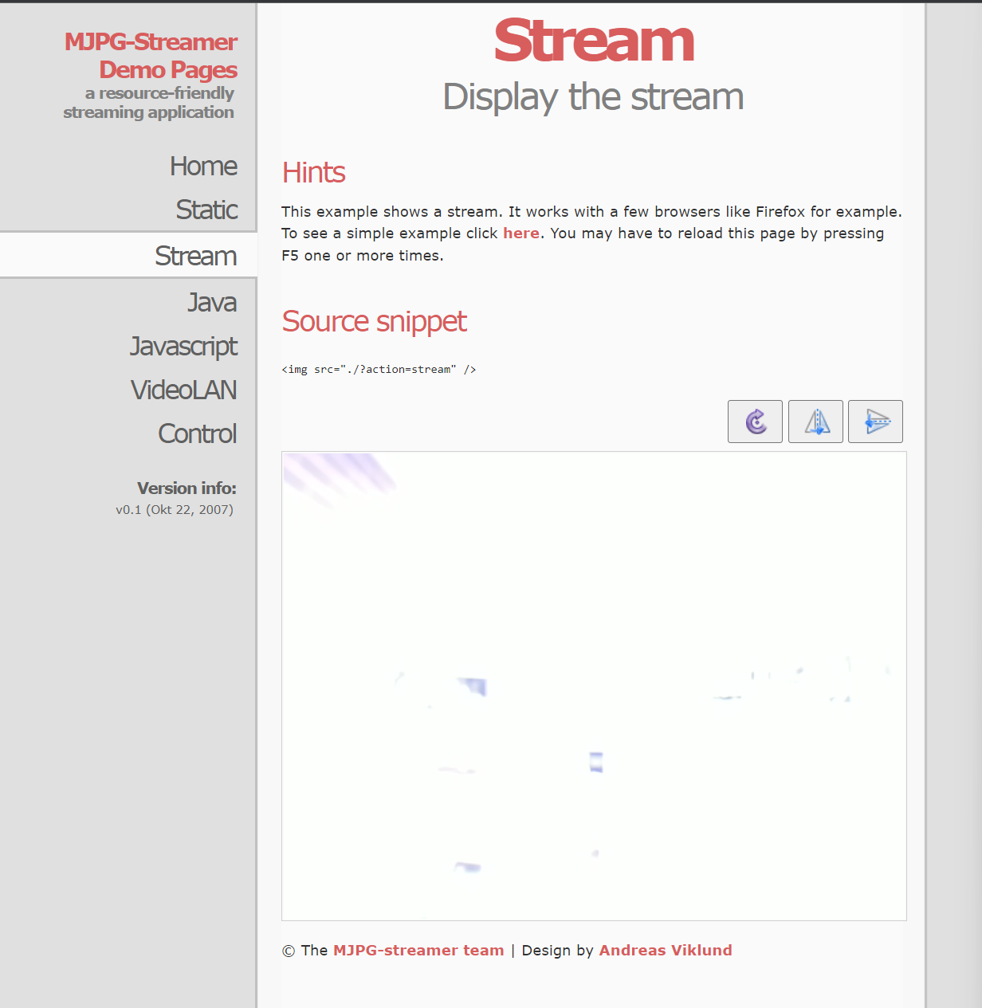

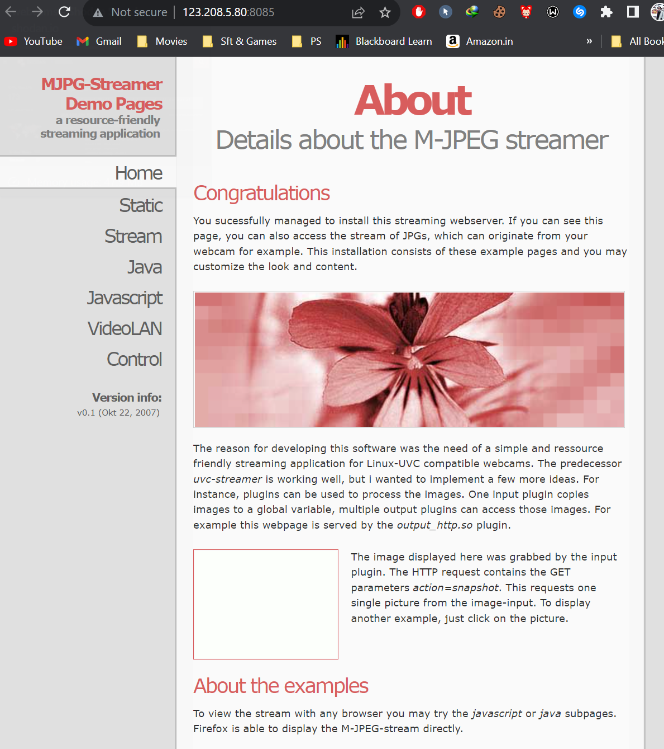

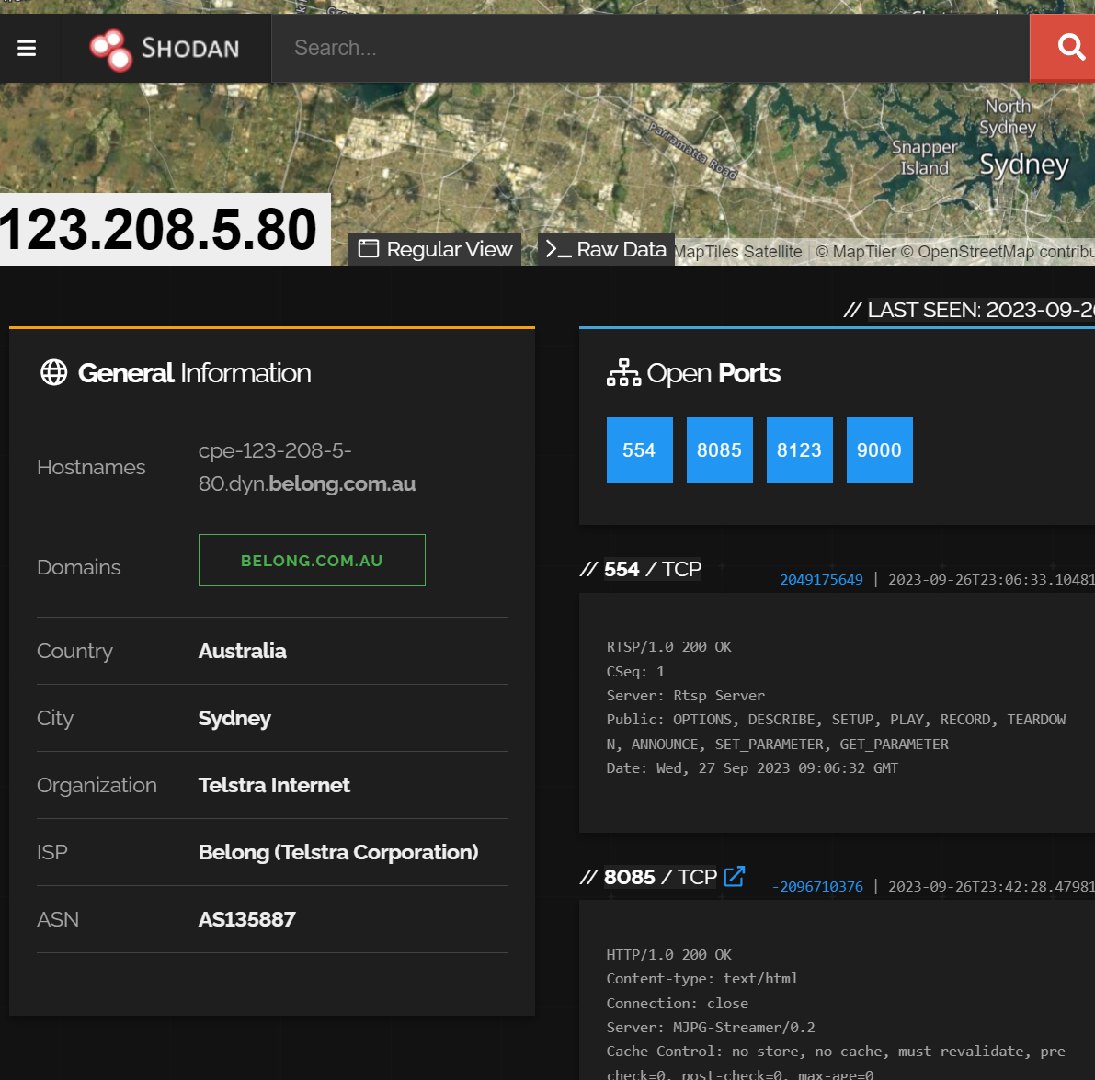

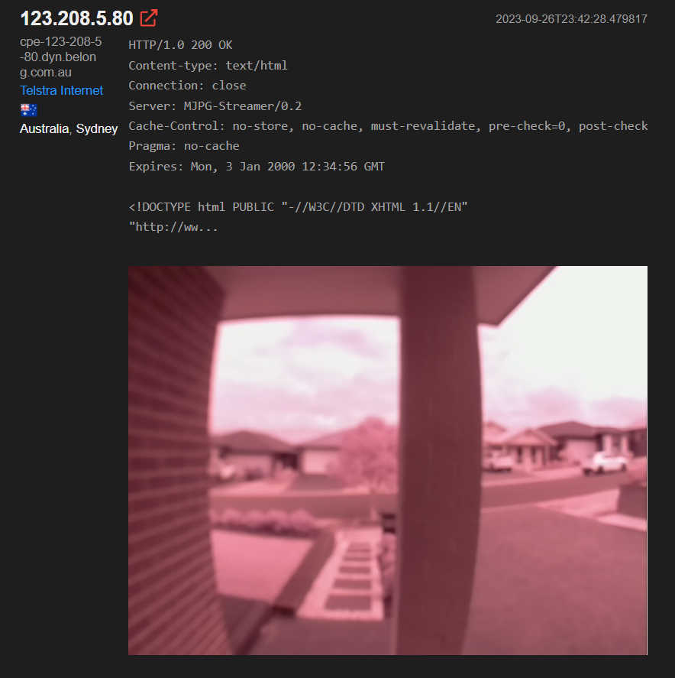

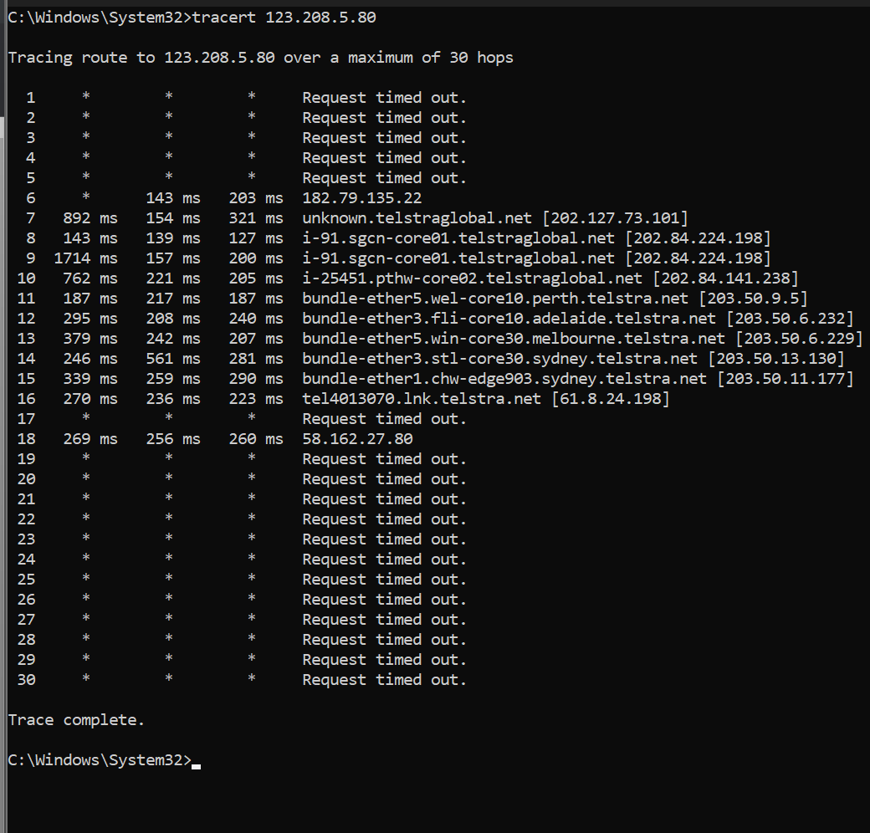

**DEVICE 2**

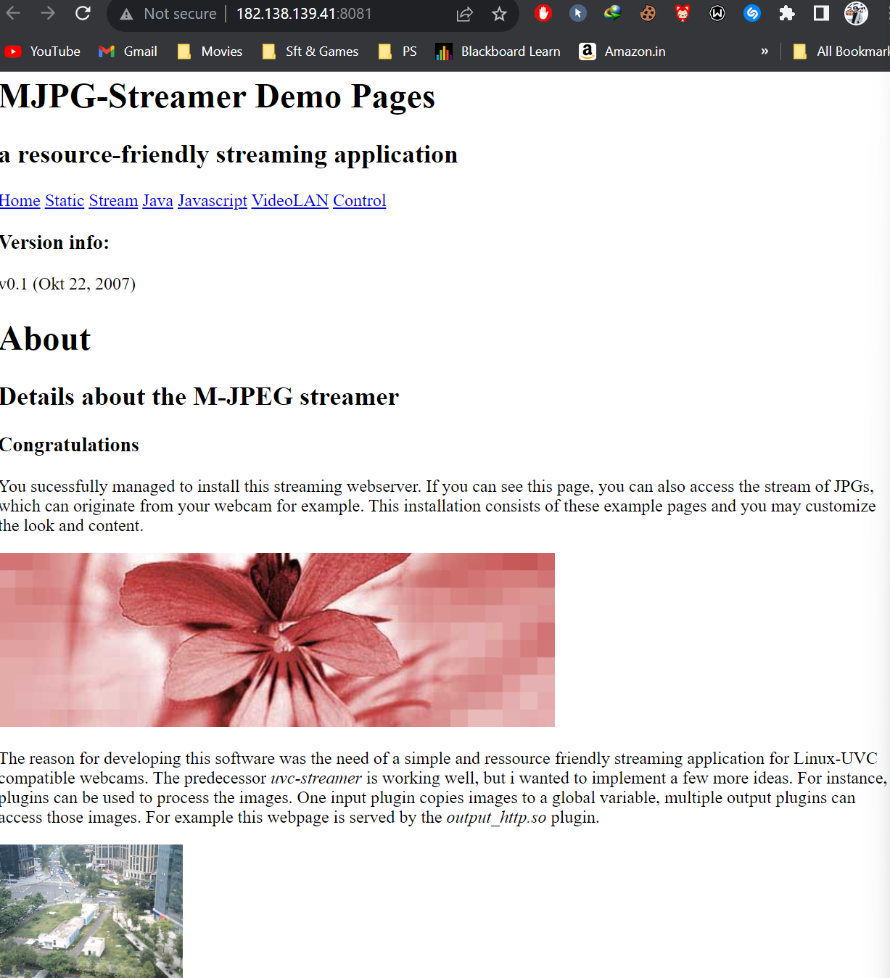

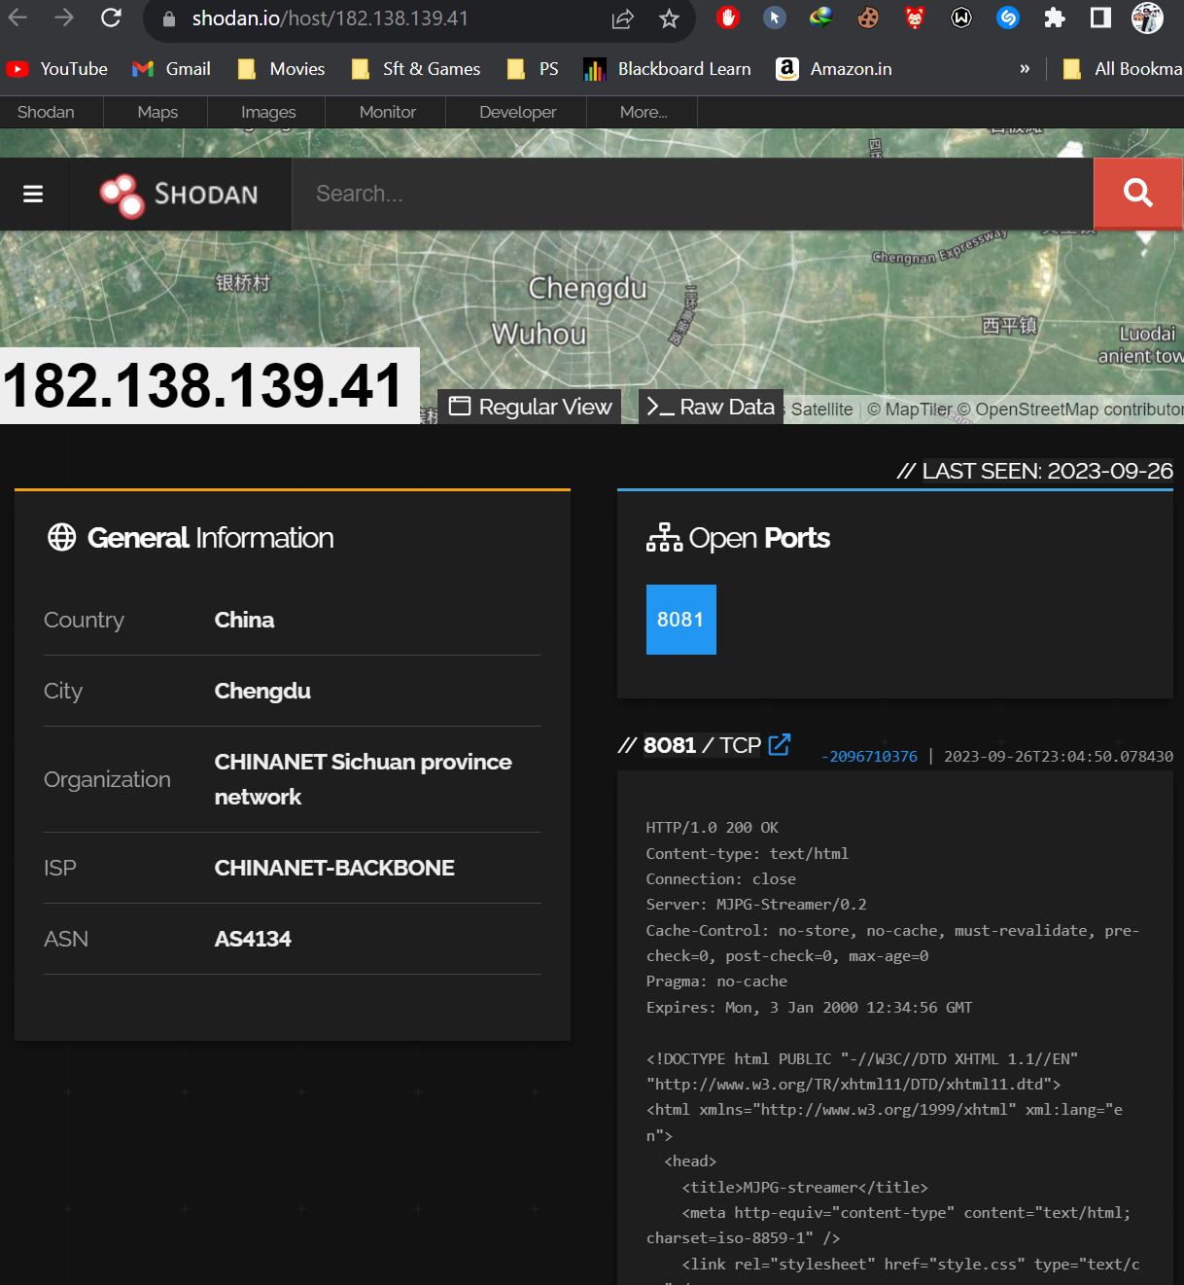

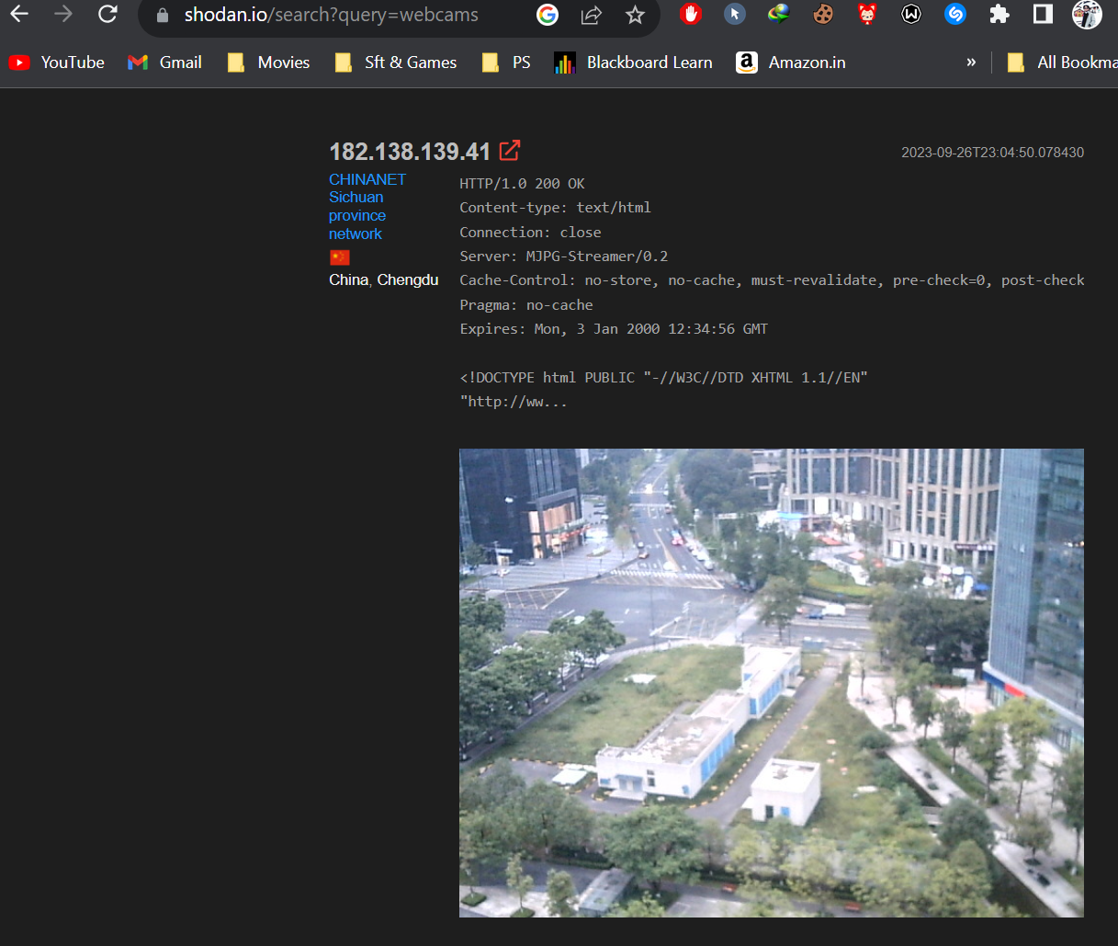

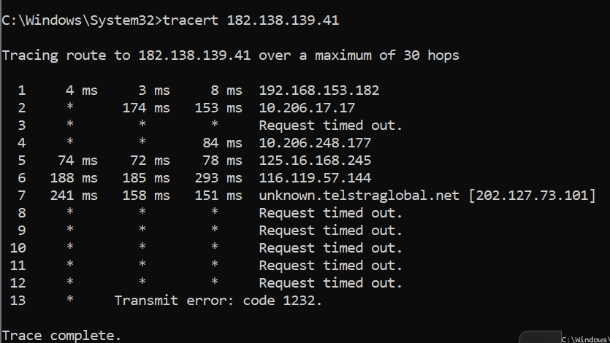

**Device 3 & BONUS**

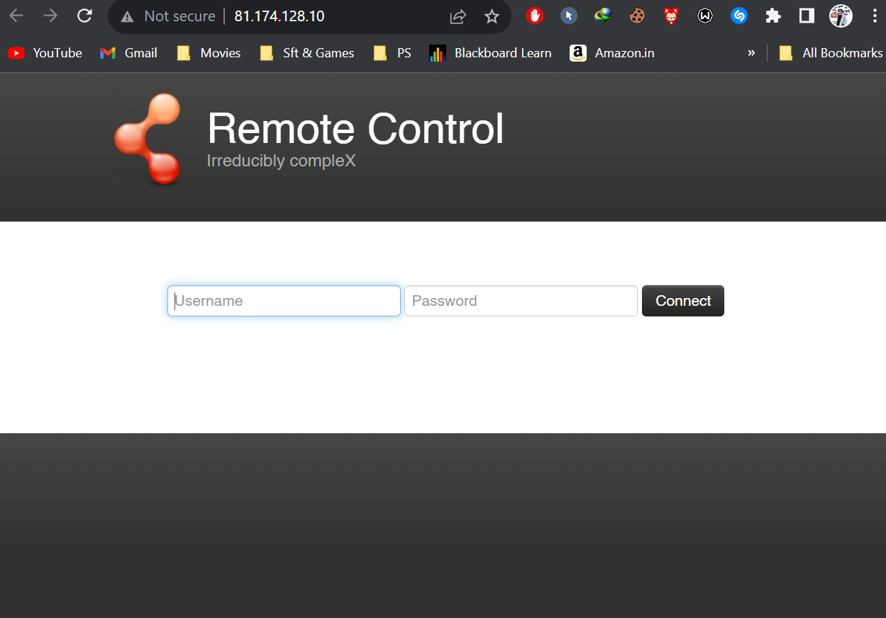

**NETCRAFT**

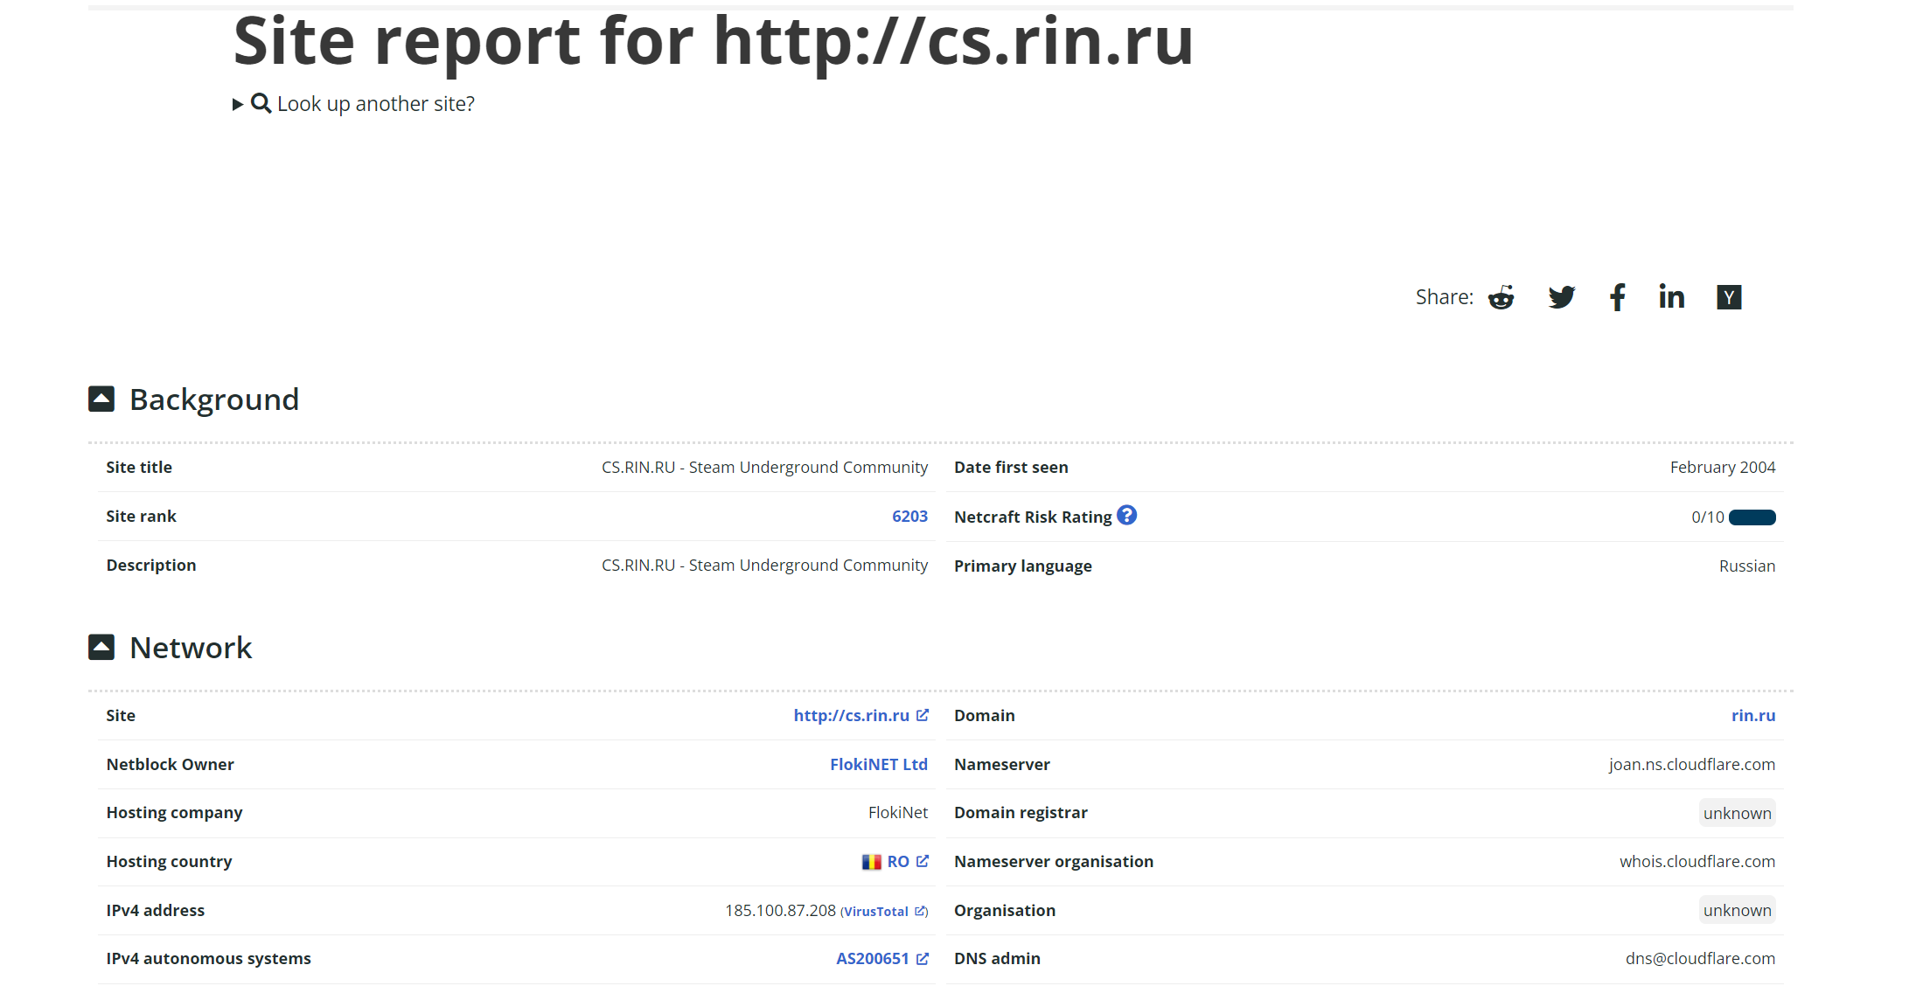

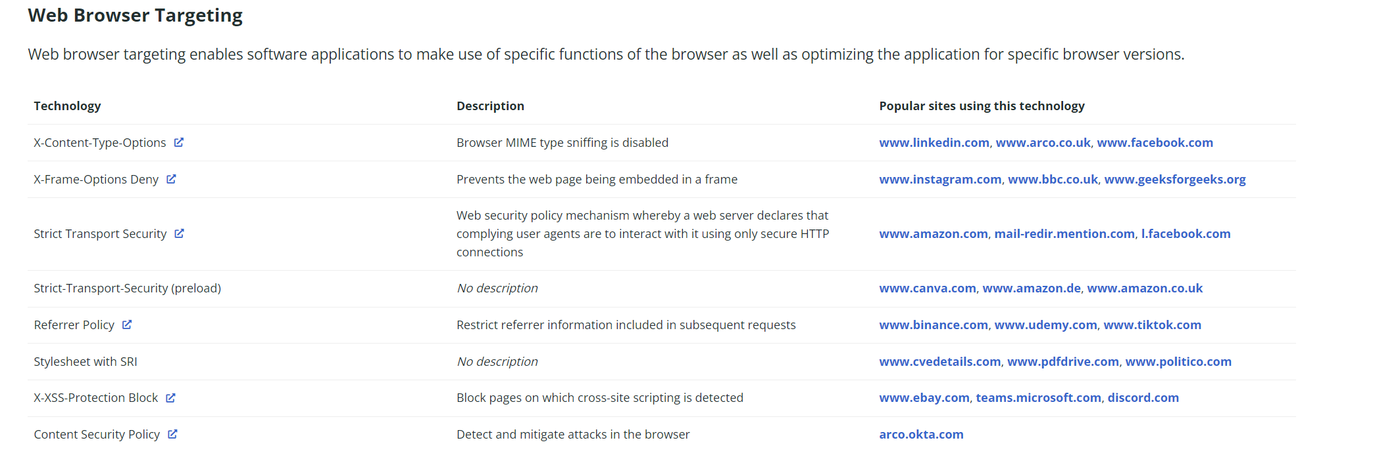

**LAB EXPERIMENT – 4**

**Perform Internet Footprinting Internet**

|  |  |
| --- | --- |
| **Type of Target** | **Information Obtained** |
| E.g. Website / Domain | * IP Address - 91.201.40.166 * Geolocation - Moskva - Moskva - Llc Ruweb * Hosted by - Private Person * Physical address - Russia * Services provided – Pirated Games * Server names - MILES.NS.CLOUDFLARE.COM   JOAN.NS.CLOUDFLARE.COM   * Server OS - Linux * Top Management - None |
| E.g. Person | * Name - Palak Singhla * Location – Himachal Pradesh * Phone – No Info * Office Address – CU, Chandigarh * Home Address - Solan, Himachal Pradesh * Role – Twitter Friend * Credit Card – No Info * Hobbies – Chatting and Gossips * Buying Habits – No Habits at all * Friends – Aditi, Shreya, Ananya * Social Media Posts 🡪 6 Pictures Captured * Twitter / Facebook - palak__016 |
|  |  |

Used Grabify and got the ip using social engineering on Instagram.

Link Used – <https://grabify.link>

Original URL - <https://www.upes.ac.in/>

Geo Location - <https://www.google.com/intl/en_in/earth/about/>

Website Information - https://whois.domaintools.com/rin.ru

**Target 1**

**Young Teen**

Source – Instagram

Method – Social Engineering

IP - 43.251.191.199

Coordinates - 28.666775, 77.216681 (28°40'0"N 77°13'0"E)

Geo Location – Delhi, India

ISP – Dnetworks Internet Services Pvt. Ltd.

Device – Real ME 7 Pro

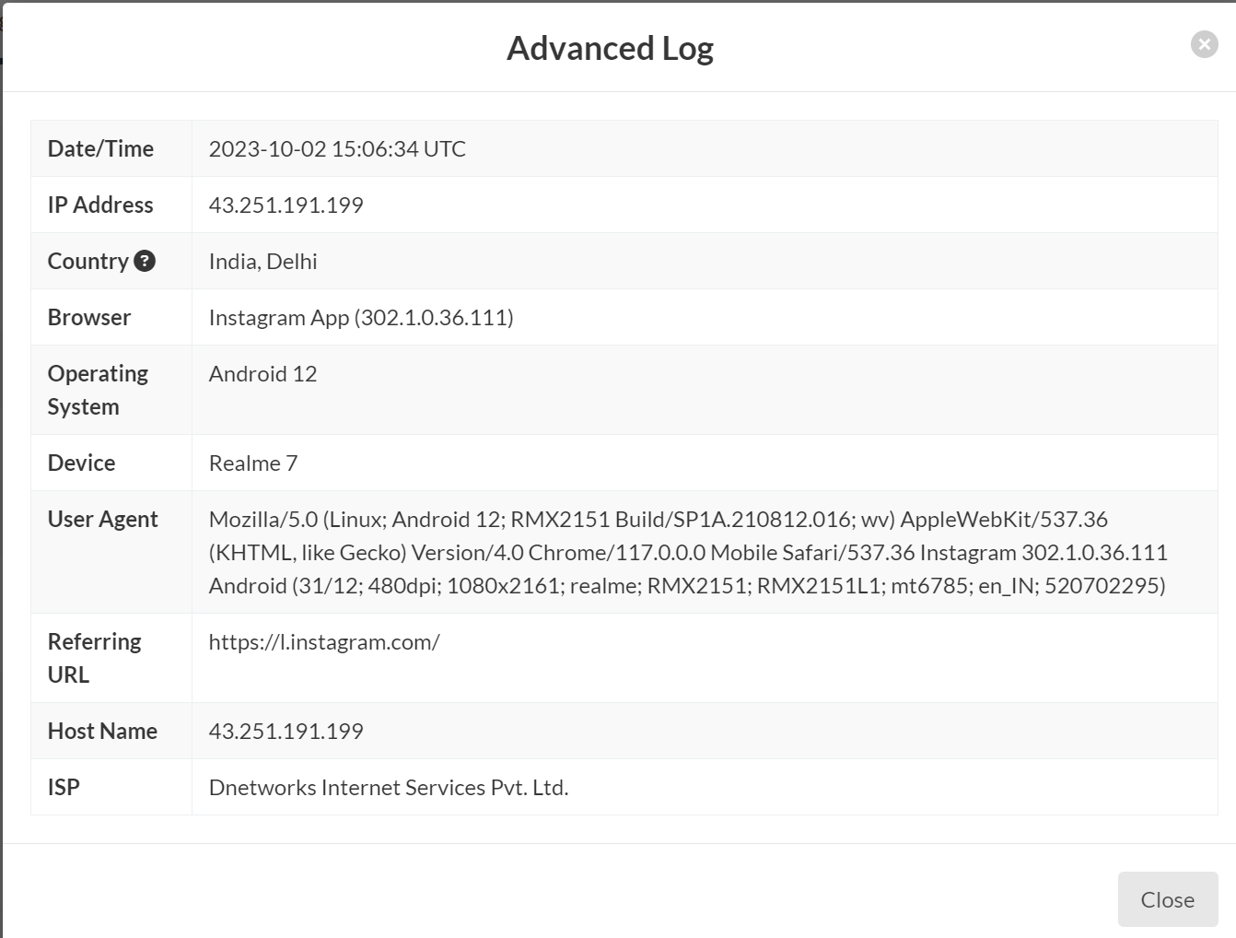

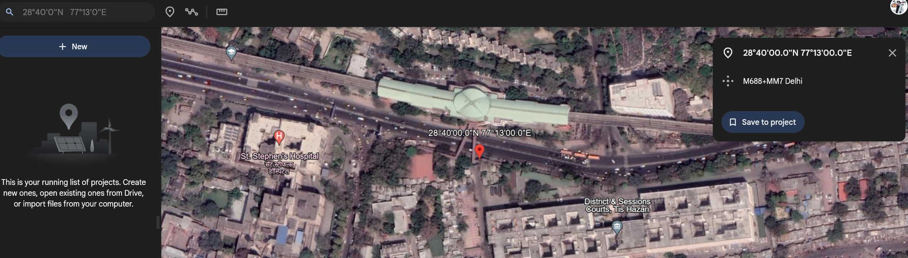

**Target 2**

**Student at CU**

Source – Instagram

Method – Social Engineering

IP - 103.41.26.231

Coordinates - 32.039330, 75.403180 (32°2'22"N   75°24'11"E)

Geo Location – Gurdaspur, Punjab, India

ISP – Fastway Transmission Private Limited

Device – Vivo Y20G (2021)

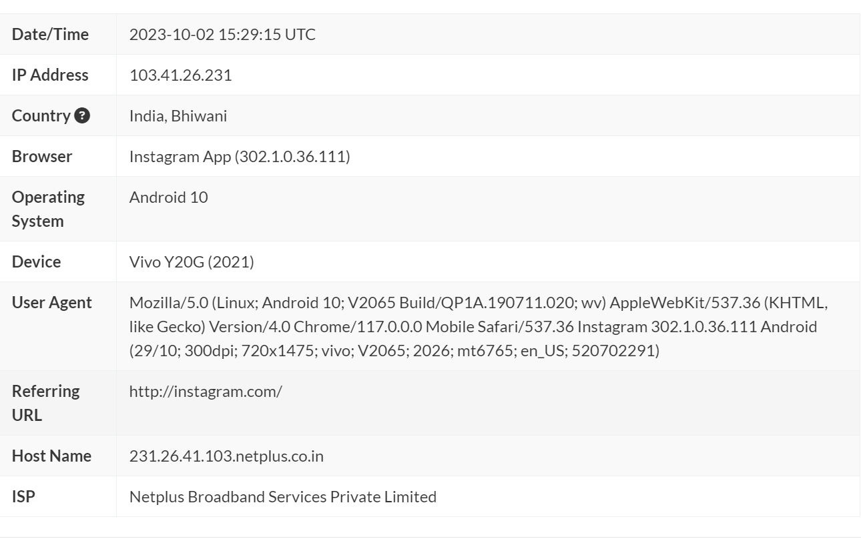

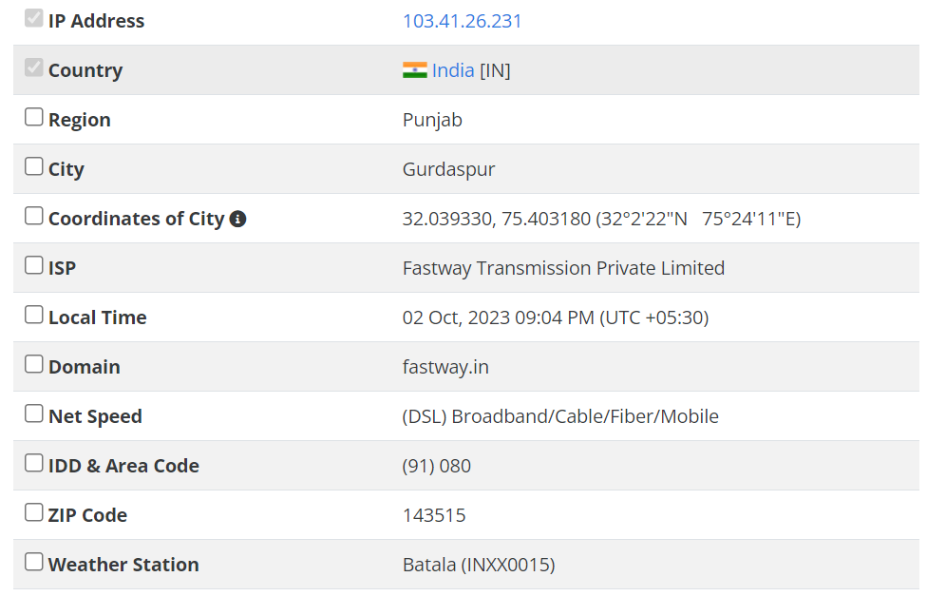

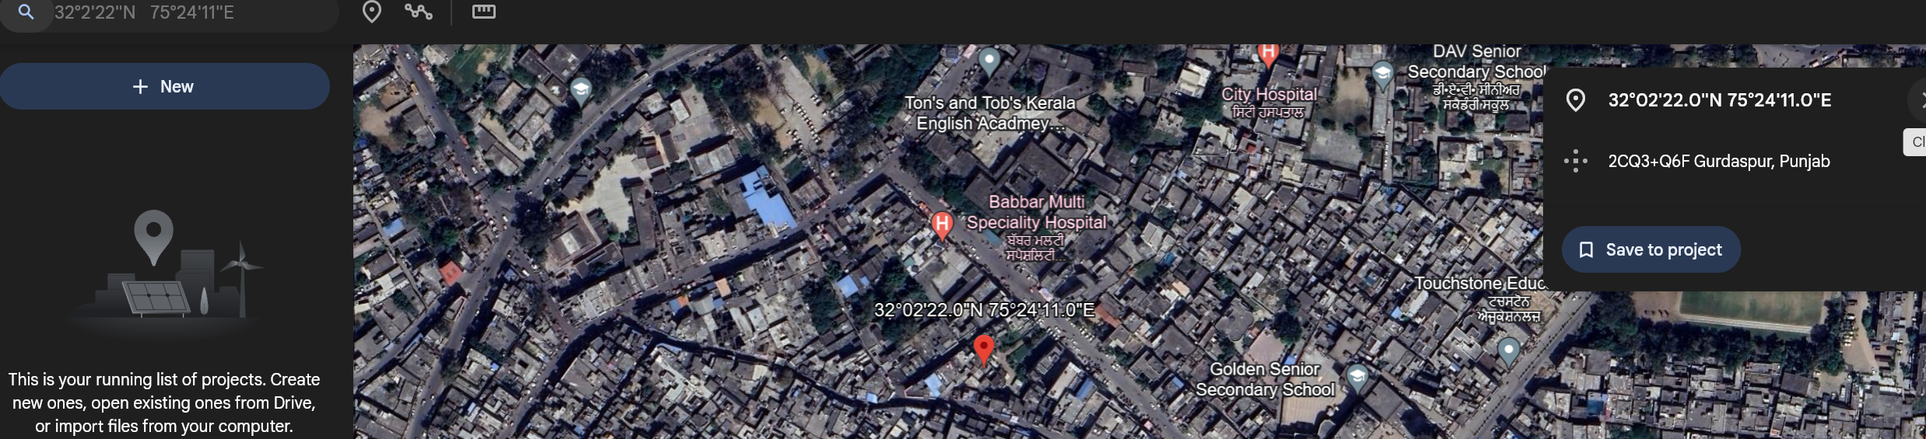

**Target 3**

**Student at CU’s Friend at Home**

Source – Instagram

Method – Social Engineering

IP - 223.187.100.126

Coordinates - 30.916670, 77.116670 (30°55'0"N 77°7'0"E)

Geo Location – Solan, Himachal Pradesh, India

ISP – Bharti Airtel Ltd.

Device – Apple iPhone (iOS 12.3.1)

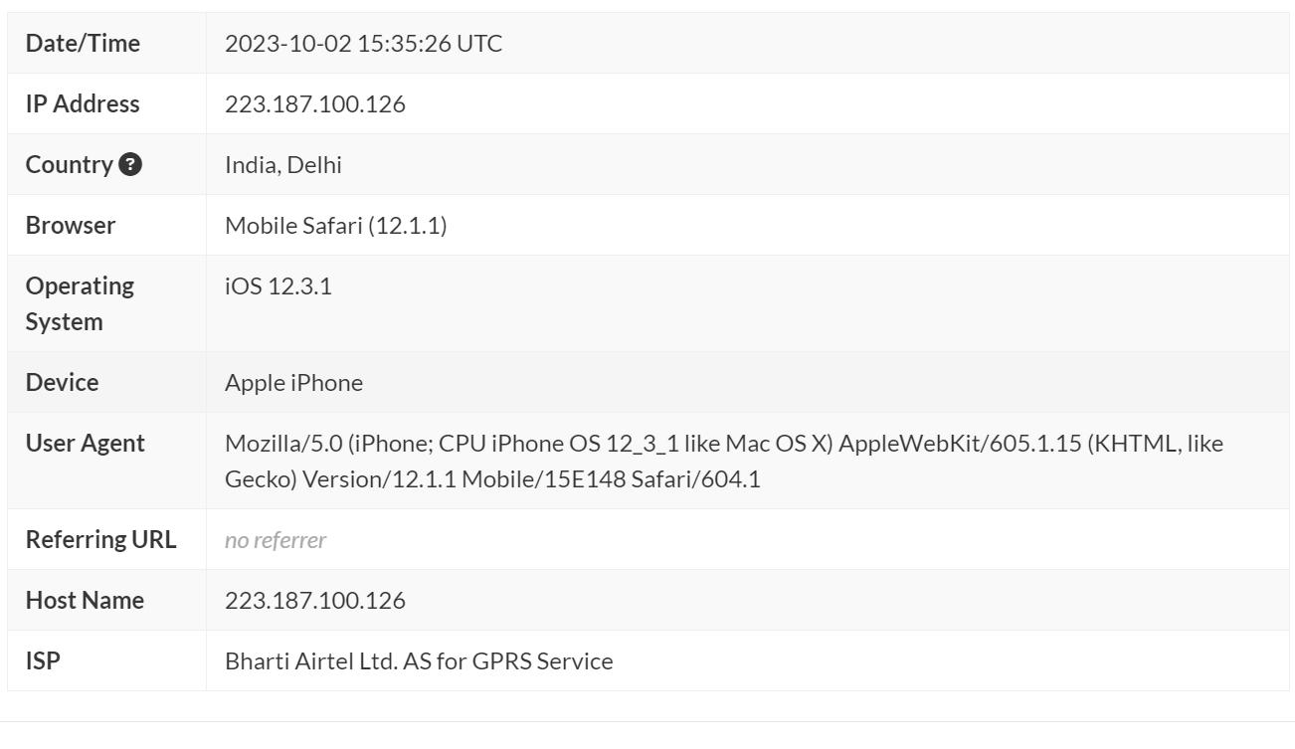

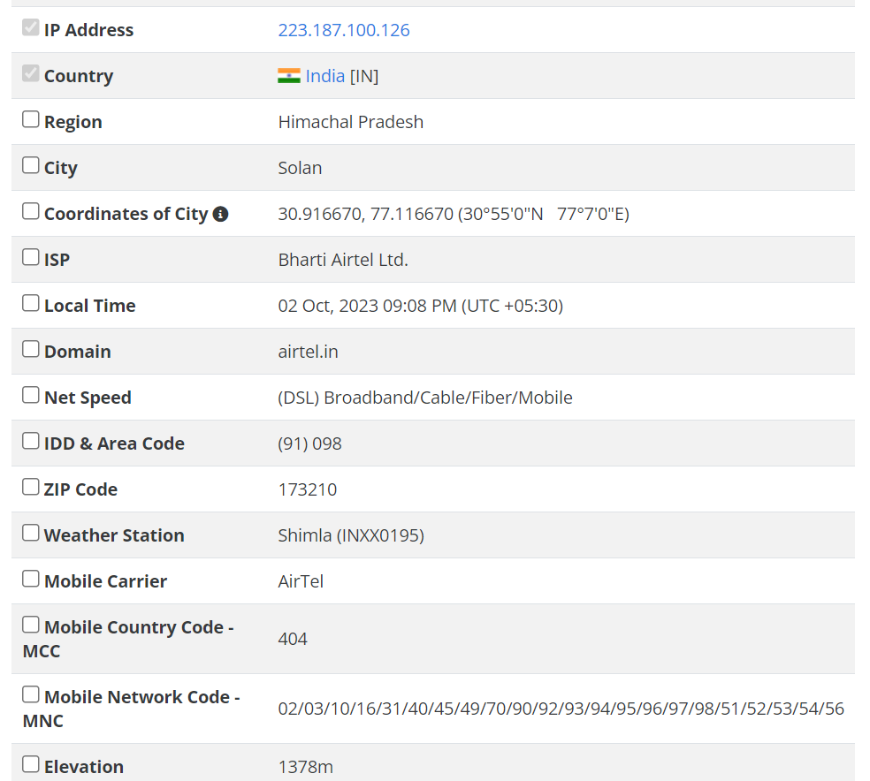

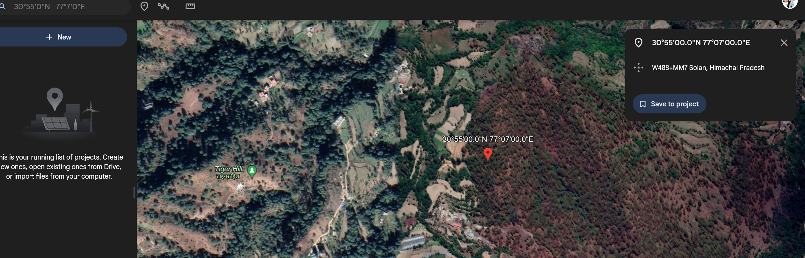

**Target – Website**

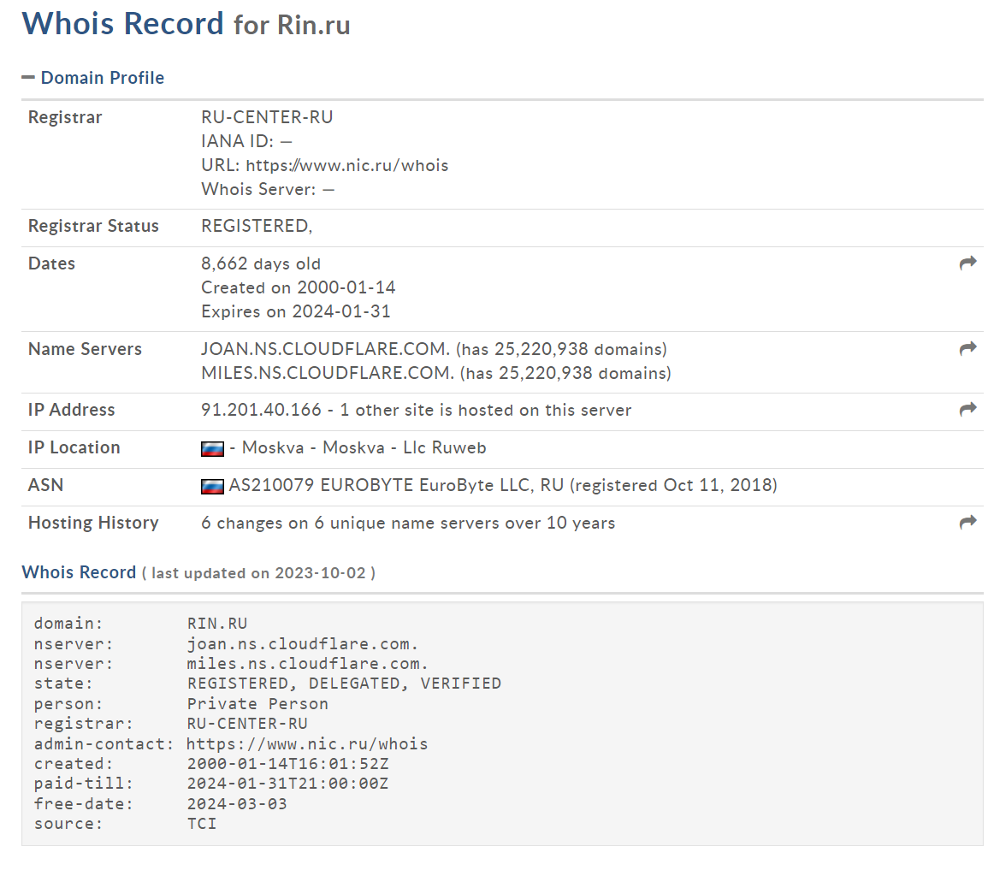

**LAB EXPERIMENT – 6**

**Hack using Search Engines**

Akshat site:upesac.in intitle:

Intitle

Intext

Inurl

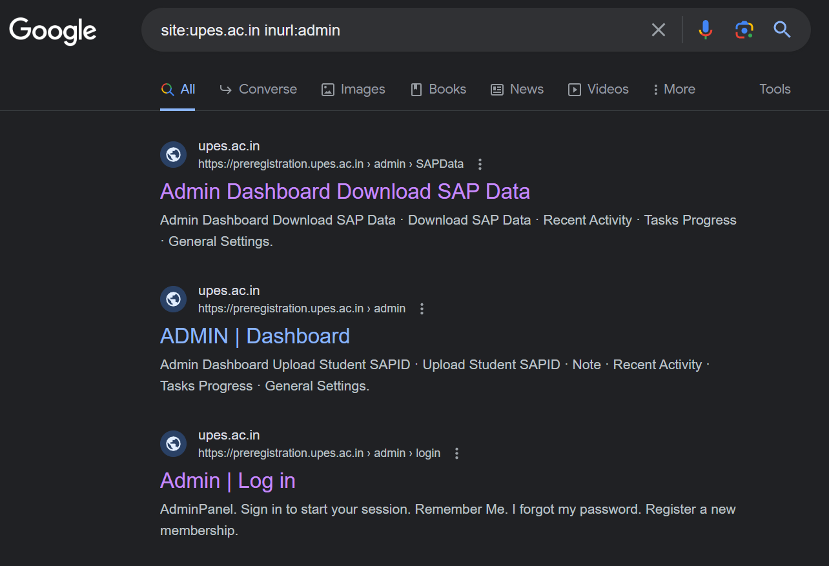

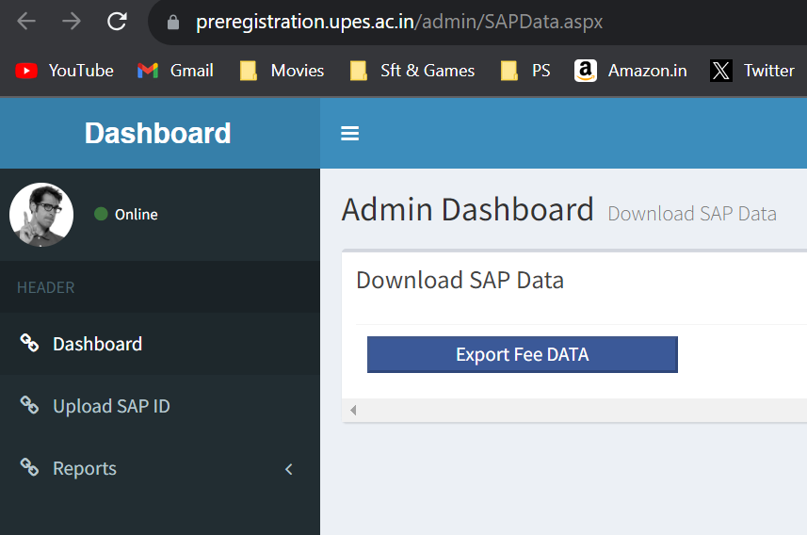

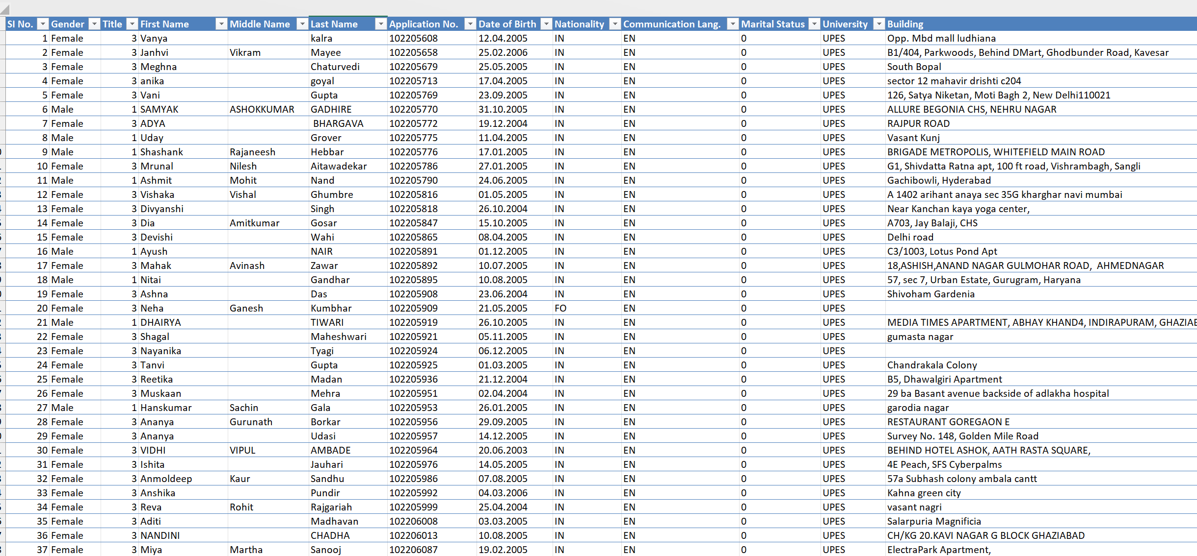

[inurl:pastebin "Windows 10 Product Keys*"](https://www.exploit-db.com/ghdb/7754)

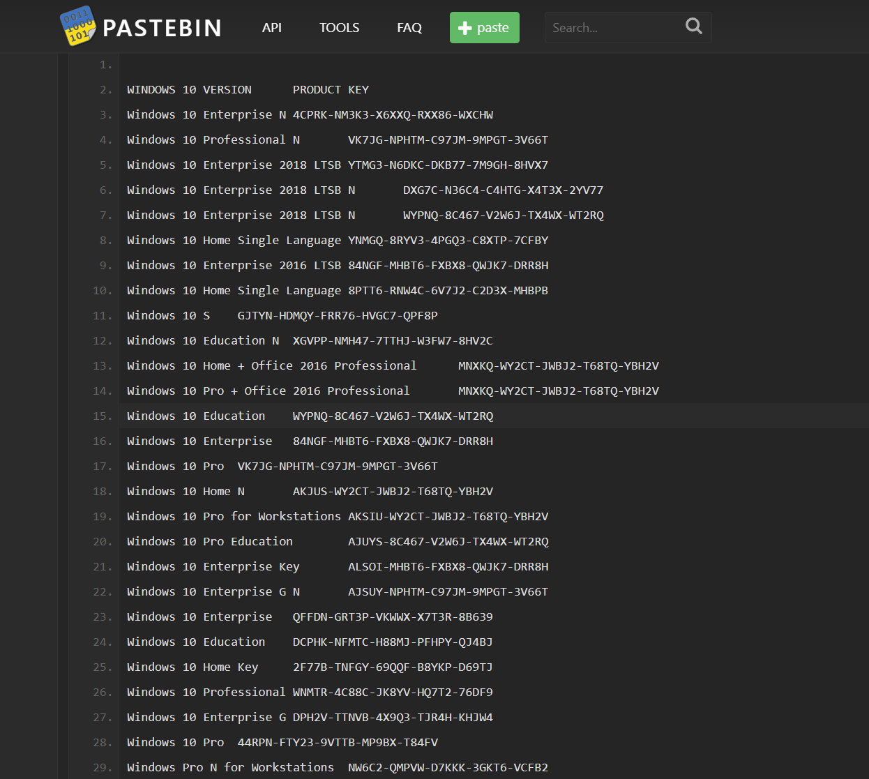

intitle:"Index of" "WhatsApp Images"

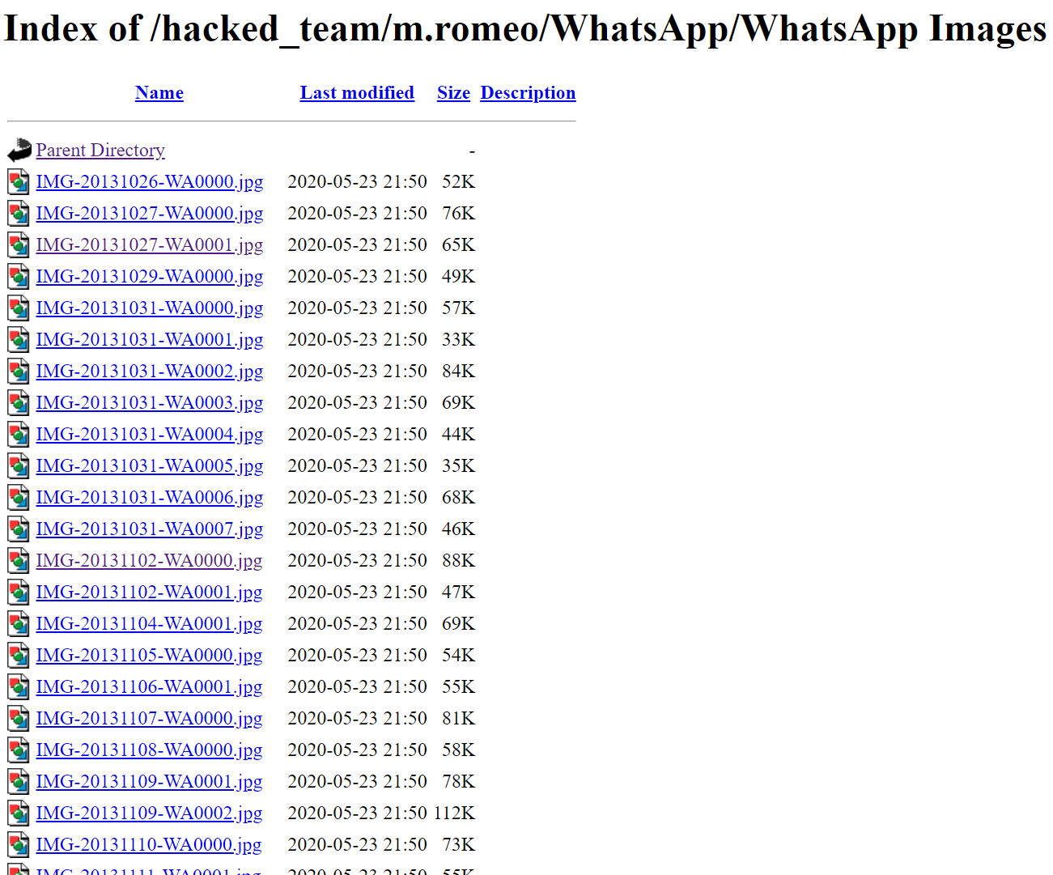

"authentication failure"; logname= filetype:log

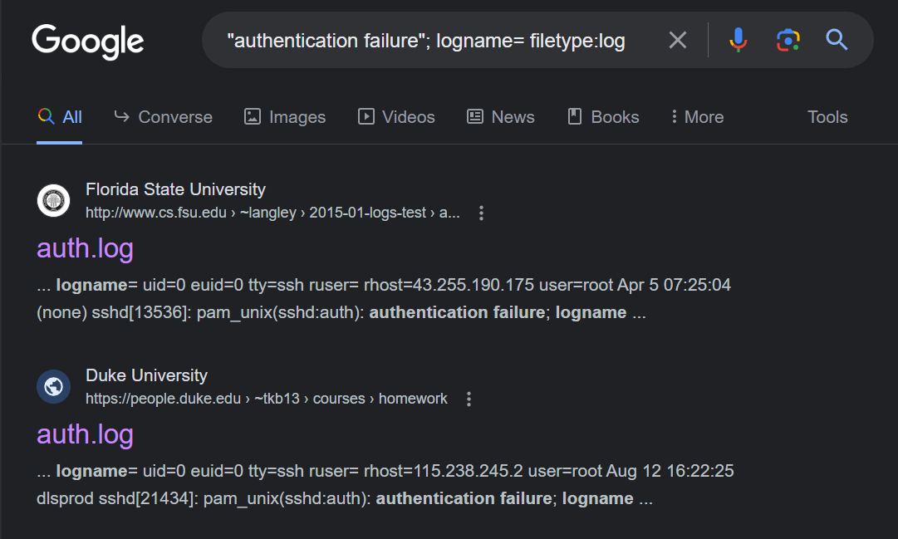

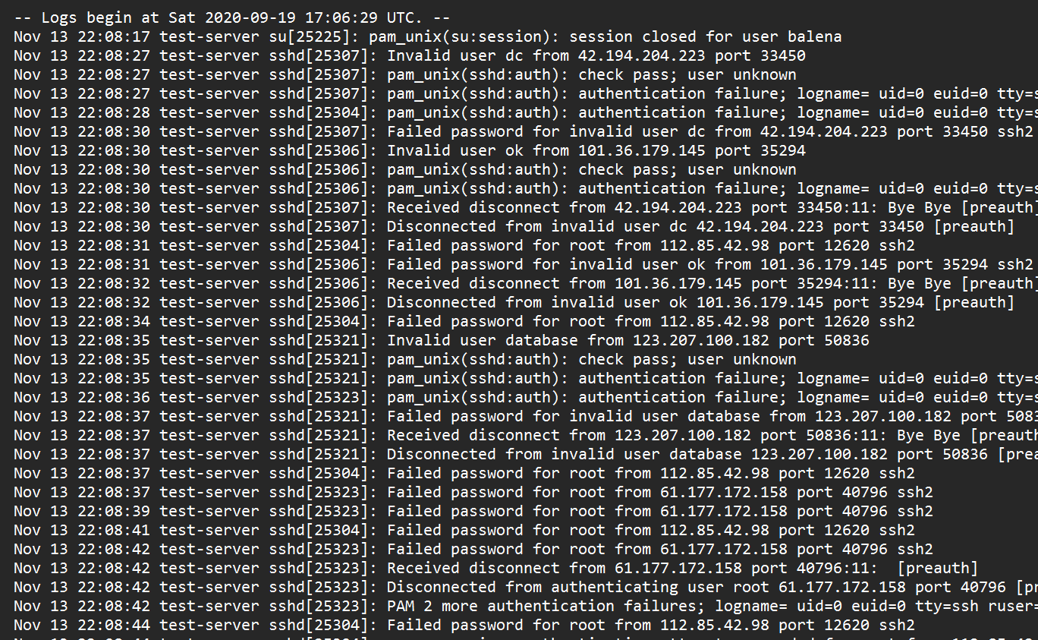

<https://www.skylinewebcams.com/en/webcam/italia/veneto/venezia/piazza-san-marco.html>

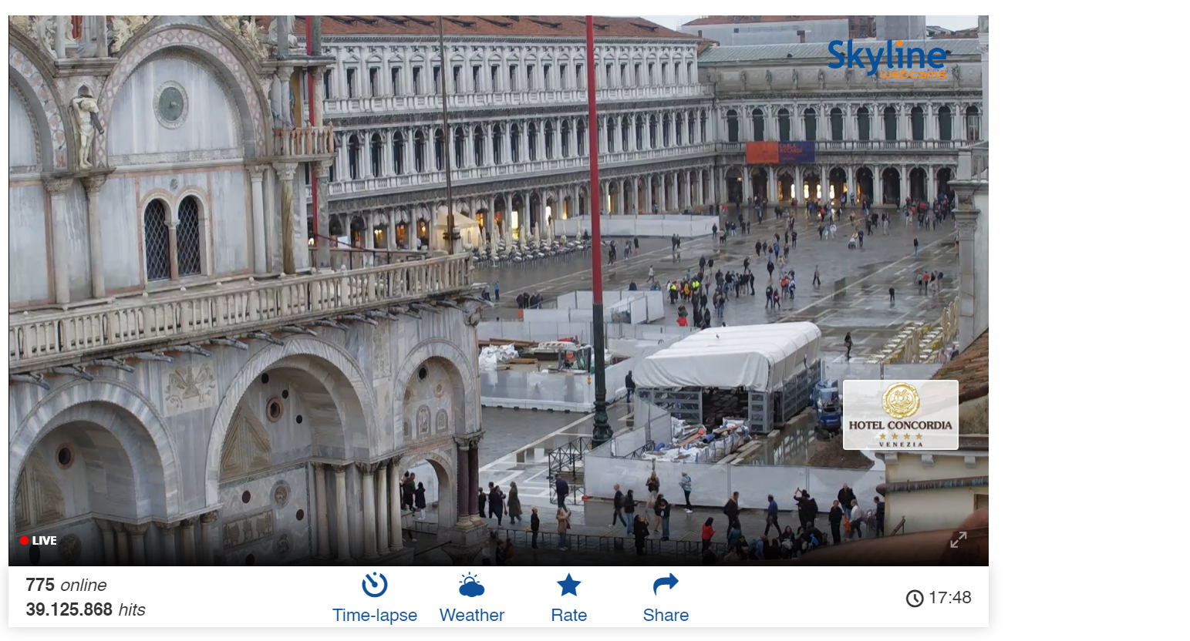

intitle:"Weather Wing WS-2"

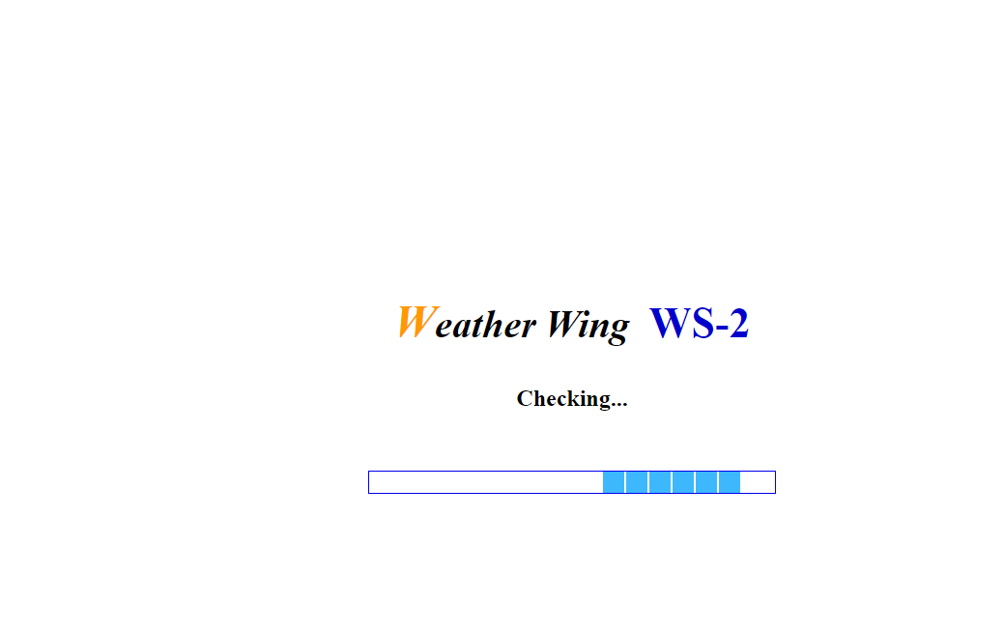

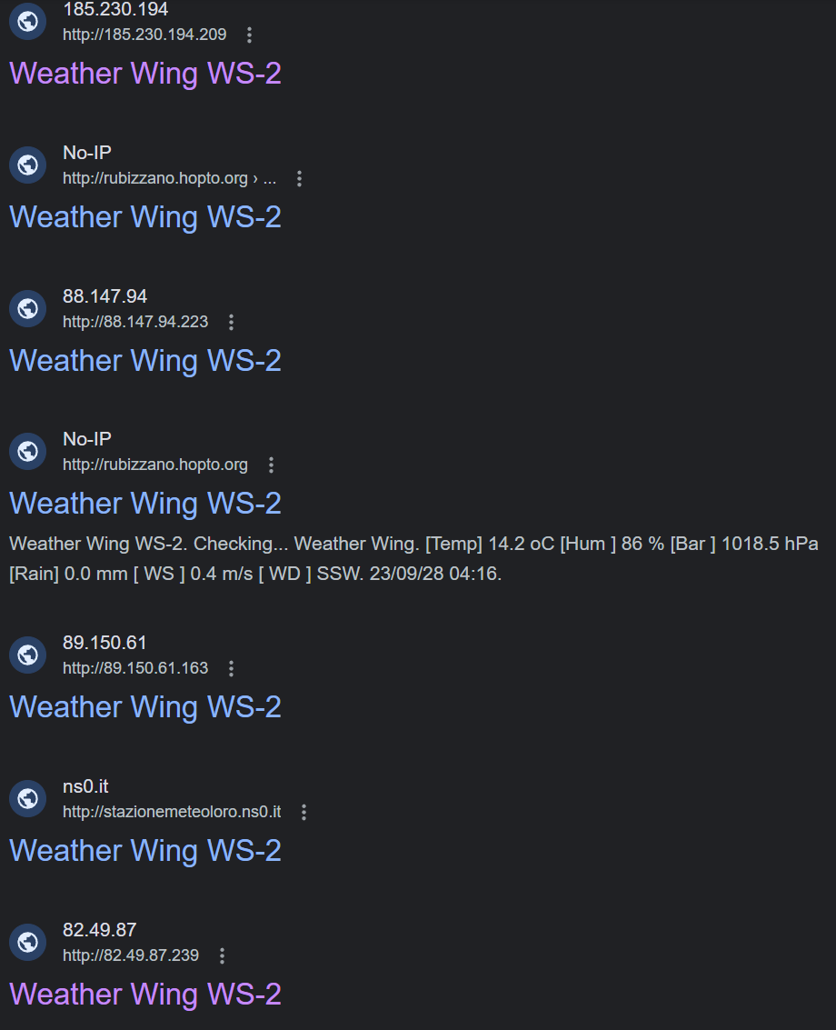

**Ways to Prevent Yourself from Google Dork Method**

1. Securely configure web applications:

Ensure that your web applications are properly secured, following industry best practices. This includes implementing strong authentication mechanisms, input validation, and access controls to prevent unauthorized access or leakage of sensitive information.

2. Limit search engine indexing:

Use robots.txt or meta tags to instruct search engines not to index certain parts of your website or specific files. This can help prevent sensitive information from being exposed through search engine results.

3. Implement access controls:

Control access to sensitive information by implementing proper authorization mechanisms. Ensure that only authorized users can access sensitive data or perform sensitive actions.

4. Regularly review and update security configurations:

Regularly review and update security configurations for your web applications, content management systems (CMS), and any other platforms you use. This includes keeping software up to date, applying security patches, and following vendor recommendations.

5. Avoid storing sensitive information in plain text:

Do not store sensitive information, such as passwords, API keys, or database credentials, in plain text within your web applications or configuration files. Utilize encryption and secure storage mechanisms to protect sensitive data.

6. Use secure coding practices:

Adhere to secure coding practices, such as input validation, output encoding, and proper handling of user-supplied data. These practices can help prevent common vulnerabilities like SQL injection, cross-site scripting (XSS), and command injection.

7. Implement web application firewalls (WAF):

Consider implementing a WAF to provide an additional layer of protection against attacks targeting your web applications. WAFs can help detect and block suspicious or malicious requests, including those generated by Google dorks.

8. Regularly monitor and audit your web applications:

Implement monitoring and auditing mechanisms to detect and respond to potential security incidents or unauthorized access attempts. This can include log monitoring, intrusion detection systems (IDS), or security information and event management (SIEM) solutions.

9. Educate users and developers:

Provide security awareness training to users and developers to help them understand the risks associated with Google dorks and the importance of following secure coding practices. Encourage them to report any suspicious activities or potential vulnerabilities they encounter.

10. Stay informed about security vulnerabilities:

Stay up to date with security news and vulnerabilities related to the software and platforms you use. Subscribe to security mailing lists, follow security blogs, and apply security patches promptly to mitigate known vulnerabilities.

**LAB EXPERIMENT – 7**

**LAN KALI LINUX**

**IP CONFIG to check the IP for the Device.**

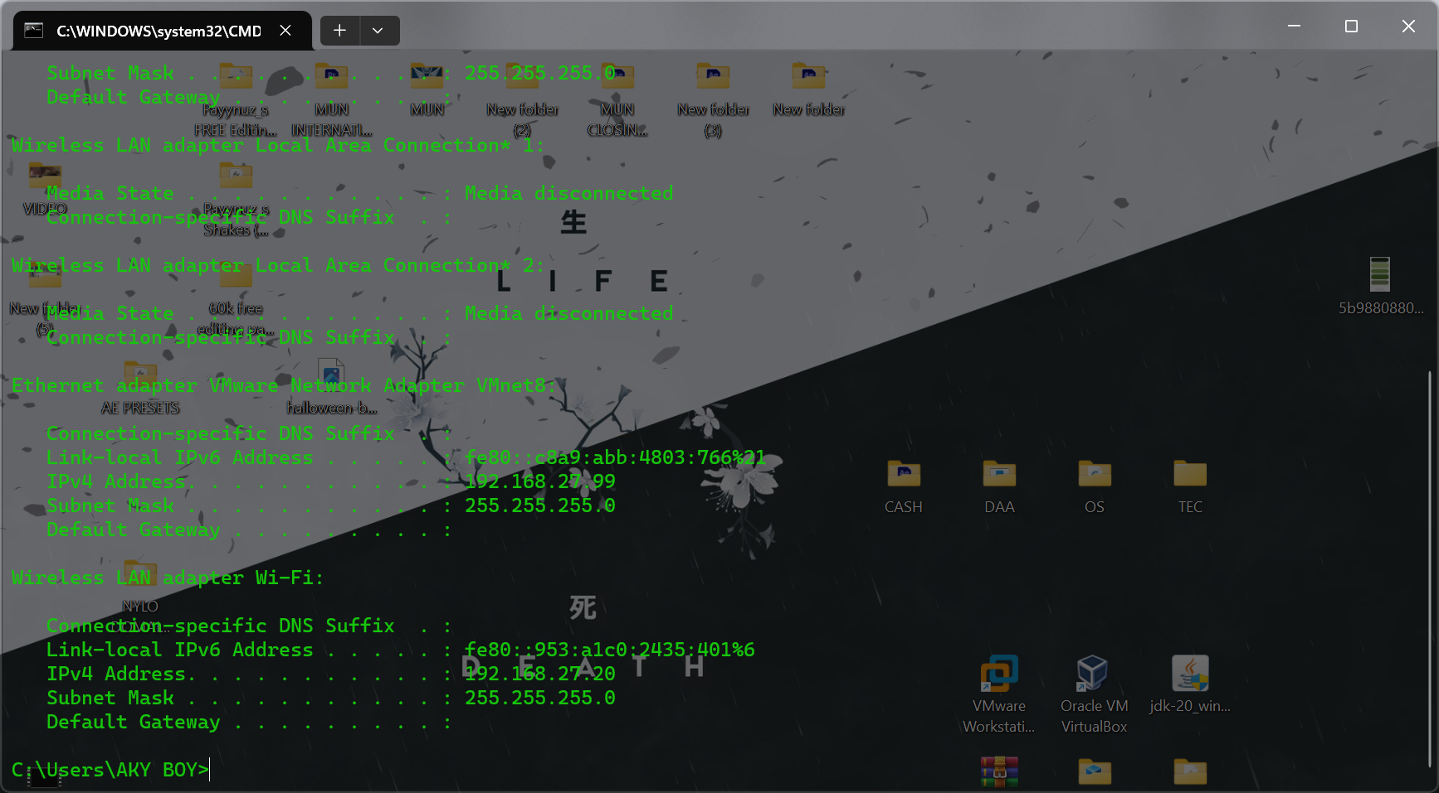

**CONFIGURATION IP**

**Turn off the Firewall for the both the devices.**

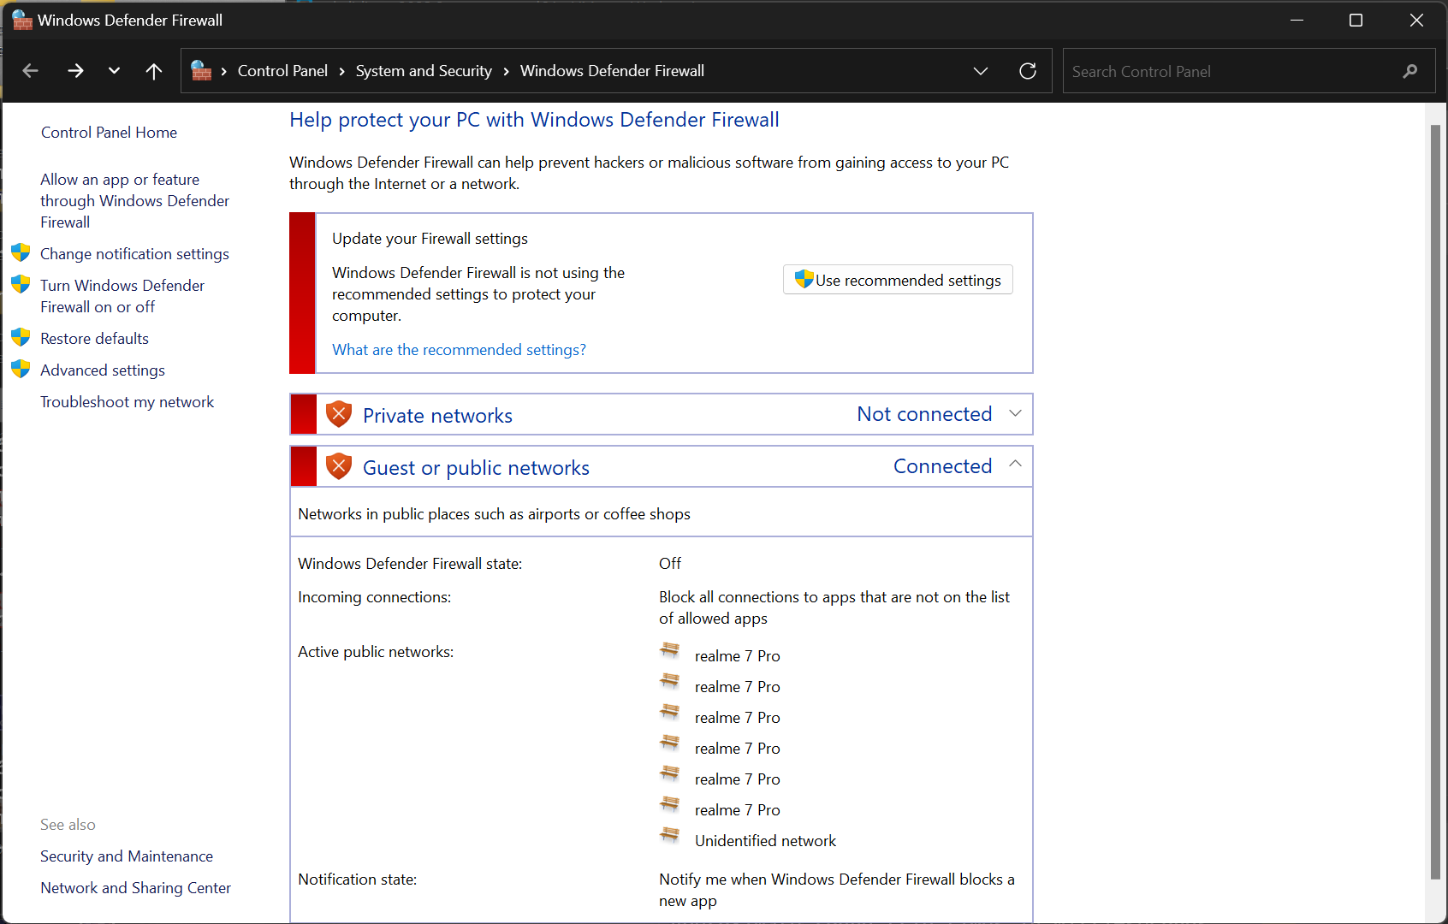

**Go for the Properties**

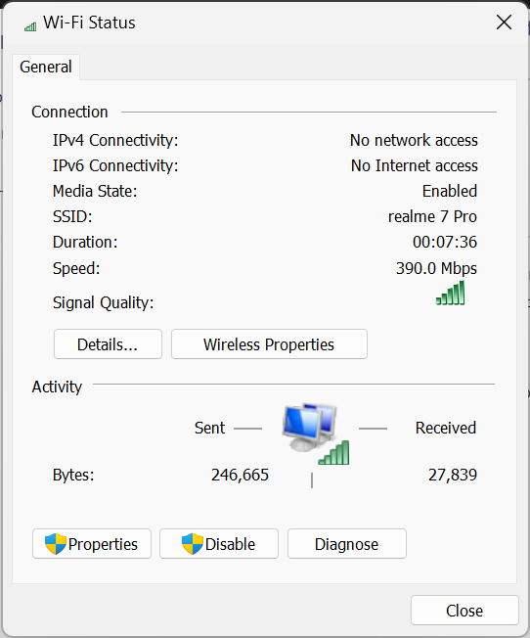

**Go for the IPV4 to configure the custom Static IP for your device.**

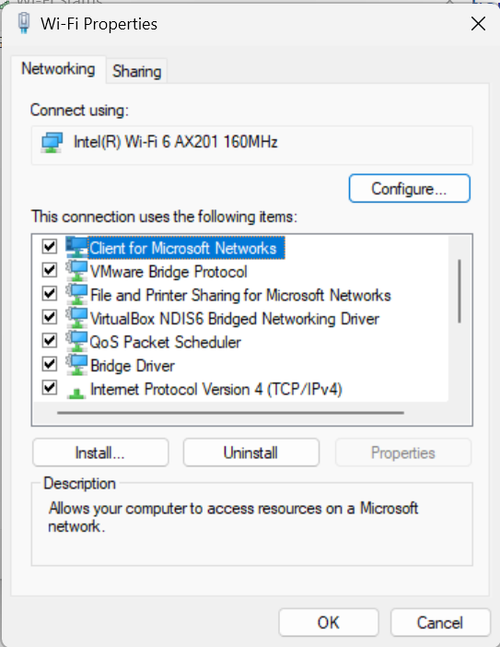

**IP for my device is 192.168.27.20**

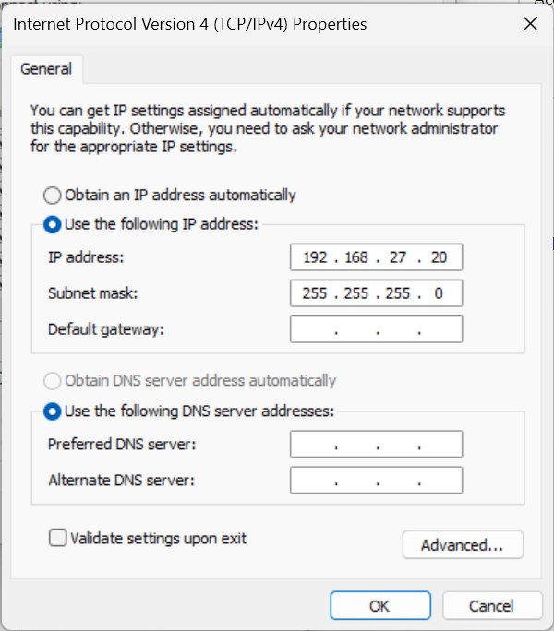

**2nd DEVICE IP – 192.168.27.10**

**3rd Deevce IP – 192.168.27.11**

**4th Device IP – 192.168.27.12**

**3rd DEVICE**

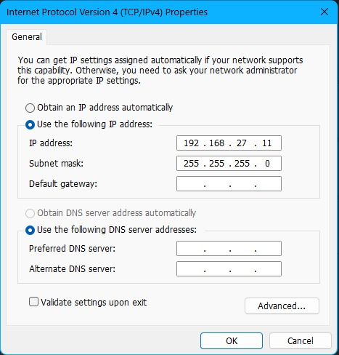

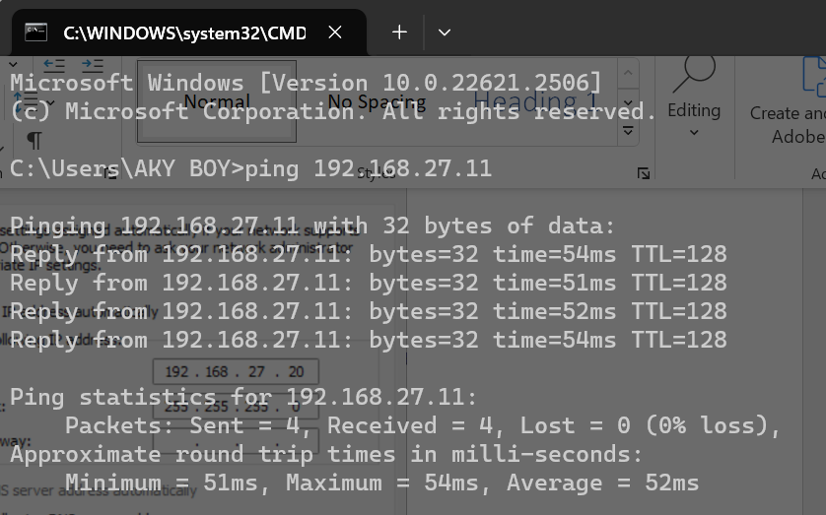

**2nd DEVICE**

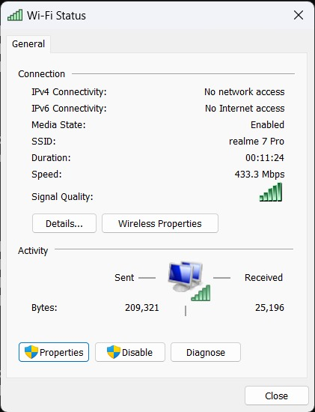

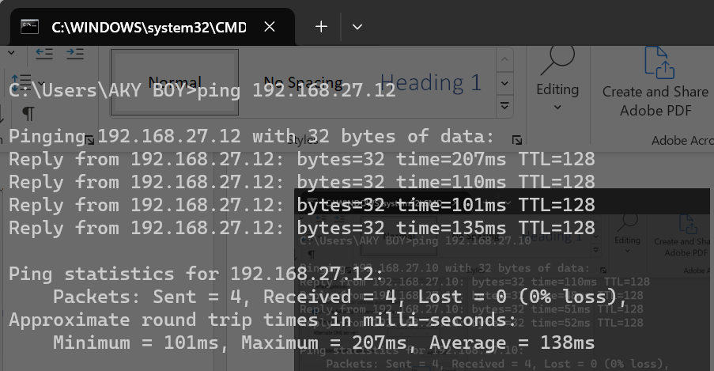

**4th DEVICE**

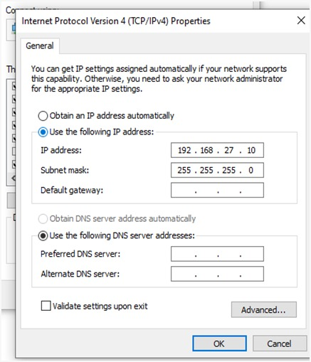

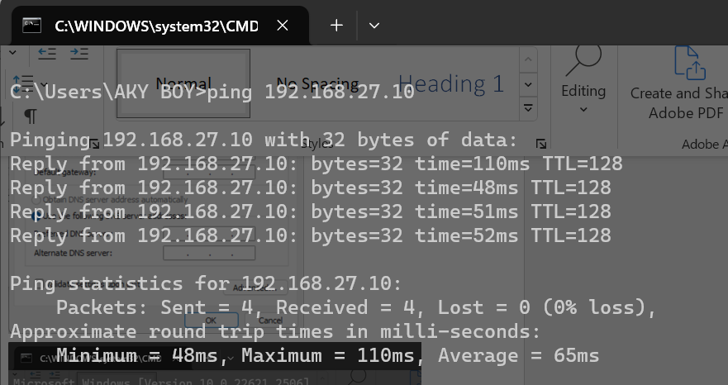

**SELF VM TO OTHER DEVICE WINDOWS**

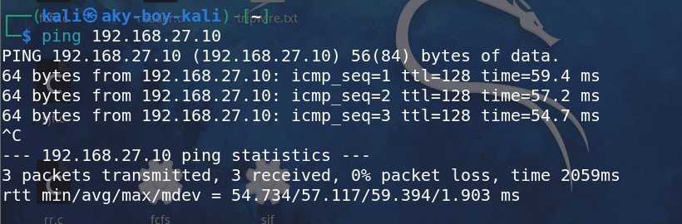

**PING FROM VM TO SELF DEVICE**

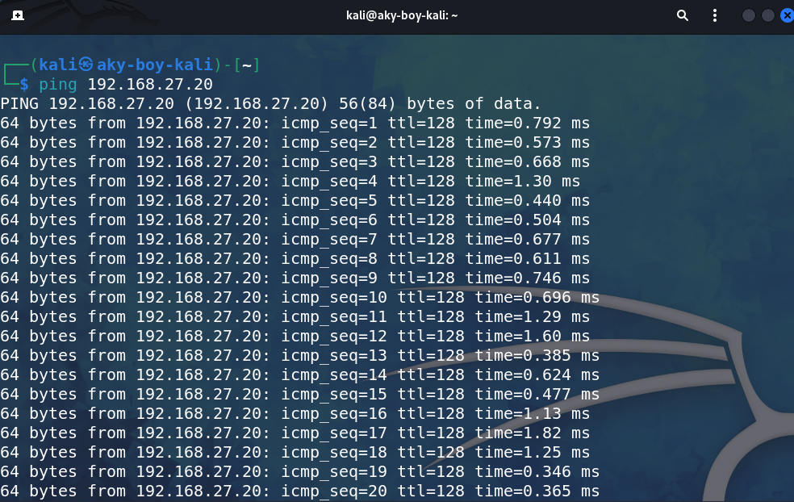

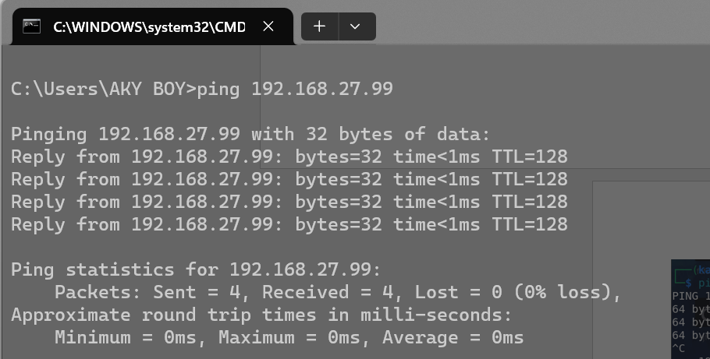**PING FROM WINDOWS TO SELF VM**

**LAB EXPERIMENT – 8**

**Network Scanning Tool - NMAP**

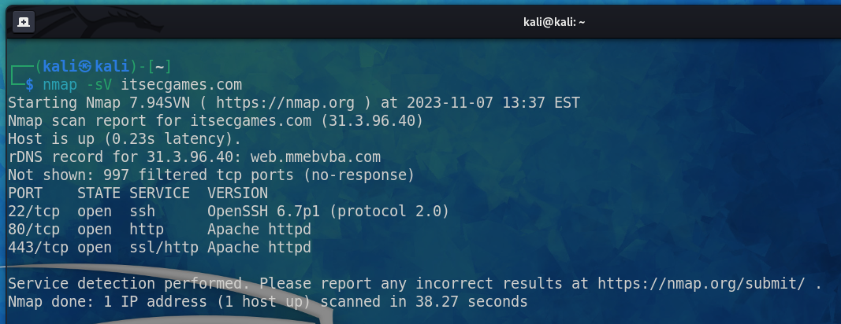

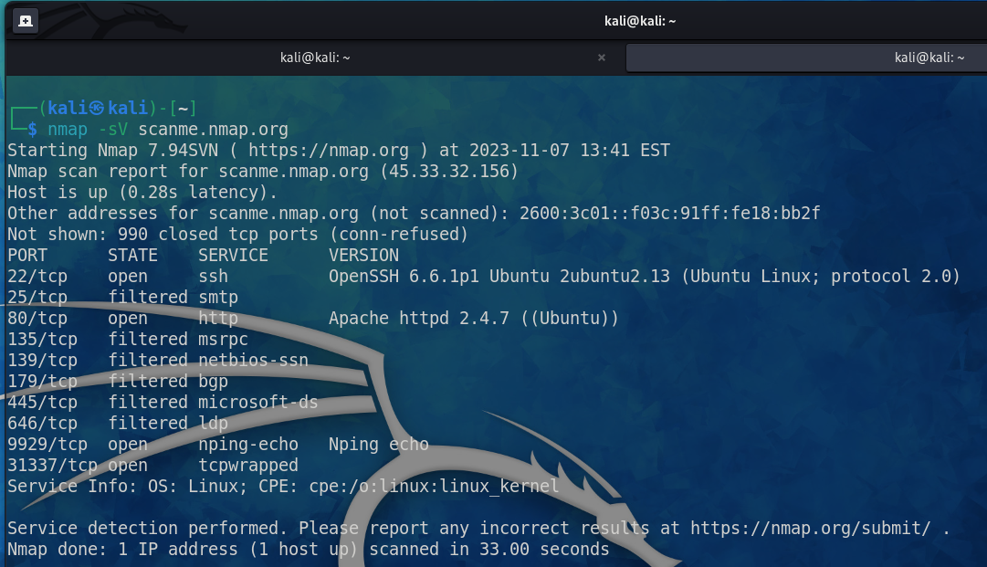

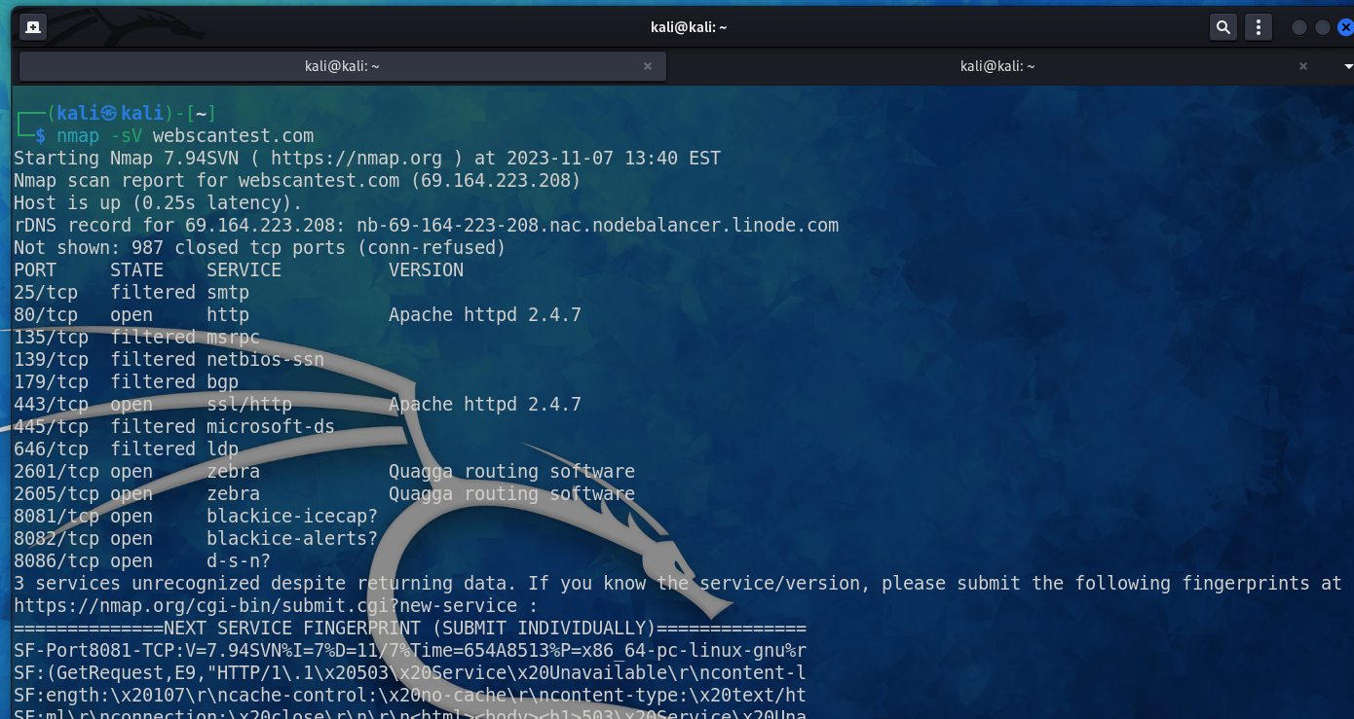

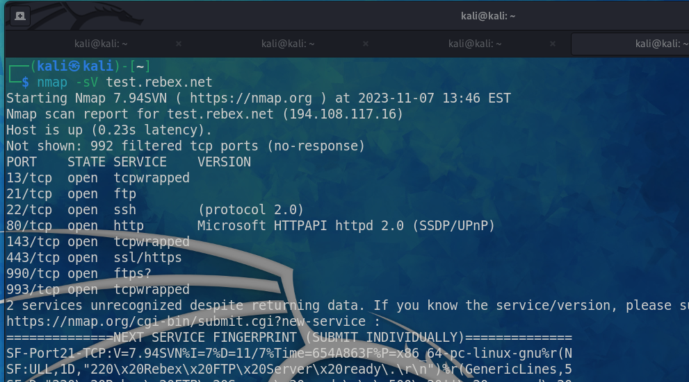

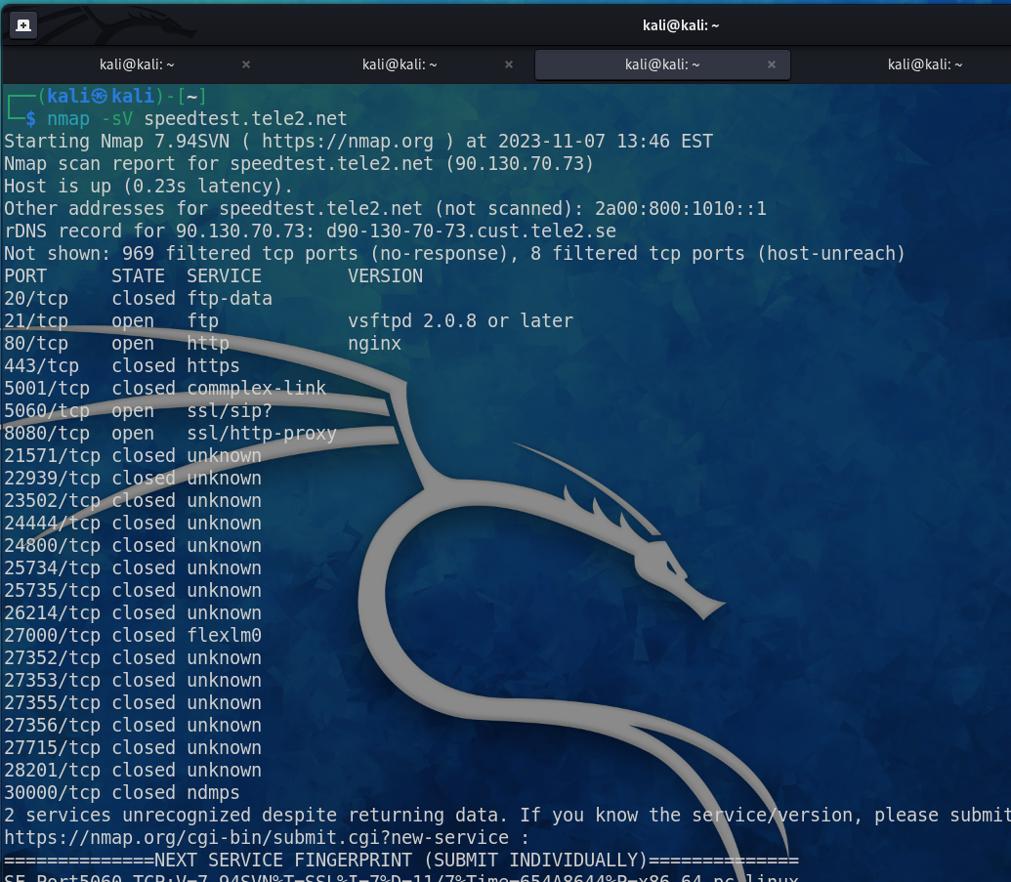

**Traceroute port 80 using nmap**

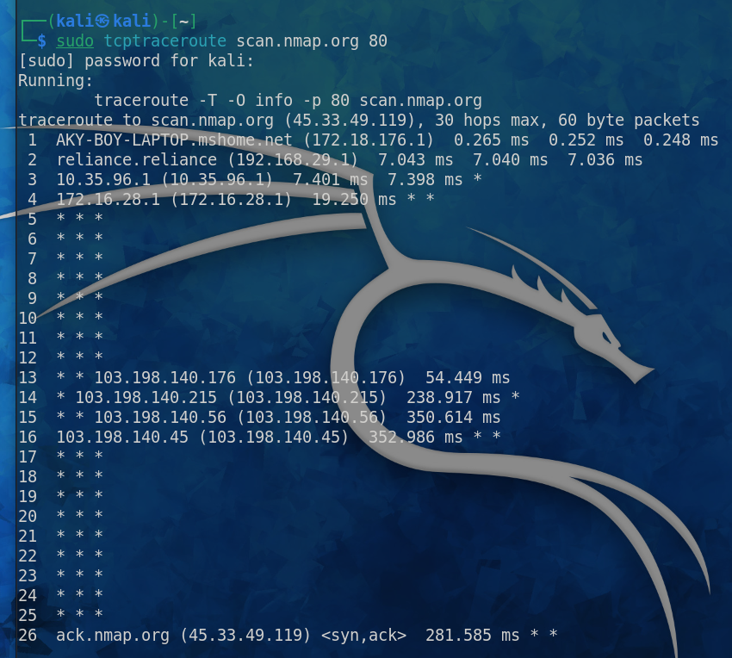

**To run the scans faster if you have faster internet use -T4 and for normal scan you can use -T3 or it’s the default way.**

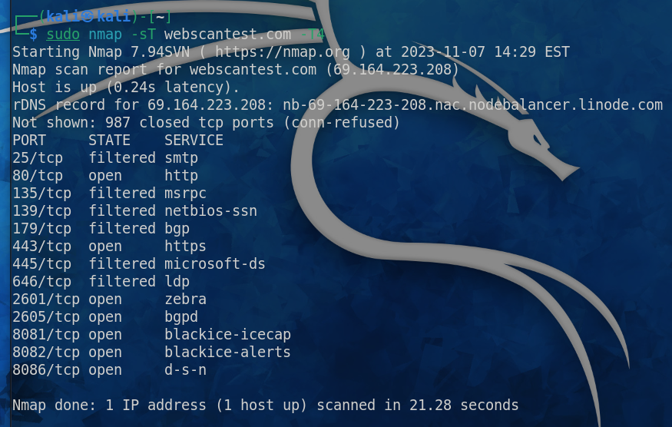

**To show the top ports from ranges 20.**

**And to show all the 65535 ports use -p-**

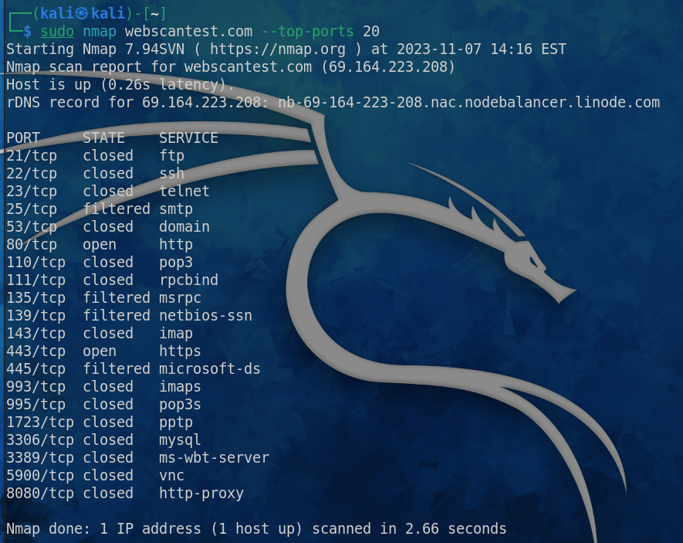

**Specific Protocol Type filtered SCAN**

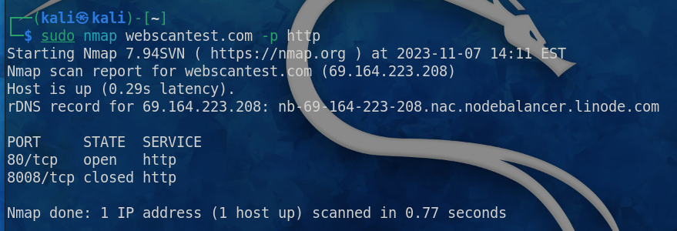

**Specific Port Type filtered SCAN**

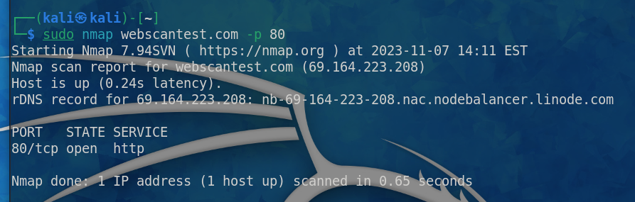

**For OS Detection on particular domain, we use -O**

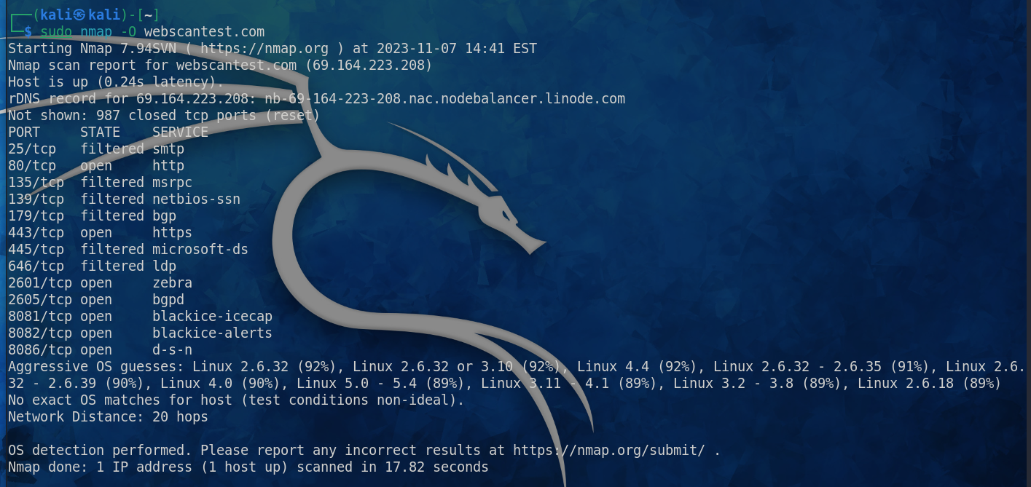

**WARNING**

This command is basically the mixture of all the commands and functionality of the nmap that is the -A which tells you about the Service Version + OS Detection + Scanning Ports + TraceRoute

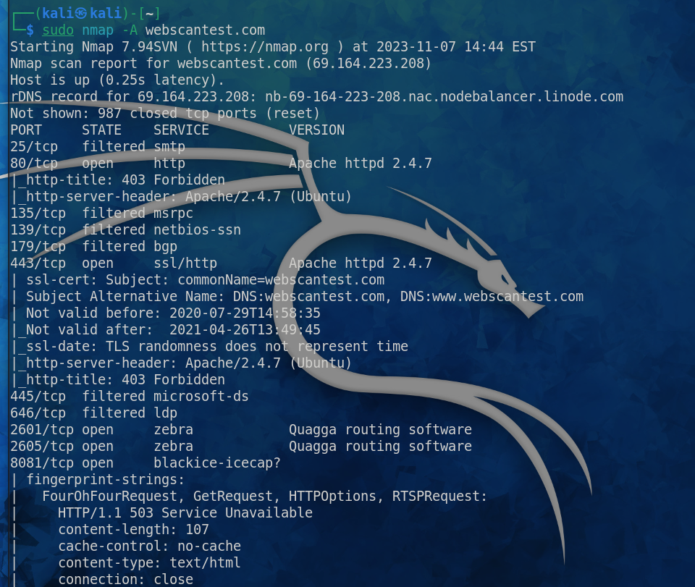

**This command shows you the live data, just like verbosity that is -v**

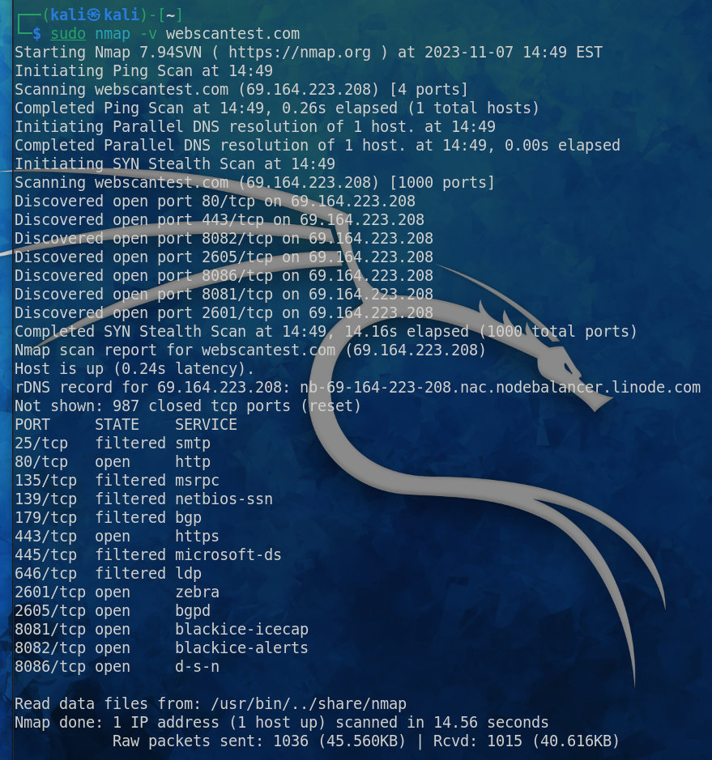

**LAB EXPERIMENT – 9**

**Network Traffic Sniffing – Wireshark**

**Own Router Traffic Analysis**

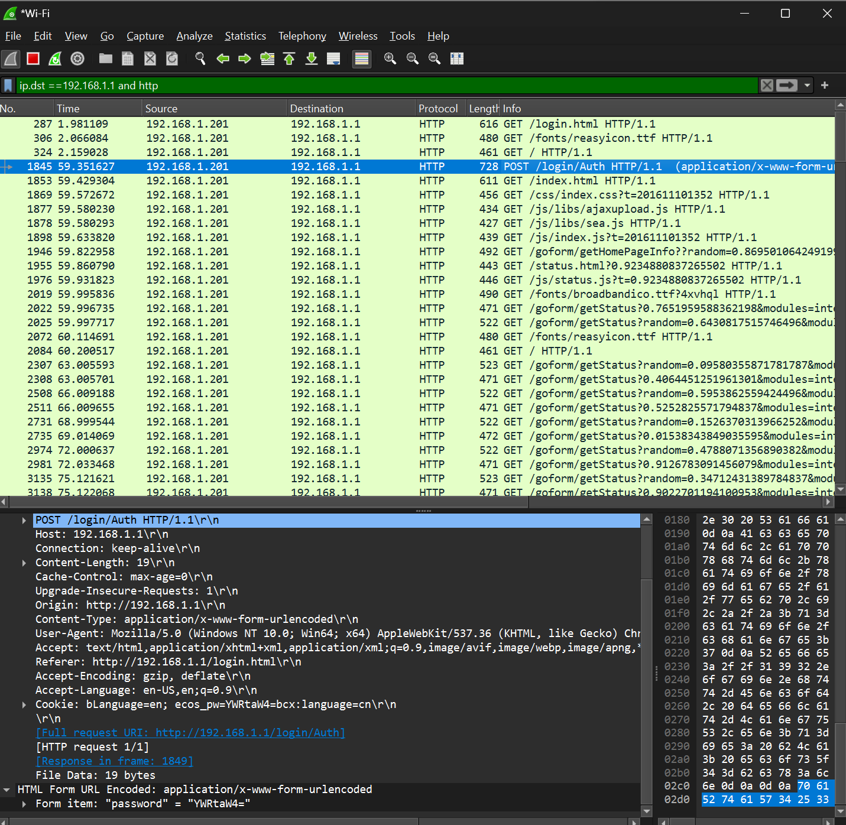

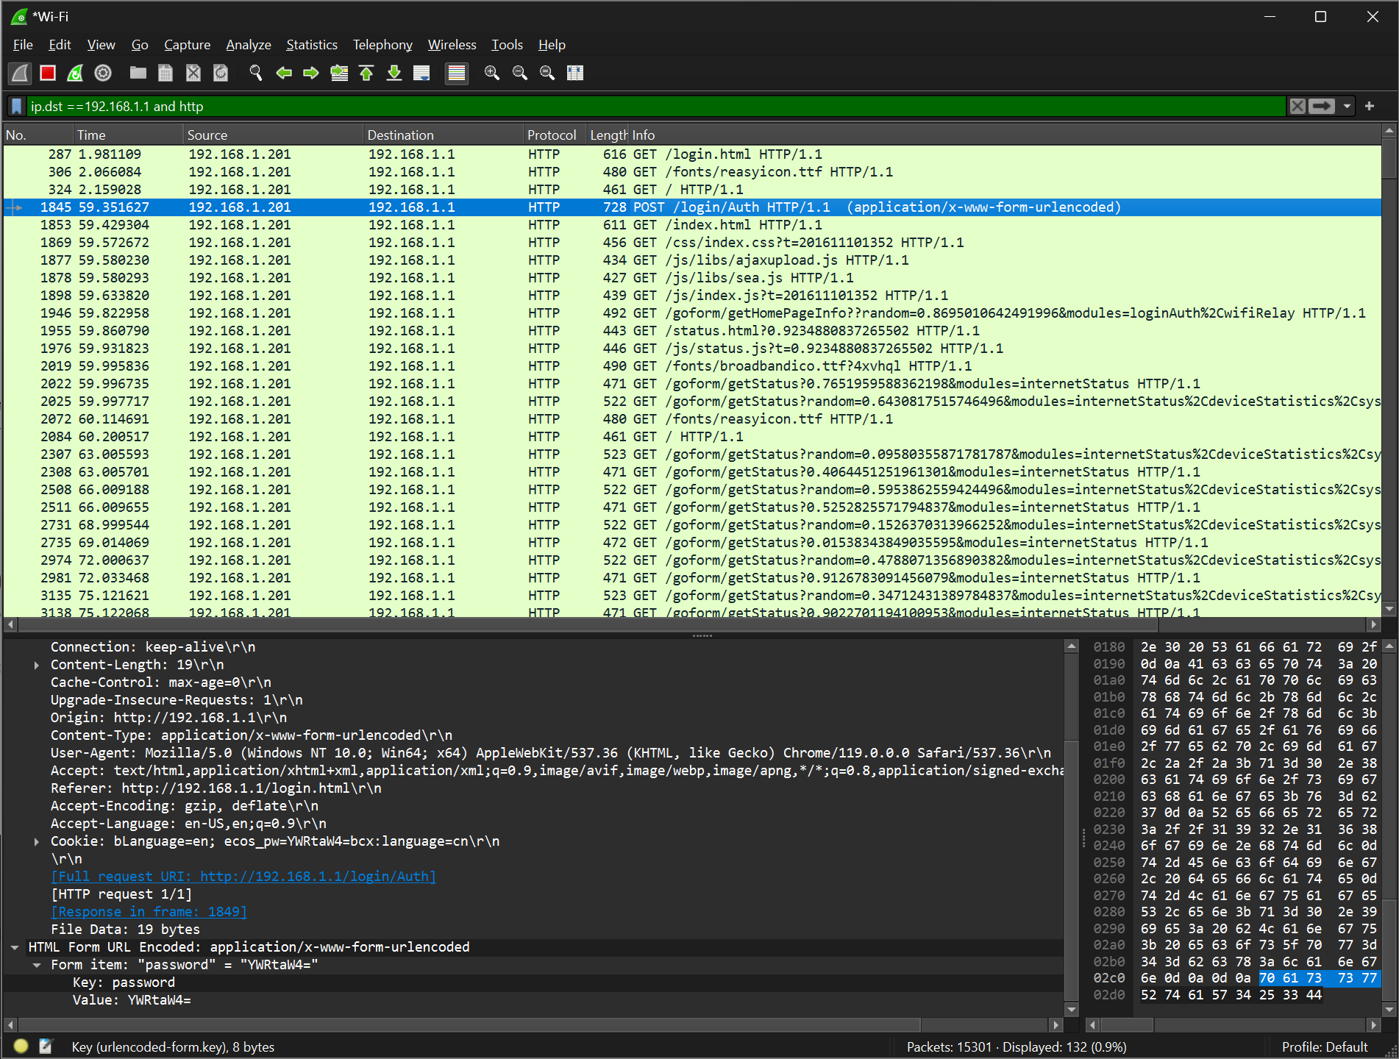

**Information Gathering from the following website:**

[**http://testphp.vulnweb.com/login.php**](http://testphp.vulnweb.com/login.php)

**Gathered the username and password using the HyperTEXT Transfer Protocol**

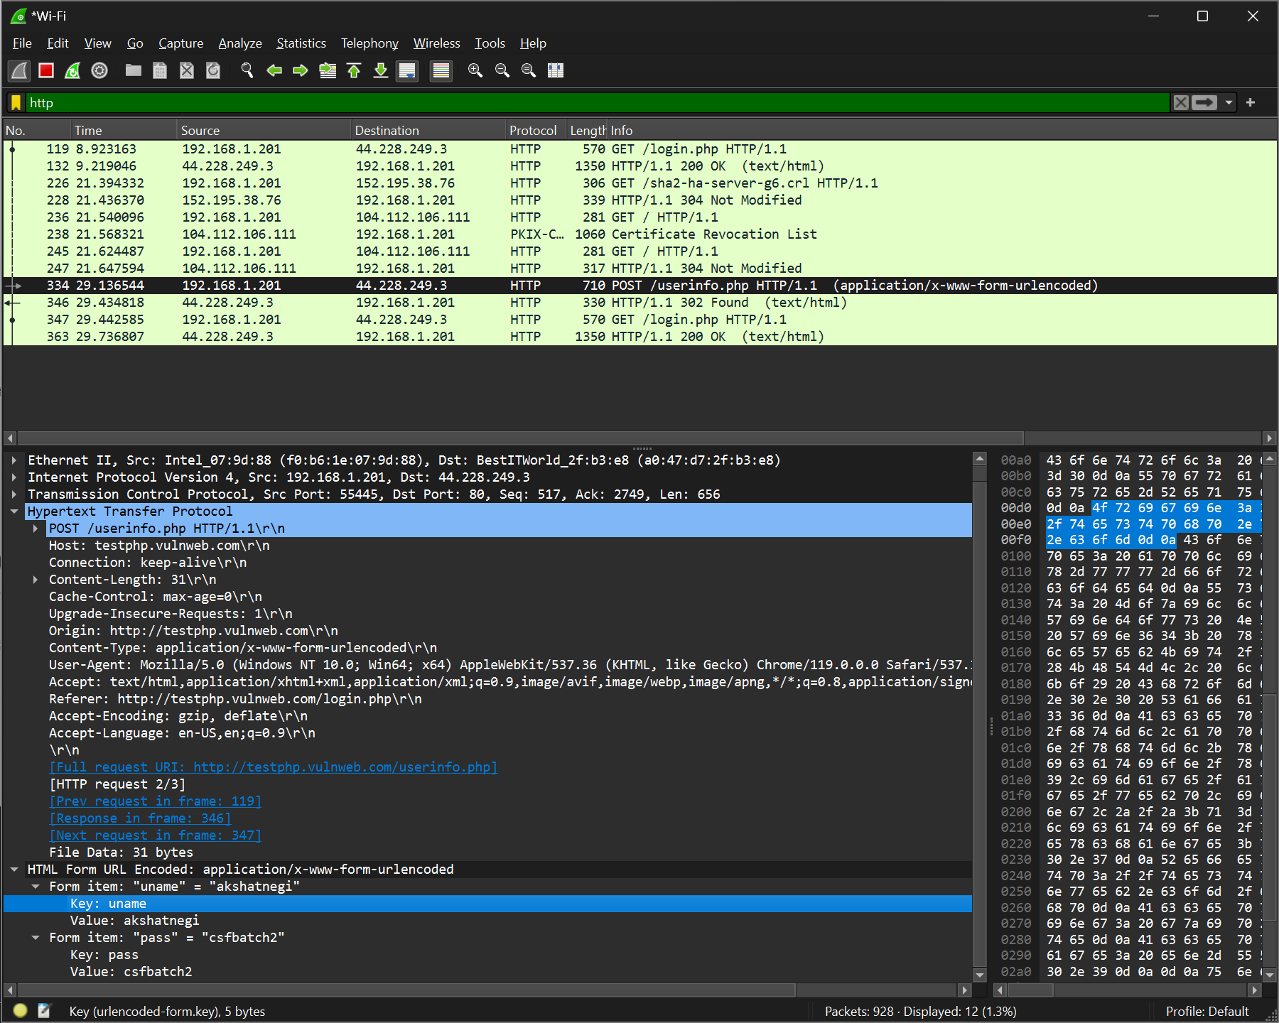

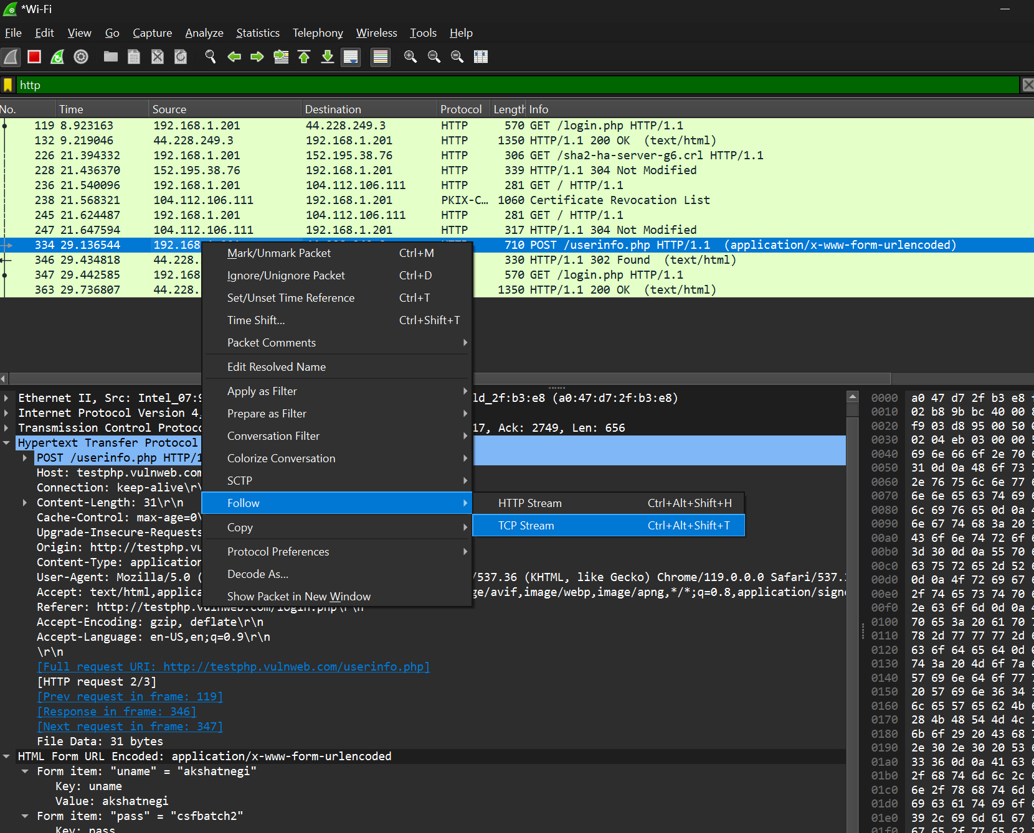

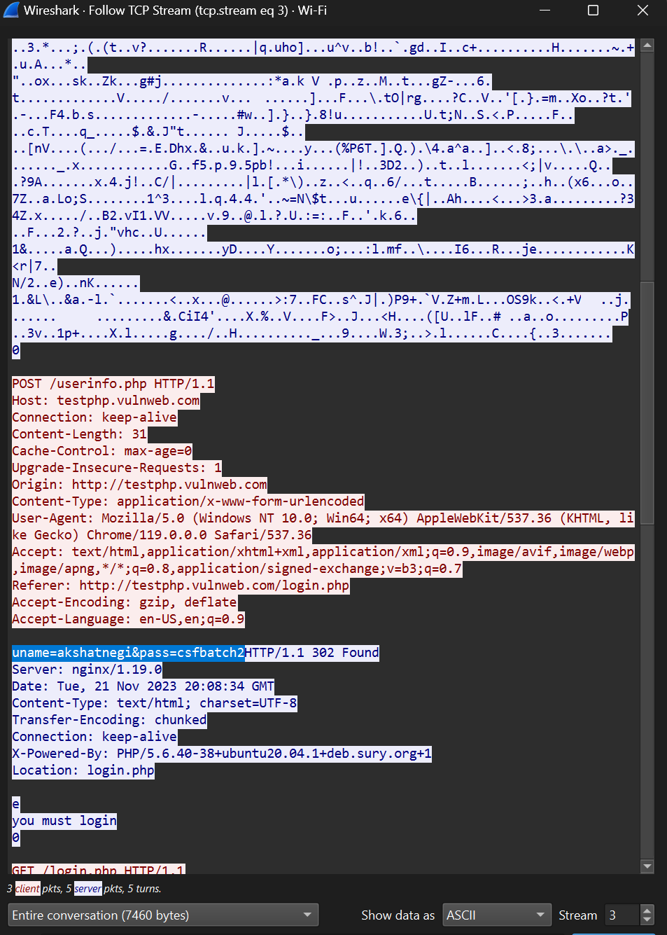

**UDP Filter**

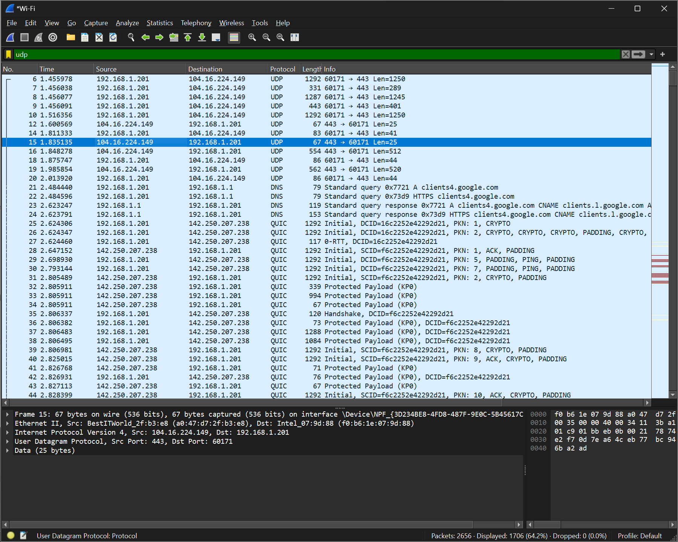

**TCP Filter**

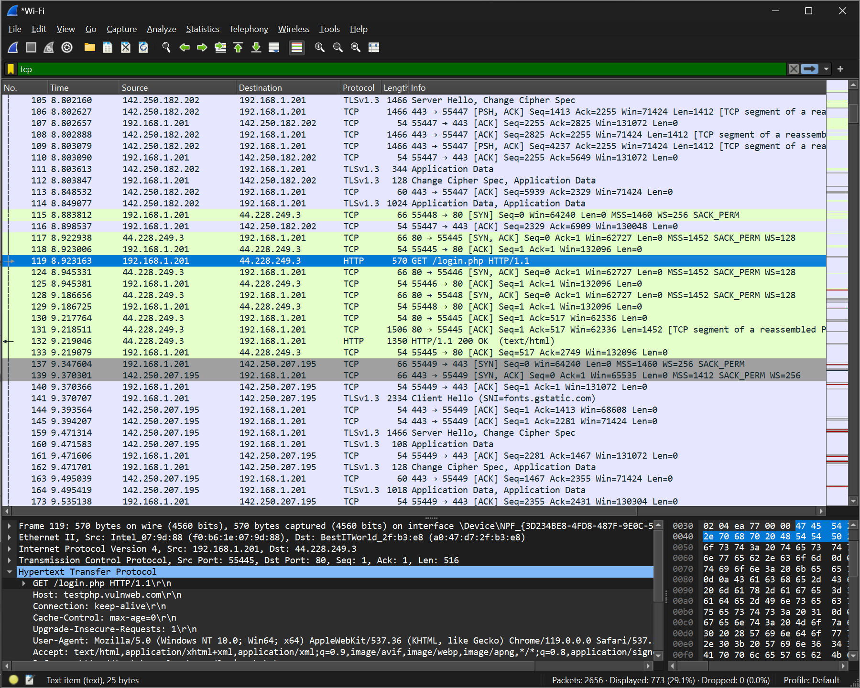

**HTTP Filtered**

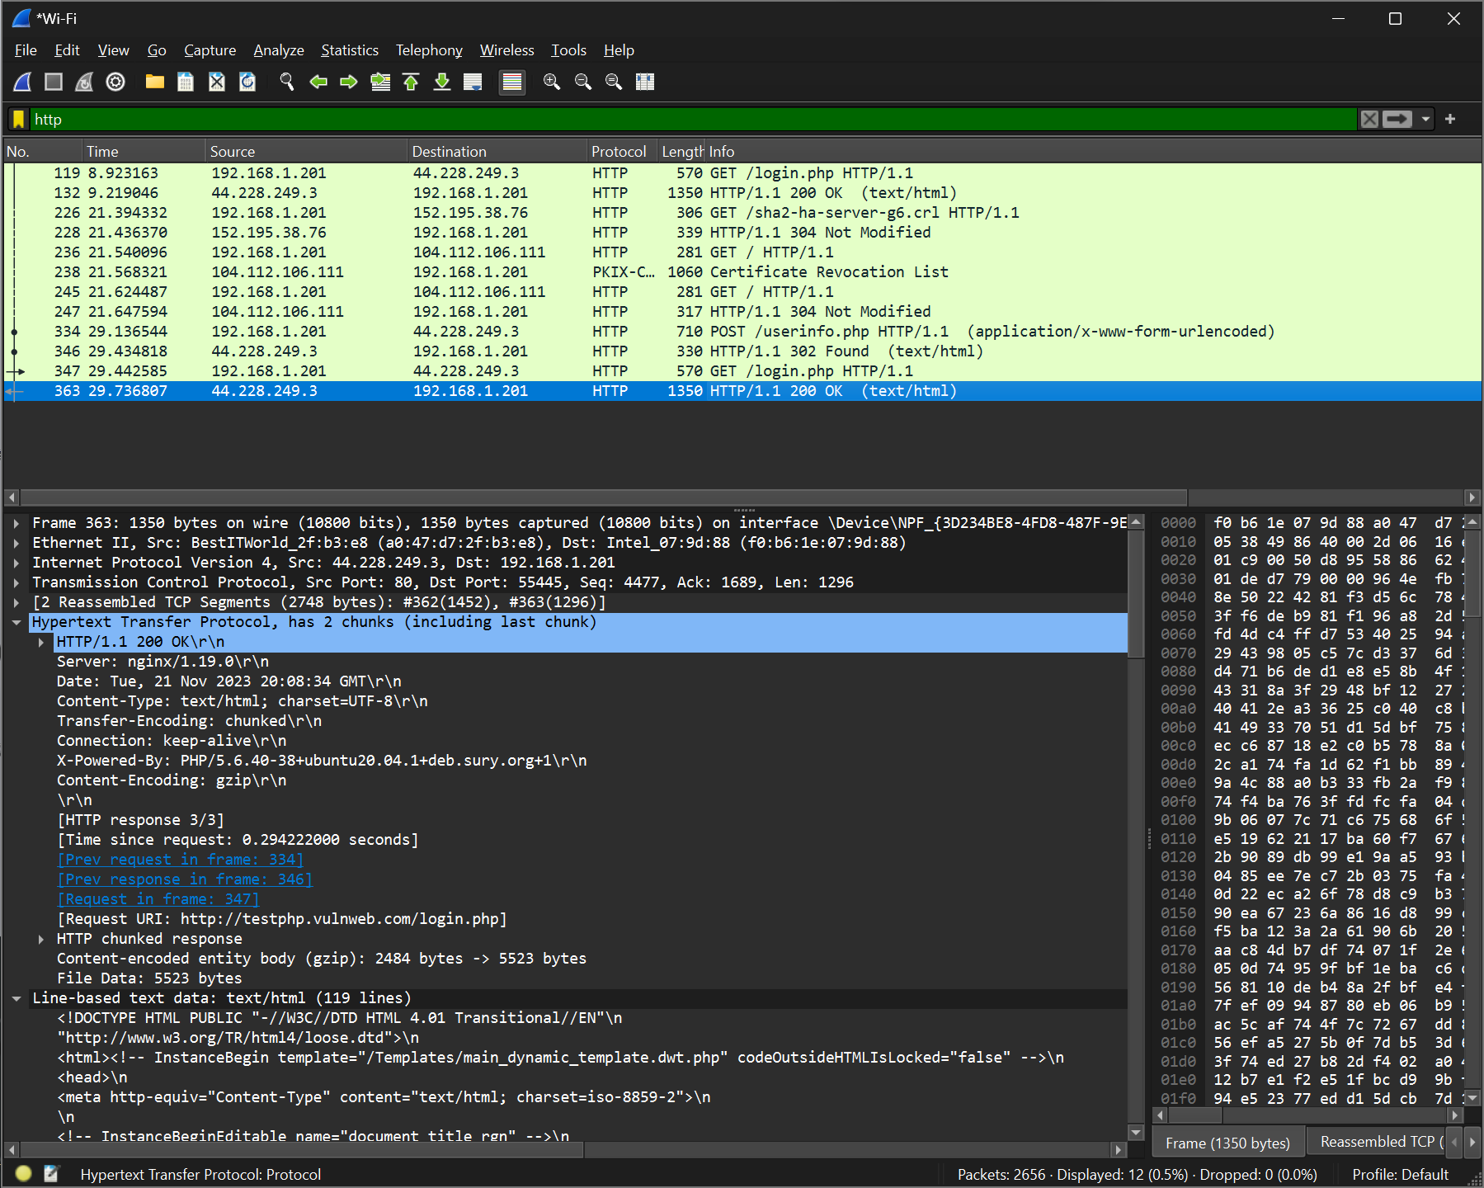

**To check which websites are surfed on a network (only http websites)**

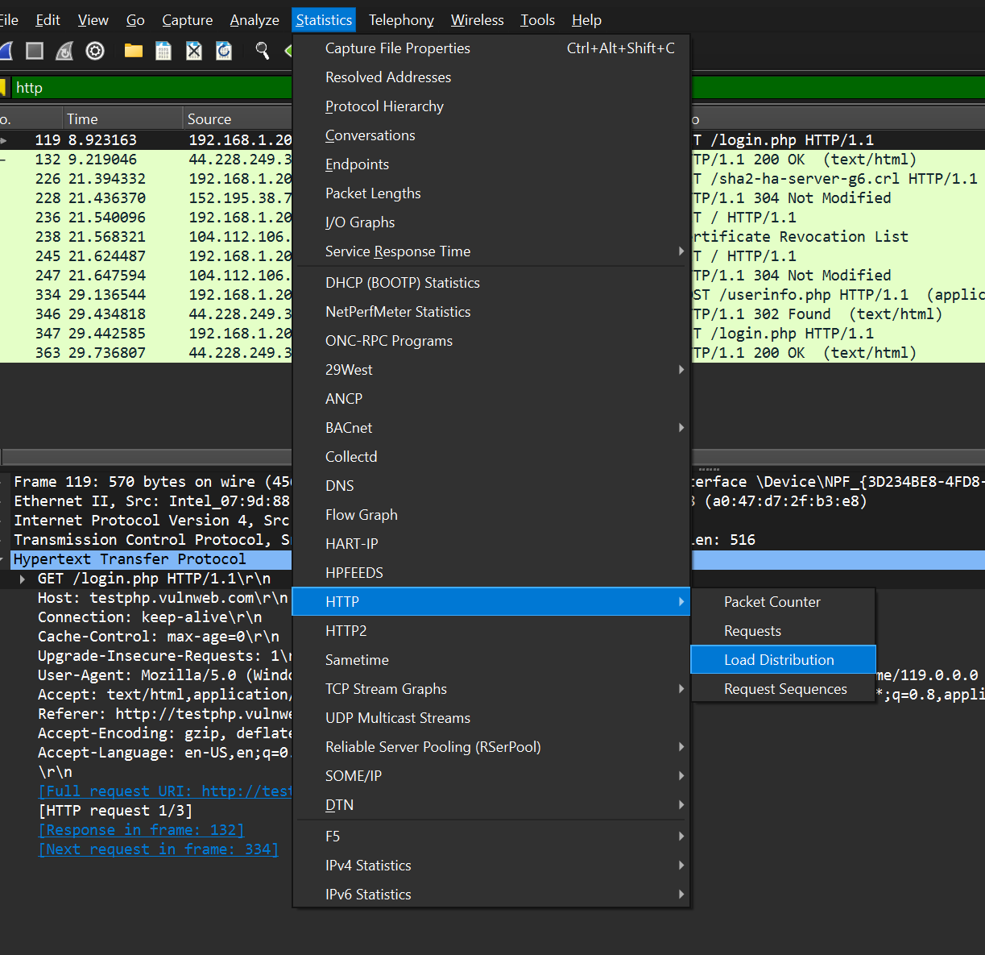

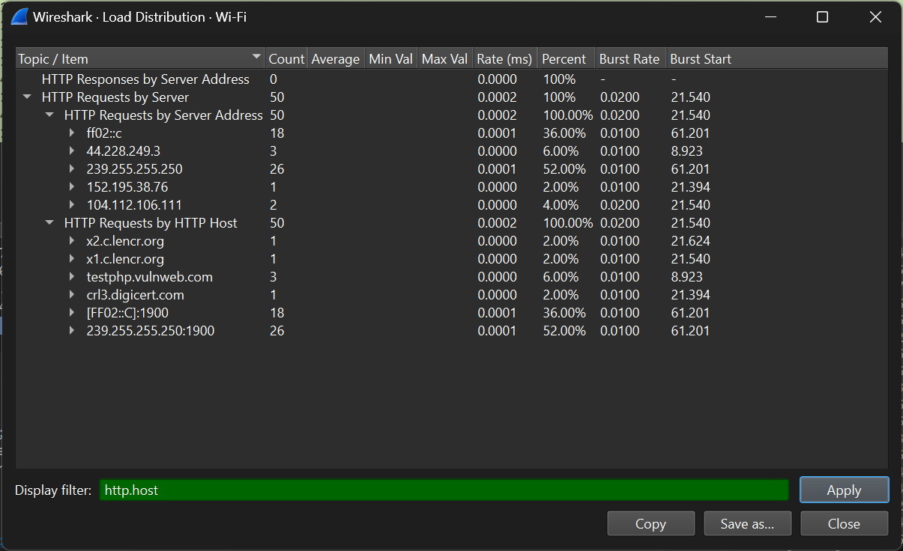

**LAB EXPERIMENT – 10**

**Nessus Essentials for Vulnerability Scanning**

**LAB PRACTICE:**

**Which company created Nessus?**

Nessus was created by Tenable, Inc. Tenable is a cybersecurity company that provides various security products and services.

**Under Scan Templates in Nessus, there is a scan for what type of Ransomware?**

Nessus does not specifically have a predefined scan template for a particular type of ransomware. Scan templates in Nessus are generally designed to identify vulnerabilities and security issues in systems rather than specific malware types.

**When creating a new Plugin Rule, what 4 fields do you need to enter?**

When creating a new Plugin Rule in Nessus, you typically need to enter the following four fields:

Name: A descriptive name for the rule.

Rule: The rule itself, specifying the conditions that trigger the rule.

Action: The action to be taken when the rule is triggered (e.g., alert, log, block).

Severity: The severity level assigned to the rule.

**Is there a scan template specifically designed for mobile devices?**

Yes, Nessus has scan templates that are specifically designed for mobile devices. These templates are tailored to assess the security of mobile operating systems and applications. Mobile device scan templates typically include checks for vulnerabilities and misconfigurations relevant to platforms such as Android and iOS.

**Vulnerabilities by Host**

**Advance Dynamic Scan**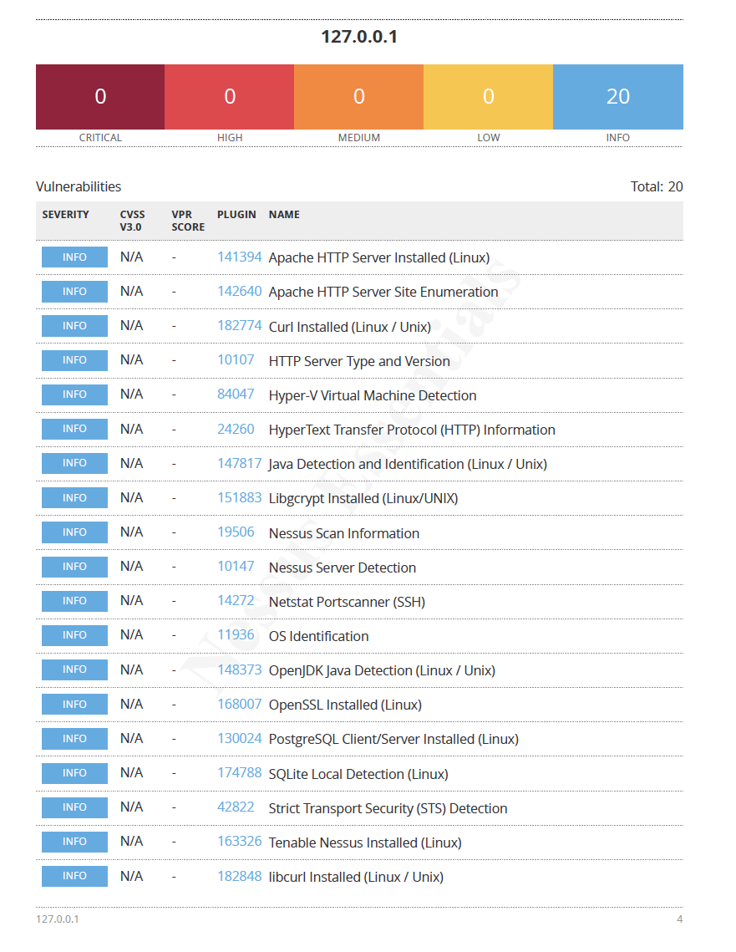

**Vulnerabilities by Host**

**Basic Network Scan**

